Ατομική Διπλωματική Εργασία

COGNITIVE ASSISTANT WITH HOT AND COLD COGNITION

Κυριακή Θεοχάρους

ΠΑΝΕΠΙΣΤΗΜΙΟ ΚΥΠΡΟΥ

ΤΜΗΜΑ ΠΛΗΡΟΦΟΡΙΚΗΣ

Μάιος 2018

UNIVERSITY OF CYPRUS
DEPARTMENT OF COMPUTER SCIENCE

Cognitive Assistant with Hot and Cold Cognition
Kyriaki Theocharous

Supervisor
Dr. Georgios Samaras, Dr. Antonis Kakas
Co-Supervisor
Dr. Marios Belk

The individual thesis submitted for partial fulfillment of the requirements for obtaining the degree of computer science, department of computer science, University of Cyprus

Μάιος 2018

Acknowledgements

I wish to express my sincere gratitude to my supervisor professor, Dr. Georgios Samaras, for believing in me and giving me the opportunity to undertake this project and also to Dr. Antonis Kakas for the significant support that he provided throughout my senior thesis.
I’m most grateful to Dr. Marios Belk for his helpful advises and assistance every time I called for his help and for the considerable amount of time that he dedicated for my senior thesis.

ABSTRACT
The main idea of this thesis is to create a cognitive assistant which will suggest a suitable activity for the elderly people and tries to persuasive them. Our users are either doctors, careers or either elderly people under our project, but it can be used for people of all ages. Our goal is to make elderly people active, happy and add more activities to their everyday life.
The assistant’s decision is based on the cold and hot cognition. Cold cognition is the interests of the older person, the doctor’s recommendations and the parameters from the environment, such as weather, time, and daylight. The hot cognition is the emotions of the older person, such as stress or relaxation which we measure from Microsoft Band 2, a digital Watch.
This idea was implemented in an application, where the user has the opportunity to create a profile and to determine whether he is a doctor or a simple user. If he is a simple user he will declare his interests, else if he is a doctor he will determine what activities are appropriate for the elderly and which are not.
The system responds in three ways. The first way is the request from the simple user, the second way is when the system recognizes the change of emotions and the third way is a specific time for eating, sleeping or taking the pills.

Contents

Chapter 1 Introduction……………………………………………………………………....1
1.1 General introduction 1
1.2 Purpose 1
1.3 Document Structure 2

Chapter 2 Cognitive Assistant ….…………………………………………………………..4
2.1 Definition 4
2.2 General cognitive assistants systems 4
2.3 Features of our care assistant 7

Chapter 3 Theoretical Approach……………….…………………...………………………9
3.1 Argumentation 9
3.2 Decision Making 9
3.3 Persuasion 10
3.4 Sample Scenario 11
3.5 Gorgias 12

Chapter 4 Analysis and Design…………………………………………………………….16
  - Requirements Analysis 16
    - Design Requirements 16
    - Technology Requirements 16
  - Response of the system 16
4.3 Architecture 18
4.3.1 Software Architecture 18
4.3.2 Hardware Architecture 20

Chapter 5 Implementation ………………………………………………………………...23
5.1 Gorgias Design 23
5.1.1 Options (Activities) 23
5.1.2 Common Sense Knowledge Rules 25
5.1.3 Preferences Vocabulary (WORLD, High Level Data) 26
5.1.4 Environment Vocabulary (SENSORY, Low Level Data) 27
5.1.5 Rules between the WORLD and the SENSORY Data 28
5.1.6 Gorgia’s rules (Preferences) 29
5.2 Database 30
5.2.1 Database Tool 30
5.2.2 ER Diagram 30
5.3 Android Application 31
Chapter 6 Active Life ………………………………………………………………………….33
6.1 Android Application Design 33
6.2 Page Design 34
6.2.1 Login/Register 34
6.2.2 Home Page 35
6.2.3 User’s Profile 35
6.2.4 Activities 36
6.2.5 Interests/Recommendations 37
6.2.6 Can I? 38
6.2.7 Notifications 39

Chapter 7 Evaluation …………………………………………………………………………40 7.1 Evaluation Process 40
7.2 Results 40
7.3 Evaluation Conclusion 45

Chapter 8 Conclusion …………………………………………………………………………46
8.1 Summary 46
8.2 Future Work 47
Bibliography…………………………………………………………………………………..…48

Table 1 – Care Assistants…………………………………………..............................................7
Table 2.1 – Options (activities) and common sense knowledge…………………………….......24
Table 2.2 – Scenarios (conditions)…………………………………………………………........25
Table 3 – Preferences Vocabulary….............................................................................................27
Table 4 – Sensory Information Vocabulary (SENSORY, Low Level Data)................................28
Table 5 – Rules between the WORLD and the SENSORY Data…............................................29
Table 6 – WORLD representation………………………………….............................................29
Table 7 – Evaluation 1…...............................................................................................................41
Table 8 – Evaluation 2…...............................................................................................................43
Table 9 – Evaluation 3….…..........................................................................................................45

Figure 1 – Software Architecture..................................................................................................18
Figure 2 – Hardware Architecture.................................................................................................20
Figure 3 – ER Diagram….….........................................................................................................30
Figure 4 – Login/Register……......................................................................................................34
Figure 5 – Home……..….….........................................................................................................35
Figure 6 – Profile…….….….........................................................................................................35
Figure 7 – Activity….….…...........................................................................................................36
Figure 8 – Interests/Recommendations..........................................................................................37
Figure 9 – Can I?…….….…..........................................................................................................38
Figure 10 – Notifications…...........................................................................................................39

Appendix A – Questionnaires…....................................................................................................49

Chapter 1

Introduction

1.1 General introduction
1.2 Purpose
1.3 Document Structure

General introduction
The people nowadays are not as active as they used to be. Most of the time either they are sleeping or working. Maybe also they are addicted to the phone or TV, so they don’t go out of the house and they don’t do something productive. This phenomenon is observed more in the older people, because some of them are alone, they don’t socialize with other people, they don’t have friends and they don’t go out of the house. Some others suffer from depression and they refuse to be active in their life.
For all these problems we mention above, we create the Active Life App project. The goal of this project is to motivate the people to be more active in their everyday life. To do various activities, go out or stay home, depends on environment conditions and emotions, do exercise, walk or just relaxing by listening to music. This project suggests some activities, which are more suitable to the user based on some parameters. The system finds the suitable activities based on the emotion of the user (relaxed, stressed), which are the most important. Then the weather and the time are checked, the interests of the user and the recommendations of the doctor. Then try to persuade the users with arguments and persuasion strategies.
The system can suggest sixteen activities. Some of them are outdoor and others indoor. Some of them need good weather and daylight, some other not. What we want is to make a combination of these activities, so the user can make a lot of different activities in one day.
The application is for android phones using wearable. It is user friendly with images and audio. Is design especially for elder people, but it can be used for all people.
For the needs of this project, other care assistants were studied. Important features of care assistances are to have many answers, not just one and also give explanations. Also the argumentation theory and decision making were important. Understanding how gorgias works and implement the rules.
The android application suggested an activity if you request it from it or if the system recognizes that your emotions have changed. You can also ask for a specific activity if it is available at the current time.

1.2 Purpose
In our days the technology is very developed and useful for our everyday life. It used in all ages now and has become a necessity. Lately the elderly people have become more intimate with computers, mobiles and more generally with technology, so our purpose is to make their life easier through them. We want to help elder people to be more active and to do the right activities for their health depending on their condition. So with the help of an application we want to try to deal with stress and monotony in their lives, motivating them to do some activities that will help their mental or physical health.

1.3 Document Structure
My thesis consists of chapters. The first chapter has the general introduction mentions the purpose of my Bachelor Thesis. The second chapter is about the Cognitive assistants, what exactly are these assistances, various similar care assistant with my assistant and the different features of each. The third chapter indicates the theoretical approach. The definition of argumentation, decision making and persuasion. Persuasion strategies which used by the system are also defined. There is a sample scenario to understand the problem better and an explanation of how gorgias works. The next chapter describes the requirements analysis, the three ways that the system responds, the architecture, the flow of information and the technologies utilized. Chapter five is about the implementation of the gorgias and android application and the connection between them. The following chapter presents minutely the design of android application. The seventh chapter explicates the evaluation of the system. How usable is the application and if the system returns satisfying results. The final chapter focuses in the future work and the general conclusion.

Chapter 2

Cognitive Assistant

2.1 Definition
2.2 General cognitive assistants systems
2.3 Features of our care assistant

Definition
[10]Sometimes it is difficult for people to perform the everyday, mundane tasks that take up precious time οr decide about things related to health, work and everyday life in general. Through the assistance of technology, innovations can be made such as a cognitive assistant. It is a software agent that augments human intelligence, perform tasks and other services like assists human in decision making and taking actions and also complements human by offering capabilities that is beyond the ordinary power and reach of human.

General cognitive assistants systems

Systems | Description | Features
Day Guide | Provide associated to locations and guidance, share and organization of tasks, through a mobile phone | - Used by elderly people suffering from mild cognitive impairment in an aging at home perspective.  - Reminder.  - Parameters: time, outside weather conditions, diary.  - Present the reminders visually and aurally.
CoME | Counts with wearable sensors to constantly monitor the elderly people and smartphones to visually interact with them and to receive self-report from them. | - Used by elderly people  - Used by caretakers to localize and receive health reports from their care-receivers.  - Visually  - Show tutorials about how to perform certain activities  - Be deployed at each elderly home  - High volume of communication
DALIA | Wrapper for the ANNE virtual assistant providing it with the abilities of linear integration with external services and a Service-oriented architecture. ANNE is in the shape of human-looking avatar. | - Used by elderly people  - Virtual assistant  - Speech  - Face recognition  - Easy communication  - Appointments calendar  - Automatic reminders  - Documenting events  - Keeping memories  - Emergency call  - Fall detection  - Localization of lost items  - Health status monitoring  - Motivation for physical and mental activities
EDLAH2 | Use gamification procedures on elderly people resorting to tablet technology. The objective is to be as appealing as possible and to have greater incentive to be used. | - Used by elderly people  - Visual interface  - Improve the mental health , physical health, social integration and self-esteem  - The execution process will give award gained by using other services.
iGenda | A cognitive assistant that focuses on elderly people and their caregivers through management of daily events and activities. | - Used by elderly people  - Maintain the cognition levels and help stopping the Alzheimer’s advance  - Manage the activities  - Schedule new activities  - Visualize the elderly vital signs  - Monitor several people at the same time  - Run on smartphones or devices with web browsers
M3W | Develop a mental wellness tool for self-usage to measure and visualize mental changes and tendencies, and to give indications, alarms or reports. | - Used by elderly people, their relatives, friends and physicians  - Improve attention  - Decision making  - Mental flexibility  - Planning  - Problem solving  - Visual memory  - Spatial memory  - Working memory
MyGuardian | Use technology to facilitate the elderly mobility, keeping their autonomy and dignity. Also the system guiding the elderly and reporting situations of confusion or risk to the caretakers. | - Used by elderly people  - The caretakers can coordinate the daily tasks step by step.  - Simple and easy interface  - Communicate by voice and automated messages  - Panic button for emergency situation
PersonAAL | Monitors the behavior of the elderly through sensors systems, adaptively displays information and health related suggestions on various devices at home. | - Used by elderly people  - Predicting some actions  - Adapt to changing contexts  - Use several different platforms to interact with the users (PC, TV, smartphone, etc.)

Table 1. Care Assistants

Features of our care assistant
Active Life
Our care assistant suggests a suitable activity for the elderly people and tries to persuasive them.
The user can request from the system to suggest him an activity or he can ask for a specific activity if it’s available. Also our assistant notifies the user at a specific time to remind him for pills either for eat or sleep. Moreover the assistant recognizes the change of emotions through a wearable, which the user has to wear in his hand.
- Used by elderly people
- Simple and easy interface
- Decision making
- Motivation for physical and mental activities
- Persuasion
- Audio

Chapter 3

Theoretical Approach

3.1 Argumentation
3.2 Decision Making
3.3 Persuasion
3.4 Sample Scenario
3.5 Gorgias

3.1 Argumentation
Argumentation is the process of giving reasons for or against something, the process of making and presenting arguments. It is how conclusions can be reached through logical reasoning. Argumentation includes the arts and sciences of civil debate, dialogue, conversation, and persuasion. It studies rules of inference, logic, and procedural rules in both artificial and real world settings.

3.2 Decision Making
Decision making is regarded as the cognitive process resulting in the selection of a belief or a course of action among several alternative possibilities. It is divided into two categories: Conscious and Unconscious. [8]Unconscious thought theory assumes that unconscious processes, which continue to work on a problem while the conscious attention is directed somewhere else, are better suited to adequately weight and integrate the given information than conscious deliberation. When you have to make a decision, the first step should be to get all the information necessary for the decision. Once you have the information, you have to decide, and this is best done with conscious thought for simple decisions.

3.3 Persuasion
Persuasion is an umbrella term of influence. Persuasion can attempt to influence a person's beliefs, attitudes, intentions, motivations, or behaviors. In our system, we want to persuade the users to take a suitable decision which suggested by the system. We use six persuasion strategies: [14]
- Rational
The system use logic reasoning to persuade the user. It provides arguments from everyday life that can hardly be challenged. Based on weather, time and daylight gives rational arguments.
- Emotion
The system use words powerfully and dramatically to sensitize the user. Based on emotions, better health, socialize, friends, family, environment, nature and etc. tries to persuade the user, strives to touch and concern him.
- Authority
The authority says his suggestion. In our case the authority is the doctor or the caregiver, who determines the time of sleep, eat and take pills. Also they suggest which activity the user must do or must not do.
- Just-InTime persuasion
The persuasive messages are highly related and available at just the moment people make a decision.
- Personalizing
Generally speaking, personalized information receives more attention than general information and may potential influence the person more effectively. The user will pay more attention to his preferences and needs.

3.4 Sample Scenario
Christine is 75 years old and lives alone in her home. Thankfully her daughter's house is nearby and she visits her every day. But Christine suffers from chronic depression and also she forgetting recent events. Although she visits her daughter every day, she complains that she is always alone and has nothing to do.
So Christine found the application ActiveLife App to help her mother. This application it’s a cognitive assistant that suggested to elderly people the best activities for the current time, based on the environment, the emotions and the physical condition. Its main goal is to convince the user to make the chosen activity and for that it uses persuasion strategies and arguments.
The emotions are recognized by the wearable, which the user must wear it in his hand all the time. Also the interests of the user play an important role in the cognitive assistant's decision, for example listening to music or watching TV. But the most influential is the doctor’s recommendation (must do, mustn’t). As it seems the application connects the elderly with his doctor in order for the doctor to take care of the mental and physical health of the patient.
Information
Christine likes to listen to music, go for shopping and walk. The doctor said that she must walk every day for one hour and takes her pills at 9:00am and 21:00pm. Also it’s good for her to socialize.
Dynamic parameters
Example 1
The weather is good, the time is 15:00 so it’s afternoon (day). Christine is relaxed at the current time.
Example 2
The weather is good, the time is 17:00, so it’s afternoon (day). Christine is stressed at the current time.
Example 3
The weather is bad, the time is 20:00, so it’s night. Christine is relaxed at the current time.
The application responds in 3 cases:
- First case : User request
Christine at the current time, want to do some activity, but she don’t know what, and also she needs some motivation. So she asked the app what is better to do at the current time. Based on her interests, the doctor’s recommendation and the Example 1 the app decided that one of the best activities for Christine is to walk. Based on the Example 2, the app decided that one of the best activities for Christine is to socialize. Based on the Example 3, the app decided that one of the best activities for Christine is to listen to music.
- Second case : The system recognizes the change of emotions
Christine at the current time is very tired and stressed and the app recognized that. So it suggested to her to watch TV, because this will help her to relax.
- Third case : The system is scheduled at a specific time to notify the user
The time is 9:00am, so the app notifies Christine that it’s time to take the pills.

Gorgias
Gorgias is a system implementing a logic programming framework of argumentation that integrates together preference reasoning and constraint solving. It contains some options and some rules with priorities based on preference. Based on rules and preference it takes decisions and then returns the appropriate options which are available and returns together the explanation.
Gorgia’s rules looks like:
- rule(o_walk(walk), activity(walk), [weather(good), daylight(light)]).
It’s the rule with name o_walk(walk), which represents the activity walk (activity(walk)) and is activated with the conditions in brackets [], in our example when the weather is good and there is light outside.
- rule(emotion_socialize, prefer(o_socialize, o_swim),[emotion(stressed)]).
It’s the rule for the preferences. Rule’s name is emotion_socialize. This rule shows the preference to socialize rather than swim when the emotion is stress.
Gorgias runs with the following command: prove([option(X)],Explanation), where X is a variable which represent an option and explanation is all the arguments which support the current option.
In the sample scenario above the options are the activities listen to music, go for shopping, socialize, read a book, watch TV, walk and take pills. Generally she likes listen to music, go for shopping and socialize so are general preferences, but bigger preference is to read a book at night than listen to music and bigger than this is the doctor’s recommendations walk and take pills. The biggest preference is to watch TV when is stress, because the emotion is stronger parameter than the others.
The parameters stress and night are in the category of the hot and cold cognition and Gorgias will use them as arguments. And with these arguments we will try to persuade the user to accept the Gorgia’s decision.
Based on the above scenario we have some results for the three examples (with dynamic parameters).
Options
Example 1:
- Listen to music
- Go for shopping
- Walk
These are the results for the gorgias at the first time. All the options will be available as the user rejects the recommending.
Explanation:
Delta: [relaxed,interest_walk,light_daylight,good_weather,o_walk(walk)]
Analyzing the explanation we see that the user is relaxed, there is light outside, the weather is good and walk is in the interests of the user.
Example 2:
- Socialize
- Play board games
- Watch TV
- Take a rest
- Listen to music
These are the results for the gorgias at the first time. All the options will be available as the user rejects the recommending.
Explanation:
Delta: [stressed,day_time,o_socialize(socialize)]
Analyzing the explanation we see that the user is stressed and its day.
Example 3:
- Listen to music
This is the result for the gorgias at the first time. The options that can be done at home (exercise, socialize, cook, play board games, watch TV, play video games, paint, take a rest) will be available as the user rejects the recommending.

Explanation:
Delta: [relaxed,interest_listen_music,dark_daylight,bad_weather,o_listen_music(listen_music)]
Analyzing the explanation we see that the user is relaxed, is dark outside, the weather is bad and listening to music is within her preferences.

Chapter 4

Analysis and Design

4.1 Requirements Analysis
4.1.1 Design Requirements
4.1.2 Technological Requirements
4.2 Response of the system
4.3 Architecture
4.3.1 Software Architecture
4.3.2 Hardware Architecture

Requirements Analysis

Design Requirements
The system should be user-friendly and easy to use, because it will be used by older people. The size and the buttons should be large. Auxiliary images will help more the elder users. The system needs to have audio in case the elder users find it hard to read the answers.

Technological Requirements
For proper use of the system, Bluetooth and Locator must be enabled. The phone and the wearable connected through Bluetooth. The locator is needed for weather information such as temperature and keywords (clearsky, snow, rain etc.).

Response of the system
The system responds in three different ways:
- User request
When the user feels that he wants to do some activity or when he is not well mentally then he can request from the system to suggest him a suitable activity from him. Or he can ask for a specific activity if it’s available.

- The system recognizes the change of emotions.
When the emotions of the user changes from relax to stress or the opposite then the system notify with a notification the user. Then the user can request from the system to see the new suggested activity.

- The system is scheduled at a specific time to notify the user.
The system notifies the user at a specific time which determine from the doctor or the caregiver. The doctor or caregiver determines the time for sleeping, eating and taking pills if it’s necessary.

4.3 Architecture

4.3.1 Software Architecture

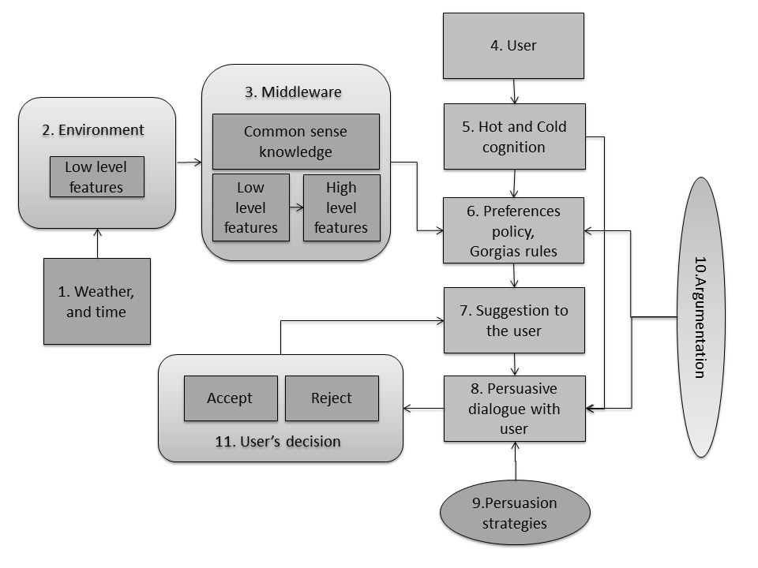

Figure 1. Software Architecture

- Collected data about the weather through APIs and time.
- Environment (low level features): temperature, time (HH:MM), stress level.
- Middleware: Transition of the low level features to high level features, with the addition of the common sense knowledge (Rules between the WORLD and the SENSORY Data).
- The user who uses the system.
- Hot cognition emotions (relaxed, stressed – stress level), cold cognition user’s profile (e.g. doctor’s recommendation).
- Analysation of all input and data, so that the final options are suggested by the Cognitive Assistant, the decision is taken.
- Suggestion of the possible options, the decision to the user.
- Persuasive dialog with the user using arguments and persuasive strategies about the assistant’s decision, the suggested options.
- The persuasion strategies such as emotion, logic, authority, personalizing and Just-InTime persuasion.
- Use argumentation for the persuasion and for gorgia’s decision.
- User’s feedback, decision on the suggested options. The user can accept or reject each suggested option. If the user rejects one option, the assistant moves on with the next option.

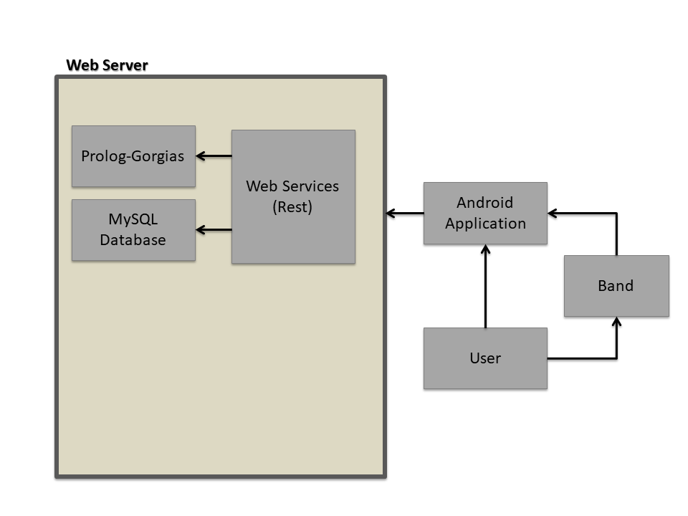
4.3.2 Hardware Architecture

Figure 2. Hardware Architecture

Figure 2 represents the hardware architecture, which includes the Band, the Android Application, and the web server. The web server includes the prolog-gorgias and the MySQL Database, which communicate with android application through web services (Rest). Each person who desires to use this system must have a Microsoft BAND and an android mobile phone. Microsoft Band 2 is a digital Watch which is responsible to measure Heart Hate, RR-intervals and Skin Response. Through some libraries and algorithms the android takes the input of band and find out if the user is stress or relax. Gorgia’s files are made by php, which takes parameters for the database and the android application.
Microsoft Band 2: [13]
Microsoft Band 2 is a smart watch which was developed by Microsoft and provides necessary features. Obviously, the device is a strong wearable option. The stats it gathers are accurate, and useful.
Microsoft Band succeeds more by tracking your heart rate, various exercises, calorie burn, and sleep quality, and helps you be productive with email, text, and calendar alerts. Certainly, it assistances you live healthier and more efficiently. The Band includes 11 sensors involving Heart Rate, RR-intervals, Accelerometers and skin conductance. It has a wide range of sensors which we have the opportunity for access.
Enhance the experience of users which in possession of digital watch because purvey many details about our live, especially our health. For this reason, we are exploited the device to retrieve immediate the data of Heart Rate, RR-intervals, Galvanic Skin Conductance and Accelerometer.
Web Services:
[11]Web service is any software component or application component available on the Internet that can complete tasks and solve problems. However, if we want to better define the concept of web services, we could use the definition that comes from IBM:
- Web services are a technology that allows applications to communicate with each other regardless of platform and programming language. A web service is a software interface that describes a collection of functions that can be accessed from the network through XML standard templates. It uses XML-based templates to describe a function to execute and the data to be exchanged with another application. A group of web services that interact with each other define a web services application.
In our case we use Restful Web Services. REST (Representational State Transfer) is a set of design principles for a network service that focuses on the resources (e.g., data) of a system. The change of the state of the system resources is described and transferred to the system via the HTTP protocol by different clients (regardless of the language in which they are implemented).
- To create a resource on the server, we use the POST method.
- To retrieve a resource, we use GET.
- To change the status of a resource or update it, we use PUT.
- To remove or delete a resource, we use DELETE.
Android Studio
The Android Studio is an open source and Linux-based operating system for mobile devices such as smartphones and tablet computers. Every project contains java programming language and XML layouts. It supports building android wear app with the appropriate libraries and connects with database.
Extensible Markup Language (XML) is a markup language from the World Wide Web Consortium (W3C). It has a standard formal recommendation which is human legible and machine readable. It is designed to store and transport data. The structure is embedded system with the data, thus when the data arrives there is redundant to pre-build the structure to store the data because it is dynamic Xml code is obligatory in android studio. It designates and designs layouts. For this reason, it manages the presentation of items in my android application.

Chapter 5

Implementation

5.1 Gorgias Design
5.1.1 Options (Activities)
5.1.2 Common Sense Knowledge Rules
5.1.3 Preferences Vocabulary (WORLD, High Level Data)
5.1.4 Environment Vocabulary (SENSORY, Low Level Data)
5.1.5 Rules between the WORLD and the SENSORY Data
5.2 Database
5.2.1 Database Tool
5.2.2 ER Diagram
5.3 Android Application

Gorgias Design

5.1.1 Options (Activities)
The 16 options between the Care Assistant can choose from, in order to suggest them as possible activities for the user are listed below. There is also a small explanation provided of each option in natural language, as well as their environment requirements that are further explained later on.
# | Option | Natural Language | Requirements
O1 | activity(exercise) | Exercise of any kind | time(day)
O2 | activity(walk) | Take a walk outdoors | weather(good), daylight(light)
O3 | activity(swim) | Swim in the pool or in the sea outdoors | weather(good), daylight(light)
O4 | activity(socialize) | Socialize with other people | time(day)
05 | activity(play_board_games) | Play board games | -
O6 | activity(shop) | Go for shopping outdoors | weather(good), daylight(light)
O7 | activity(cook) | Cook or bake in the kitchen | time(day)
O8 | activity(watch_tv) | Watch TV | -
O9 | activity(paint) | Paint in any form | -
O10 | activity(plant) | Plant or do gardening outdoors | weather(good), daylight(light)
O11 | activity(play_video_games) | Play video games | -
O12 | activity(listen_music) | Listen to music | -
O13 | activity(rest) | Take some rest | -
O14 | activity(sleep) | Sleep for the night | time(night)
O15 | activity(eat) | Eat, have a meal | time_to_eat()
O16 | activity(take_pills) | Take pills | time_for_pills()

Table 2.1 Options (activities) and common sense knowledge

Scenarios | O1 | O2 | O3 | O4 | O5 | O6 | O7 | O8 | O9 | O10 | O11 | O12 | O13
<S1: weather(good), daylight(light),  time(day)> | X | X | X | X | X | X | X | X | X | X | X | X | X
<S2: time(night),  daylight(dark)> |  |  |  |  | X |  |  | X | X |  | X | X | X
<S3: (weather(bad) or daylight(dark)) , time(day)> | X |  |  | X | X |  | X | X | X |  | X | X | X

Table 2.2 Scenarios (conditions)

5.1.2 Common Sense Knowledge Rules
The Care Assistant follows some common logic for some of the options. The common sense knowledge rules are based on the sensory data, so they have to do with the weather, the time of the day etc. These rules allow the assistant to know when some specific options are possible or not, so that it knows whether it can suggest them to the user or not. The description of the rules can be found in the following description.
The assistant suggests the user to eat (activity(eat)) when the alarm for taking meals is off on specific times of the day (time_to_eat()) according to the doctor. It also suggests the master to take pills (activity(take_pills)) only when the alarm for taking the pills is off on specific times of the day (time_for_pills()) also according to the doctor’s instructions. The assistant suggests the master to sleep (activity(sleep)) only during the night (time(night)) and to rest (activity(rest)) only during the day (time(day)).
The assistant suggests the user the following activities only when the weather is good (weather(good)) and there is light outside (daylight(light)).
- to take a walk (activity(walk)),
- to swim (activity(swim)),
- to shop (activity(shop)), or
- to plant (activity(plant)).
The assistant suggests the rest of the activities without requiring any special circumstances.
- to exercise (activity(exercise)),
- to socialize (activity(socialize)),
- to play board games (activity(play_board_games)),
- to cook (activity(cook)),
- to watch TV (activity(watch_tv)),
- to paint (activity(paint)),
- to play video games (activity(play_video_games)) or
- to listen to music (activity(listen_music)).

5.1.3 Preferences Vocabulary (WORLD, High Level Data)
The assistant uses a specific vocabulary in order to describe or model the environment that affects its thinking, so that it understands them in a simpler way compared to the sensors. These specific words that are used by the assistant to encode the preferences can be found in the table below for each type of information.
Type |  | Possible Values (High Level)
Time |  | day, night
Daylight |  | light, dark
Weather |  | good, bad
Stress Level |  | relaxed, stressed
Special Parameters |  | time_to_eat, time_for_pills, time to sleep

Table 3. Preferences Vocabulary (High Level Data)

5.1.4 Environment Vocabulary (SENSORY, Low Level Data)
The environment that affects the assistant’s suggestions is based on sensory information about the time, the daylight, the temperature and the weather, as well as the stress level of the elder person. There are also three special parameters that have to do with the instructions of the doctor concerning specific times of the day that the elder person has to eat, sleep or take pills. The options of these values - the data ranges for each sensory information can be found in the table below for each type of information.
Type |  | Sensory Values (Low Level)
Time |  | Format: “HH:MM”, Range: [00:00, 23:59]
Daylight |  | light, dark (based on time, month)
Weather |  | Temperature, Weather Keywords
Temperature |  | Range: [-60, +60] Celsius Degrees °C
Weather Keywords |  | Clearsky, fewclouds, scatterclouds, brokenclouds, mist, snow, rain, showerrain, thunderstorm
Stress Level |  | Range: [0, 100] Degrees of stress level
time_to_eat |  | Specific times given by the doctor and for now this process is done during the pre-phase.
time_for_pills
Time_to_sleep

Table 4. Sensory Information Vocabulary (Low Level Data)

5.1.5 Rules between the WORLD and the SENSORY Data
In order for the assistant to be able to understand the sensory data sent by the environment, it has to relate each point of its world to specific range or values for each sensor. The rules set for the reason mentioned above can be found in the following table.
Type | WORLD | SENSORY
Time | day | [07:00, 22:59]
 | night | [23:00, 06:59]
Daylight | light | (time>=6 and time <=8) AND  ( month>=4 and month<=9) OR  ( time>=4 and time<=6) AND  NOT( month>=4 and month<=9)
 | dark | time<6 and time>8
Weather | good | Temperature: [+10, +35] °C  Keywords: Clearsky, fewclouds, scatterclouds, brokenclouds, mist
 | bad | Temperature: [-60, +9] °C, [+36, +60] °C  Keywords: Clearsky, fewclouds, scatterclouds, brokenclouds, mist, snow, rain, showerrain, thunderstorm
Stress Level | relaxed | [0, 40] Degrees of stress level
 | stressed | [41, 100] Degrees of stress level
Special Parameters | time_to_eat | Specific times set by the doctor
 | time_for_pills | Specific times set by the doctor
 | Time_to_sleep

Table 5. Rules between the WORLD and the SENSORY Data
The following table shows the WORLD representation as rules in Gorgias code as high level data, along with their PROLOG representation as low level sensory data.
Type | WORLD | Gorgias Code  (high level) | PROLOG Representation  (low level, sensory)
Time | Day | time(day) | clock(HH, MM),  where HH and MM integers
 | Night | time(night)
Daylight | Light | daylight(light) | altitude(X),  where X is light or dark
 | Dark | daylight(dark)
Weather | Good | weather(good) | temperature(X), keywords(Y), where X integer and  Y one of the weather keywords
 | Bad | weather(bad)
Stress Level | Relaxed | emotion(relaxed) | stress(X),  where X integer
 | Stressed | emotion(stressed)
Special Parameters | time_to_eat | time_to_eat() | This depends on specific times given by the doctor (pre-phase)
 | time_for_pills | time_for_pills()
 | Time_to_sleep | Time_to_sleep()

Table 6. WORLD representation

5.1.6 Gorgia’s Rules (Preferences)
Some activities have priorities over other activities based on the parameters. At first, we prefer the activities that are interesting to the user. The doctor’s recommendations are higher priority than the interests, when the user is relaxed.
Moreover, after a research in a nursing home, we found out what activities are better to suggest when the user is stressed.
- Rest
- Socialize
- Play board games
- Listen to music
- Watch TV
The above activities have the highest priority when the user is stressed, because the emotions are more important.

5.2 Database

5.2.1 Database Tool
The database tool which is used for this project is called phpMyAdmin. It is a free software tool written in PHP, intended to handle the administration of MySQL over the Web. Frequently used operations (managing databases, tables, columns, relations, indexes, users, permissions, etc.) can be performed via the user interface, while you still have the ability to directly execute any SQL statement.

5.2.2 ER Diagram
The user is divided into 2 categories. The first category is the normal user, who is an old person, and the second category is the doctor or the caregiver. In the database are stored the name, surname, username, id, password and role. Role is used to determine if the user is an old person or is a doctor. The normal user stores his interests and the doctor stores his recommendations.

Figure 3. ER Diagram
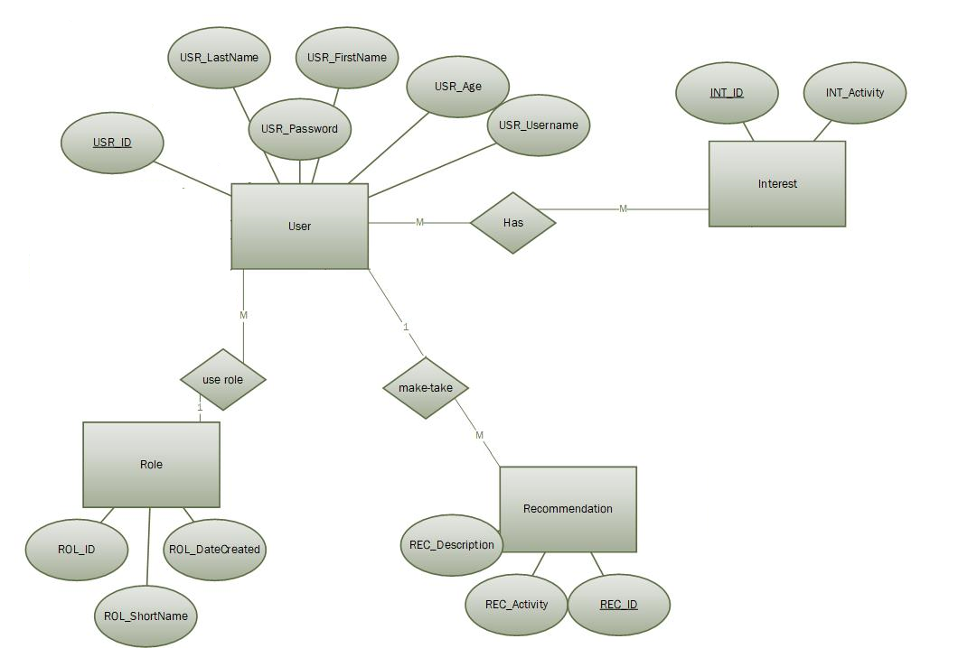

5.3 Android Application
Through the Android, we implement three scenarios. The first scenario is when the user request for an activity. The second scenario is when the system recognizes the change of the user’s emotions and notifies him and the third scenario is when the system notifies the user at a specific time.
For all the scenarios android uses the current time, to finds if its day or night for the first two scenarios or to check if the current time is the same with the specific time that the doctor was set. For the first two scenarios the android uses weather API to get the temperature and keywords. API is a set of functions and procedures that allow the creation of applications which access the features or data of an operating system, application, or other service. Also we use the time and the months to determine the daylight.
The android saves in the database the user’s personal information, and the doctor’s recommendation. It runs parallel and checks from the database if the current time is the same with the one determined by doctor, if so then it notifies the user that is time for peels or to sleep or to eat. Also it runs parallel to check the algorithm with the percentage of stress as a result. If the result is over %50 then the user is stressed else if the result is below or equal to %50 then the user is relaxed.
Generally the android send some parameters to gorgias through a PHP file. Gorgias then converts the low level parameters to high level and processes all inputs and rules. After gorgias makes a decision, returns the result to the android through a PHP file again. The android has a hash map with the results of gorgias for finding in it the explanation in a phrase.
To run gorgias (prolog) through PHP file we use this code:
$cmd = "\"c:/programfiles/swipl/bin/swipl.exe\"-fproject.pl -g \"prove([activity(X)],D),write(X),write(D),halt\"";
$output = shell_exec($cmd); [2].

Chapter 6

Active Life

6.1 Android Application Design
6.2 Page Design
6.2.1 Login/Register
6.2.2 Home Page
6.2.3 User’s Profile
6.2.4 Activities
6.2.5 Interests/Recommendations

6.1 Android Application Design
The user is able to register and login as a normal user or as a doctor/caregiver. The id of the user must be given so that the doctor can store the user’s information. After the user wears and connects the wearable with the phone and of course activate the locator, he can request from the application to suggest him some activities. He can accept or reject the activity and also he can ask if an activity is suitable. Moreover the application set notifications in the top of the phone, to notify the user if emotions have changed.

6.2 Page Design

6.2.1 Login/Register
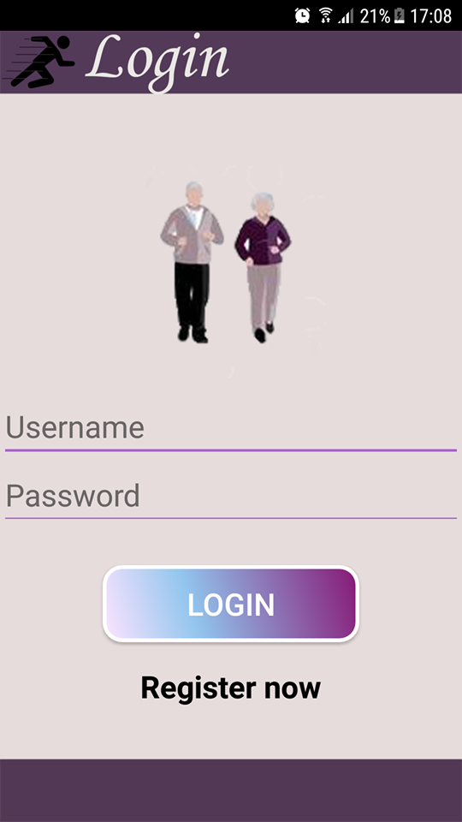
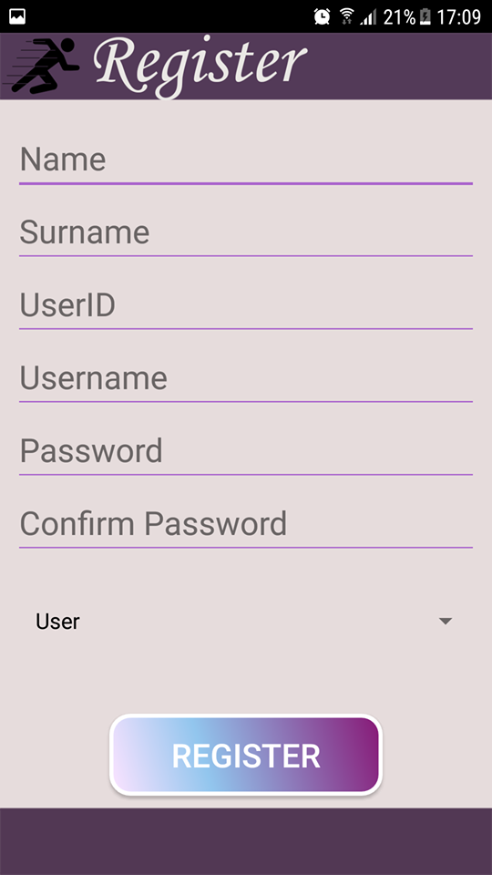

Figure 4. Login/Register

At the register page the user must complete his personal information such as Name, Surname, UserID, Username Password, Confirm Password and choose from the list if he is a normal user or a doctor.
At the login page the user must complete his username and password to login.

6.2.2 Home Page
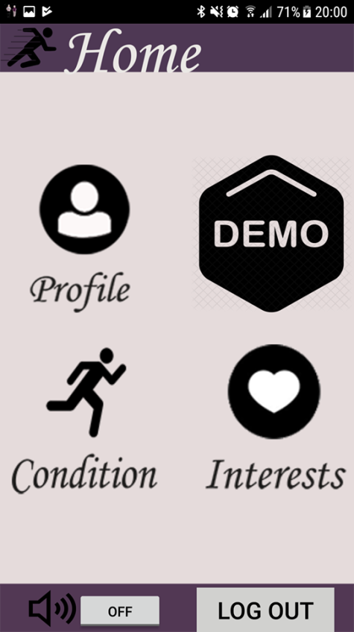

Figure 5. Home
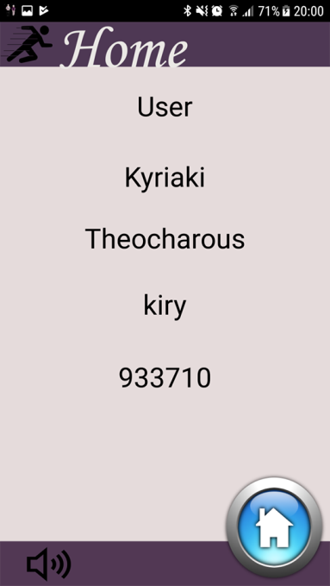
Here we see the home page. There is an audio, so the user can listen some instructions. There is the log out button and four general buttons. The buttons (Profile, Demo, Condition and Interest) will discussed below in more detail.

6.2.3 User’s Profile

The user’s Profile contains the personal information of the user, such as Name, Surname, username and id.

Figure 6. Profile

6.2.4 Activities

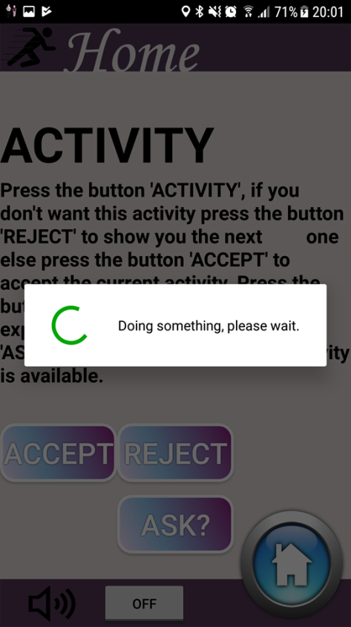
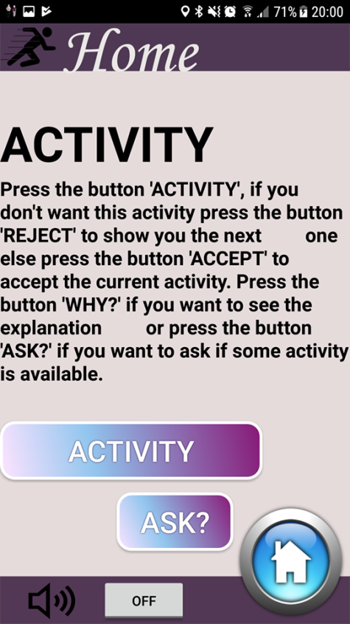
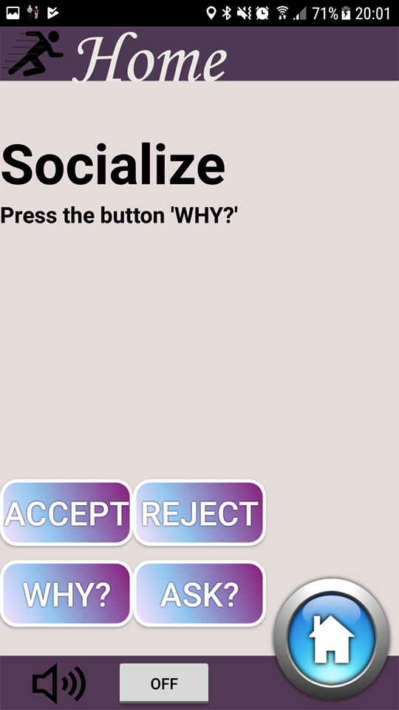

Figure 7. Activity

In the ACTIVITY page the user can press the button ‘ACTIVITY’ to run the program and suggested him a suitable activity. He can press ‘WHY?’ to see the explanation. He can press ‘ACCEPT’, to accept the activity or ‘REJECT’ to run the program again and suggested him a new activity. Also he can press the button ‘ASK’, to find out if an activity is suitable the current time.

Here the user if presses the button ACTIVITY, based on examples 1, 2, 3 we saw in the chapter 3, depends on the dynamic parameters, the results as we saw will be walk, socialize and listen to music.

6.2.5 Interests / Recommendations

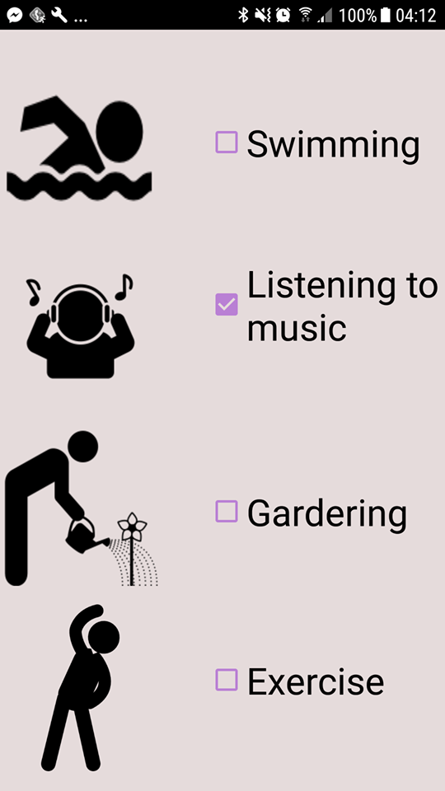
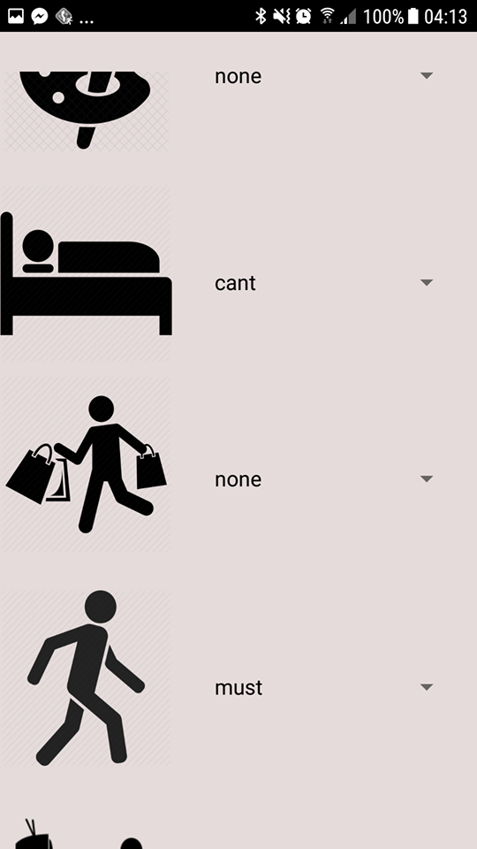

Figure 8. Interests/Recommendations

In this page are the interests which can be selected by the user. There are thirteen options.
In this page are the recommendations which can be selected by the doctor for a specific patient. There are thirteen options.
As the sample scenario we saw before in the chapter 3, the user’s interests were listening to music, walking and shopping.
Moreover the doctor recommend to the user to walk every day.

6.2.6 Can I?

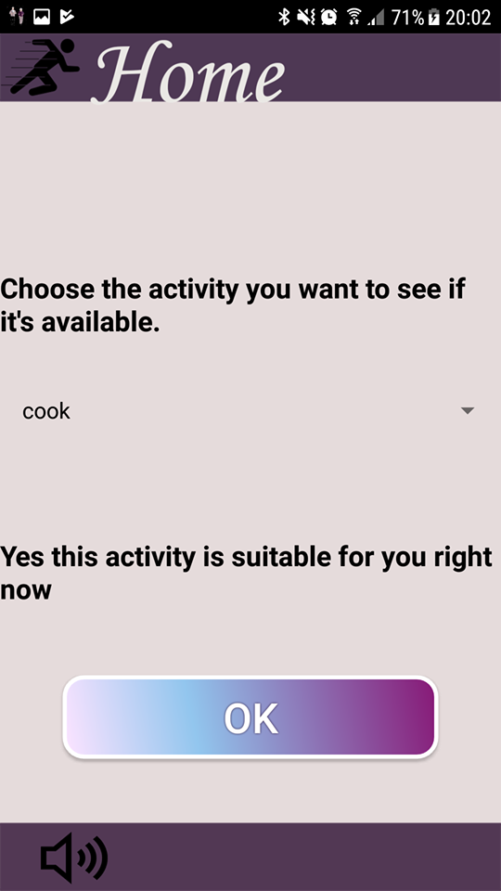
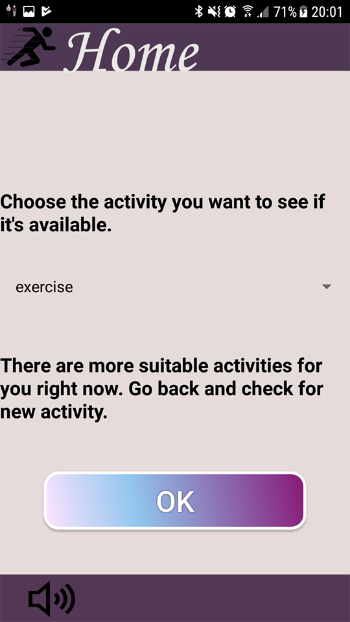

Figure 9. Can I?

In this page, the user is able to choose a specific activity to see if it’s available. If there are more suitable activities then the system said to user to go back and check the activity page.

6.2.7 Notifications

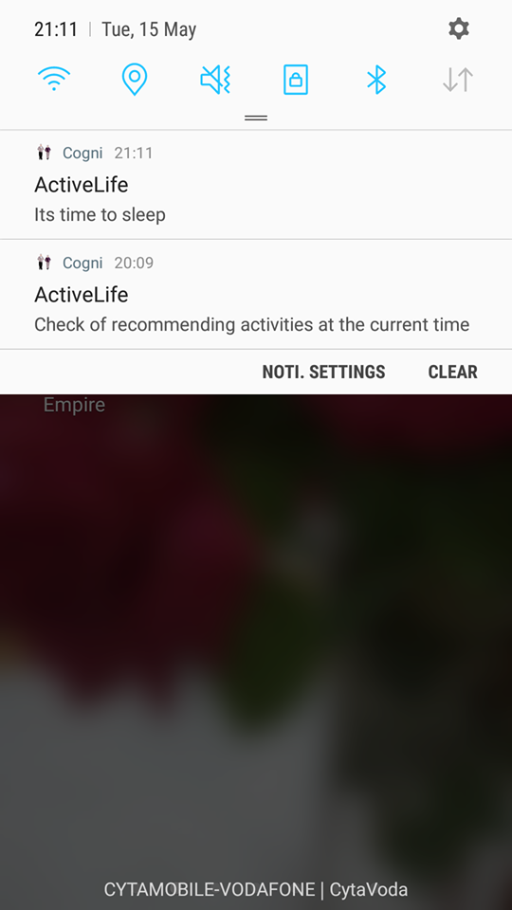

Figure 10. Notifications

The system notifies the user in two cases.
- First case: When the emotions of the user change from relax to stress or from stress to relax.
- Second case: The doctor set a specific time for sleeping, eating or take pills

Chapter 7

Evaluation

7.1 Evaluation Process
7.2 Results
7.3 Evaluation Conclusion

7.1 Evaluation Process
Twenty people complete a questioner for the usability and functionality of the system. Also they answered questions about how the results of the application fit to them and to reality. The average age of the participants was about 23-24. The most participants were males (18 males, 2 females) and students.
Each user during the experiment was wearing a Microsoft Band 2, which is responsible for tracking the emotions after processing algorithms through android (stress or relax). Additionally, smartphones, which developed with the Android mobile operating system and they are compatible with Microsoft Bans 2 were used for the implementation of the system.
All users had previous experience with mobile phones, but no one had practiced wearable. They were all easily familiarized with the whole experiment.
The participants at first navigated and explored the android application so they become more familiar with it. Then, they complete their favorite activities and run the activity page.

7.2 Results
There are two questionnaires for all the participants. The first questionnaire is about the suggested activities, how much the system motivates and persuades the users.
The first two questions were about the activities:
Q1: Do you accept the first activity the app offers you?
Q2: Do you accept one of the first five activities the app offers you?
The results of the twenty people are in the table below.
To mention that the experiment was complete in the afternoon and the weather was good.

Users | Q1: Do you accept the first activity the app offers you? | Q2: Do you accept one of the first five activities the app offers you? | Accepted Activity
 | YES | YES | Socialize
 | YES | YES | Exercise
 | YES | YES | Swim
 | YES | YES | Exercise
 | YES | YES | Walk
 | YES | YES | Listen to Music
 | YES | YES | Walk
 | YES | YES | Walk
 | YES | YES | Shop
 | YES | YES | Socialize
 | YES | YES | Watch TV
 | YES | YES | Walk
 | YES | YES | Exercise
 | NO | YES | Exercise
 | NO | YES | Cook
 | NO | YES | Cook
 | NO | YES | Socialize
 | NO | YES | Listen to music
 | YES | YES | Swim
 | YES | YES | Exercise

Table 7. Evaluation 1
The results were satisfying as the first suggested activity was accepted by the most participants (15 from 20 – 75%).
Also all the participants accepted an activity which was in the first five activities (100%).
Subsequently we have questions about motivation and persuasion:
Q3: Does the app motivate you to do the suggested activities?
The most participants think that the app could motivate a lot of people to be more active (75%).
Q4: Does the app convince you to do the suggested activities?
The most participants convinced by the arguments and the persuasion of the app, to make the suggested activity (71%).
Afterwards there are questions about how the results of the application fit to the people and to environment.
Q5: Do you think the app suggested you the activities that fit you?
The results here were 92%, which are very high percentage, this means that the app suggested the most suitable activities based on the personality of every user.
Q6: Do you think the app suggested you activities that are feasible based on the current time and the weather?
The results here were 91%, which are also a very high percentage. This means that the most participants think that the suggested activities are based on the environment data.
Strongly Strongly
disagree agree
Users | Q3 | Q4 | Q5 | Q6
 | 4 | 2 | 4 | 4
 | 5 | 5 | 5 | 5
 | 3 | 3 | 4 | 5
 | 2 | 2 | 5 | 5
 | 4 | 5 | 4 | 4
 | 4 | 3 | 5 | 5
 | 4 | 4 | 5 | 5
 | 4 | 4 | 4 | 4
 | 5 | 5 | 5 | 5
 | 4 | 4 | 5 | 5
 | 5 | 5 | 5 | 5
 | 3 | 5 | 5 | 5
 | 4 | 4 | 5 | 4
 | 3 | 3 | 3 | 4
 | 2 | 2 | 4 | 5
 | 5 | 5 | 5 | 5
 | 3 | 2 | 4 | 5
 | 3 | 3 | 5 | 3
 | 3 | 4 | 5 | 5
 | 5 | 5 | 5 | 3

Table 8. Evaluation 2
The scale is from 1 to 5 (Strongly disagree to strongly agree). The users are 20, so we multiply the number which was selected by the user with the number of the users (X*20) to find the percentage.
The second questionnaire is about to measure the usability and the necessity of the system. The System Usability Scale (SUS) [12] supports stochastic questions. It is a veritable simple scale to measurement the usability of the system through management of the answers of the users. It collects the answers of 10 inquiries in the questionnaire. The five questions in the odd numbers are to strongly agree with the system and the other five in the even number are to strongly disagree.
The tables below present the score of each user based on their answers in SUS questionnaire about the usefulness of the Android Application.

Users | Usability (Percentage)
1 | 77.5%
2 | 90%
3 | 70%
4 | 70%
5 | 85%
6 | 72.5%
7 | 80%
8 | 100%
9 | 95%
10 | 100%
11 | 92.5%
12 | 100%
13 | 82.5%
14 | 95%
15 | 95%
16 | 82.5%
17 | 92.5%
18 | 67.5%
19 | 82.5%
20 | 82.5%

Table 9. Evaluation 3
The outcome of the questionnaire indicated an average of 85.5% usability for the Android application. This means that the most users found the app easy to use and useful.

7.3 Evaluation Conclusion
The evaluation was successful and the results very good. The rates are about 80%-90%, this means that the system meets the criteria. The android application is usable and functional. The participants didn’t have difficulty to learn the system and navigate. The activities are really suitable for the users and the argumentation are really convincing. This system managed to motivate the users to have an active life, to go out or stay home making interesting things.

Chapter 8

Conclusion

8.1 Summary
8.2 Future Work

8.1 Summary
We all need some motivation to do various activities in our life, to be more active and healthy. A lot of times we don’t know what to do and maybe we siting all day in front of a TV, or sleeping. Often due to a lot of work, we forget to eat, to socialize or even to live. We stopped being active and we began to live our lives through the movies, watching the lives of others.
The Active Life application comes to change the attitude of people towards life, to make people more active, to motivate and persuade them to make a lot of activities every day. To help them feel better with themselves, their lives and be happy and relaxed.
Initially the application recognized the emotions (stressed, relaxed) of the user using a wearable. Also the weather and the time are detected and the interests and recommendations are defined by the users (normal user, doctor).
The android application is designed to be friendly to the user, especially to older people. The font size is large and there are photos and audio that helps the user understand it better.
Except from the android, there are other programs running such as gorgias (prolog), MySQL Database, PHP. In the database are stored the personal information of the user, the interests and the recommendations. Gorgias takes the low level parameters (numbers and percentages) and converts them to high level (descriptive words). Moreover it has rules for the preferences. Gorgias then, processes the activities, the parameters and creates the rules and then, makes a decision and returns the result.
After the implementation was completed, the evaluation was carried out. There were two questionnaires which were answered by 20 participants. The results were really good and the participants were pleased with the application.

8.2 Future Work
This intriguing project has the capability to continue and expand. The expectations of the project are to turn into a more efficient and attractive project for everyone. The details make the system more manageable and functional. For this reason, the application can improve.
Firstly we can add much more parameters, such as emotions (happy, sad, anger, enthusiasm, surprise etc.). It would be good to have a historical data for each user, so we know which activities he has done during the day. Furthermore, the application can have more activities, or even better the users can add their own activities, which can be stored in the database and used for all the users. In the future the system could be evaluated by nursing home in the Netherland, where there is cooperation
- Study program
A nice idea would be to expand the system with a study program. A lot of students need some motivation and persuasion to start studying for their homework or exams. The application can suggest to the users when to study, what to study based on their programs and how long studying or taking a break.
- Decision making based on Accept/Reject
We can store every time the decision of the user in the database and use this information in gorgias, so we will know what preferences has the user.

Bibliography

[1]Android Studio. (n.d.). Retrieved from https://developer.android.com/studio/intro/index.html

[2]How to Call SWI-Prolog from PHP 5. (n.d.). Retrieved from http://www.j-paine.org/dobbs/prolog_from_php.html
[3] A Survey of Cognitive Assistants
[4]DOI:10.1007/978-3-319-62530-0_1

[5]In book: Personal Assistants: Emerging Computational Technologies, 2018

[6]Project: Cognitive Life Assistant. Retrieved from https://www.researchgate.net/project/Cognitive-Life-Assistant
[7] https://link.springer.com/chapter/10.1007/978-3-319-62530-0_1
[8] Nikolaos I. Spanoudakis, Antonis C. Kakas, Pavlos Moraitis:
Gorgias-B: Argumentation in Practice.COMMA 2016: 477-478
[9]Antonis C. Kakas, Pavlos Moraitis:
Argumentation based decision making for autonomous agents. AAMAS 2003: 883-890
[10]Yannis Dimopoulos, Antonis C. Kakas:
Logic Programming without Negation as Failure. ILPS 1995: 369-383
[11]Reconciling Hot and Cold Cognition in Persuasive Technologies
[12]Personalizing persuasive technologies: Explicit and implicit personalization using persuasion profiles (January 2015).
[13] Unconscious vs. Conscious Thought in Causal Decision Making
[14] The role of spontaneous thought in human cognition

[15]Weather API. (n.d.). Retrieved from https://openweathermap.org/api
[11] What are Web Services? Retrieved from https://www.tutorialspoint.com/webservices/what_are_web_services.htm
[12] System Usability Scale (SUS). (n.d.). Retrieved from https://www.usability.gov/how-to-and-tools/methods/system-usability-scale.html
[13] Microsoft. (n.d.). Microsoft Band 2. Retrieved from https://www.microsoft.com/en-us/band [14] Persuasion Strategies for Computers as Persuasive Technologies
[15] The role of affect in decision making

Appendix A – Questionnaires

Personal Questionnaire

Age:

Gender:

Profession:

Active Life Application

Do you accept the first activity the app offers you? (Which activity)

Do you accept one of the first five activities the app offers you? (Which activity)

Does the app motivate you to do the suggested activities?
Strongly Strongly
disagree agree
Does the app convince you to do the suggested activities?
Strongly Strongly
disagree agree
Do you think that app suggested you the activities that fit you?
Strongly Strongly
disagree agree
Do you think the app suggested you the activities that are feasible based on the current time and weather?
Strongly Strongly
disagree agree

