Bachelor Thesis Project

Mental Health-Care Services using an Internet Based Platform

Kyriakos Kyriakides

Computer Science Department

UNIVERSITY OF CYPRUS
COMPUTER SCIENCE DEPARTMENT

BACHELOR THESIS PROJECT

Mental Health-Care Services using an Internet Based Platform

Kyriakos Kyriakides

Supervisor
Christos Schizas

Bachelor Thesis Project was submitted for partial fulfillment of the requirements of obtaining the Bachelor Degree of Computer Science of the Computer Science Department of the University of Cyprus.

Chapter 1
Introduction
1.1 General Introduction
1.2 Goal of Thesis Project
1.3 Structure of Thesis Project

  - General Introduction
Mental Health is one of the most important aspects in human beings! In my opinion, mental health is even more important than physical health! Mental Health-Care is a huge topic that covers various Disorders. There are so many Mental Health disorders, that people usually ignore. Few examples of Mental Disorders are Depression, Anxiety, Anorexia, Stress, Alcohol Abuse, and so many other disorders. We’ve found out, from the World Health Organization (WHO), that 1 out of 4 people in the world will be affected at least once in their life from a Mental Disorder!¹ And from those people that will be affected, 66% of them will never seek help from a mental health professional!¹ The numbers we’ve found out were so huge that we wanted to make a survey ourselves and find out why people don’t go to psychologists.

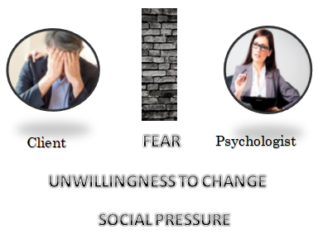
So, we performed a survey to random people asking questions, for the topic: “Why people don’t go to Psychologists”. After performing our survey, we’ve found out that the 3 main reasons that a person won’t seek for help from a Mental Health Professional are: 1) Fear, 2) Social Pressure 3) Unwillingness to Change. After we did our survey we wanted to cross the results of it with researches that WHO also did. After searching the W.H.O. we found also there that the main reasons people prevent to search for a professional treatment are
1) Stigma and 2) Discrimination.² Those 2 reasons are the same reasons we also found out in our survey, Fear and Social Pressure.
After the research that we’ve made, we wanted to create a solution where we can reduce the numbers of people that don’t visit psychologist. Our main goal is to delete the Stigma that exist in our society and help people understand and see the benefits that visit a psychologist have.
In the next Sub-chapter we are going to discuss The Goal of the Thesis Project and why we are doing the specific project.

  - Goal of the Thesis Project
This project started when we realized how huge the stigma that exists in our society is. How huge the stigma about Psychologists is. In European countries the Stigma is even bigger! We’ve researched and found out that compare to USA, in Europe exists a huge Stigma and Social Pressure about going to a Psychologist. So we decided to create this project in order to reduce the Stigma in Europe and in the whole world!

We will create an Internet Based platform! This platform will make easier and more comfortable for potential clients to receive mental health-care services from Licensed, Approved, and Professional Psychologists. Our platform will provide affordable packages, with multiple Mental Health-care services to our clients, with security, confidentiality, and transparency!

The Potential Client is able to load our Platform, and he land on the Homepage. There he is able to chat with one of our Online Life Coaches on Demand for 50’. This will be the 1st evaluation of the client for his issue. Eventually the Online Life Coach refers to our client the profile of the ideal Psychologist based on his knowledge for the specific client. The client clicks the reference link, and is redirected to the psychologists profile with the 3 available packages. There he choose the most convenient package, fills a form to create an account, and is redirected to a page where he is going to pay. He pays for the 1st week of the package, and then he is redirected again to the psychologist’s schedule to arrange the first Online Session.

  - Structure Of Thesis Project
The Structure of this Thesis Project is based on the Guidelines of my Professor, and Supervisor Christos Schizas.³

Chapter 1: Introduction
In the Chapter 1 we describe the Problem that drive us to create this project, the Goal of our Project, and we also describe a brief explanation how our System will work.

Chapter 2: Description of the Problem and Bibliography Review
In the Chapter 2 we describe in extreme depth the Problem. In addition we research and review the Bibliography that is needed. Specifically when we say Bibliography we mean that we researched and we describe the solutions that exist right now and we compare the benefits that our project will have.

Chapter 3: Required Technologies and Knowledge
In the Chapter 3 we describe the system that we will build and it’s main functionalities. We also describe the possible technologies that we can use in order to implement our System. We describe the possible technologies, and eventually we choose the ones that we believe that are the most ideal for the platform that we are planning to build. We specifically mention the advantages of the technologies that we chose and we also describe the knowledge that is necessary to implement this platform.

Chapter 4: Requirements Analysis and Specifications
In the Chapter 4, we analyze the requirements of our System. We break our system into smaller parts and we study in depth what is needed to implement and work for each separate part. Also in this step we discuss with Psychologists, and Life Coaches in order to give us their feedback and advises on what is needed and what it is not needed for our System. After we discuss with Psychologists and Life Coaches we create possible Use Cases that will describe better our System.

Chapter 5: System Design and Implementation
In the Chapter 5, we start the actual implementation of our Internet Based Platform. The implementation only started after we collected all the necessary Requirements, information, tips, and advises from Psychologists and Life Coaches.

Chapter 6: System Evaluation - Results - Discussion
In the Chapter 6 after we create a prototype of our Platform, we will give the platform to Specialist Psychologists that they will give us valuable feedback and advises of what changes are needed to be done and what possible problems exist.

Chapter 7: Results and Future Work
In the Chapter 7, which is the final stage of the Project, we will start using the platform, we will input real Psychologists and Life Coaches in the platform, and we will measure to see if we reached the goals that we’ve set. We will also mention suggestions on how we can use this platform in the future, what is the long-term goal of this platform, and what are our plans for this platform.

Chapter 2
Description of the Problem and Bibliography Review

2.2 Challenges we faced in the process of developing the Platform
2.3 Similar Platforms
2.3.1 betterhelp.com - Platform
2.3.2 yourdost.com - Platform
2.3.3 talkspace.com – Platform
2.3.4 online-therapy.com – Platform
2.3.5 7cups.com - Platform

2.1 Deep description of the problem and why a Platform like this is needed

As we’ve said in Chapter 1, Mental Health-Care is in a huge need in the world! Is the most important aspect in human beings, but people ignoring it! Based on World Health Organization (WHO), that 1 out of 4 people in the world will be affected at least once in their life from Mental Disorder! And from those people that will be affected, 66% of them will never seek help from a mental health professional!
Those numbers are really shocking and we wanted to really learn and find out why people aren’t seeking for help when they need it. From a survey that we did we collected information from people in order to answer our main questions: “Why people don’t go to Psychologists?” From our survey we found that the 3 main reasons that people don’t go to psychologists are: 1) Fear, 2) Social Pressure and 3) their Unwillingness to Change. After our survey we also research on WHO to find what they believe that are the main reasons that prevent people to search for treatment for their mental health. From our research on WHO we found out that also their main reasons were Stigma and Discrimination (which are the same with Fear and Social Pressure that we found out).
I want to get a bit more into those 3 reasons, as those 3 reasons are the Why of our Project.
- Fear: Most of the people afraid to go to a Psychologist. They don’t know how it will be like, they don’t know what to expect, if it will actually help them, if it won’t help them, if it is going to do some good to their problem and so many other doubts. People afraid that if they go to a psychologist they will think that are crazy. They don’t understand the benefits of going t a psychologist and how much it can help in their life.

- Social Pressure: This is actually the main reasons for this project. There is a huge Stigma in our Society. People think that you need to go to a psychologist, when you have something really serious. There is this theory that psychologists are just for crazy people. And even if a person will think to visit a psychologist a main reason that will prevent him to go, is because he will be afraid what the society will say. What his friends will say, what his family will say, and what the society In general will think about him because he went to a psychologist. That’s why most of the people decide not to visit a psychologist.

- Unwillingness to Change: This is another reason that people don’t go to a psychologist. They think that they are ok and that they don’t have problems. They are not willing to change their selves, to take a courageous step and go to psychologist for their issue or challenge.

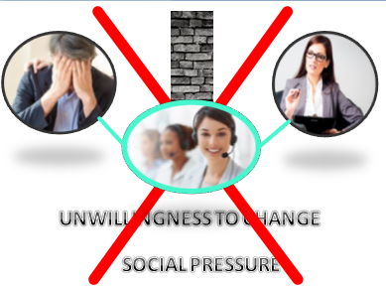
By creating a Platform like the one of our Project, we instantly eliminate Fear and Social Pressure.
When a person afraid of what it will be like to visit the psychologist, we give him, the opportunity to get Mental Health-care services from the comfort of his home. The psychological fight that would happen in his mind from the point that he will decide to go to a psychologist, until the point that he will actually do the 1st session (and even IF he will do it), by providing online services with our Platform is eliminated. The home of the client it’s his holy place. It’s his comfort zone. From there it is extremely easier for him to do the sessions, and get the help that he needs without ever getting out of his home. And there are also some issues that people can’t even get out of their house! With online services we give the opportunity to those people too, to get the help that they really need!
Now as we described above the 2nd reason that prevents people to visit a psychologist is the Social Pressure. People are afraid what their family will say, what their friends will say, what the society will say and think! By providing to the client the opportunity to get the mental health-care services from his home, is easier for him to not reveal to the other people that he is seeing a psychologist if he doesn’t want it. He can still go to the psychologist without afraid what the society will say, and without really think that they are “crazy” because they visit the psychologist.
Now, for the 3rd reason, the Unwillingness to Change we can’t do a lot as this is entirely up to the other person. But, by providing a more easy and simple way to the person to get the professional help that he really needs, it’s a push in order for him to at least give a try to him to change.

2.2 Challenges we faced in the process of developing the Platform
The main challenge that we needed to solve is to find the experience of a Professional Psychologist. We need to be in a frequent communication with Psychologists in order to have information about the requirements of our platform, advises and tips based on their knowledge and experience! Having communication with a psychologist will give us valuable information also for the security issues. As we are going to have a lot of sensitive personal information of the clients we need to think of all the situations about security, and ensure 100% that the data will be safe and secure in our Platform! Thanks to some contacts we found, and also to the great and valuable help of Mr.Schizas we have contact with many Psychologists. This is a great asset for our project as we can have as many conversations we want, with as many psychologists we want.
The second most important challenge that we needed to solve is to find Life Coaches that are willing to give us their advice and tips. Eventually, we were able to find Life Coaches that can help us with their knowledge and experience in order to build the most functional platform and achieve the goals that we have.
Another challenge that we had but we were able to solve is the knowledge that is required for the platform. We needed to first of all find all the available and possible technologies that we can use. Then we needed to research all of them to find their advantages and their disadvantages. After our research, we had to find the most ideal technologies for our case. After that we had to acquire the knowledge for those technologies so we can actually build and implement the platform. This process was really difficult and needed a lot of time but eventually we found the ideal technologies and we learned the knowledge that is necessary in order to build the platform. Of course in the next chapters we are going to talk more specifically for the Technologies that we studied, the Ideal technologies that we chose, and the Knowledge that we needed to acquire.

2.3 Similar Platforms
We made a research of platforms that already exist in this field. All of them technologically has the same concept on what we want to build to. More specifically all of them are Internet Based Platforms. But every one of those platforms lacks something, and with what we are going to create, we combine all in one.

2.3.1 betterhelp.com – Platform⁴
Betterhelp is a platform with a similar concept of what we will build. It’s an Internet Based-platform and technologically is the same with what we want to build.
One of the main differences is that in our platform there would be a live chat in the homepage in which the potential client will have the opportunity to talk for free with one of our life coaches that would be available 24/7. This first session will be for 50 minutes and its main purpose is a first evaluation of the potential client in order to be matched to a licensed psychologist that matches the specific client for the best therapy outcome.
On the other hand, at betterhelp.com, there is an automated questionnaire that the potential client needs to complete. Then the platform matches him with a psychologist and then the potential client needs to pay and starts his therapy.
The benefits of our platform are that the potential client has one free 50 minutes session with an experienced life coach and a more accurate referral to an ideal licensed psychologist.

2.3.2 yourdost.com – Platform⁵
Yourdost provides 24/7 chat for support from people with different fields not from licensed and experienced psychologists. Some of them are psychologists. However, our platform will provide professional therapy from licensed psychologists only for better therapy outcomes.
2.3.3 talkspace.com – Platform⁶
Talkspace unlike our platform provides therapy through messages ONLY (text, audio, or video messages). The psychologist answers to the client through messages only 1-2 times per day whatever is the message (text, audio, or video message).
In contrast, in our platform the client will have online sessions through video call, phone sessions and messaging with the psychologist depending on the client’s needs. In addition, the psychologist replies back to him more than 2 times per day.

2.3.4 online-therapy.com – Platform⁷
In online-therapy.com psychologists use only one psychotherapeutic approach (CBT). In contrast, in our platform there will be licensed psychologists trained in different psychotherapeutic approaches in order to provide the best professional services depending on the needs of the client.
Another main difference of online-therapy.com with our platform is that online-therapy.com provides therapy through worksheets that the client need to fill daily and he communicates with his therapist to discuss about his progress.
Additionally, online-therapy.com does not provide a free first evaluation session as our platform does.

2.3.5 7cups.com – Platform⁸
7cups is a platform with a slightly different concept. In this platform there are listeners. There are people from different fields that are willing to listen to other people that are facing difficulties. Our platform will provide professional services from licensed psychologists in order to provide the best outcome to each client.
In 7cups.com there are licensed psychologists which they provide therapy through messages only. In contrast in our platform will provide psychological services through messages, video and phone sessions.

In this chapter we discussed the most popular platforms that already exist in this field. We compared their disadvantages and what they lack compared on what we will build. Of course there are hundreds of platforms out there with similar concept technologically but those are the ones that are the most popular.

Chapter 3
Required Technologies and Knowledge

3.1 Description of the basic Functionalities of the Platform
3.2 Data Flow of the Basic Functionalities
3.3 Description of possible Technologies that we can use
3.3.1 Front-End Programming Languages
3.3.2 Back-End Programming Languages
3.3.3 Framework on Top of Database Programming Language
3.3.4 Database Programming Languages
3.4 Ideal technologies that we decided to use

3.1 Description of the basic Functionalities of the Platform
We will create an Internet Based platform. In the homepage will be an informative video for the whole platform, and the services and below will be a chat. On the chat, the visitor will be able to discuss with a Life Coach on Demand, 24/7, for 50’, for his 1st evaluation. Below the chat will be more information about the website, the concept, etc.
In the website there will be the Menu Bars:
- FAQ about health care, psychologist’s sessions, etc.
- Our whole dictionary with all the available Psychologists in our platform and a profile for each one of them.
- Contact information.
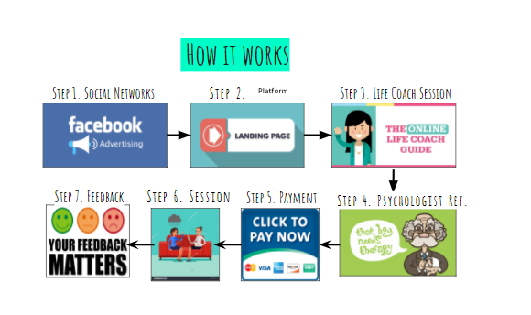
Now, when a new visitor want a 1st evaluation, will be able to chat in the chat box with our Life coach. He will need to insert his email and phone and we will send him a confirmation code, to make sure he is a real person. After verifying that he is a real person, then we verify that it’s the first time that uses the 1st evaluation feature. After we verify that too, he has the opportunity to chat with our Life Coach on demand, for 50’, for free. On that chat conversation our Life coach will make a 1st evaluation of the client to identify his issue. Eventually the Life coach will send a link to the client, with the Ideal Psychologist, based on the Evaluation. The client will click the link and will be redirected to the profile of the psychologist. In the profile will be all the information for the psychologist and 3 available weekly packages to choose. After he chooses the package he wants, he will be redirected to the page where he will pay for the 1st week. He will also fill a form with all his information in order to create an account. After his payment, and creating the account, he will arrange the 1st session online with his psychologist. Every end of the week, the client will be able to give feedback for the psychologist (for the online session, the chat, and all the services he had in his package).

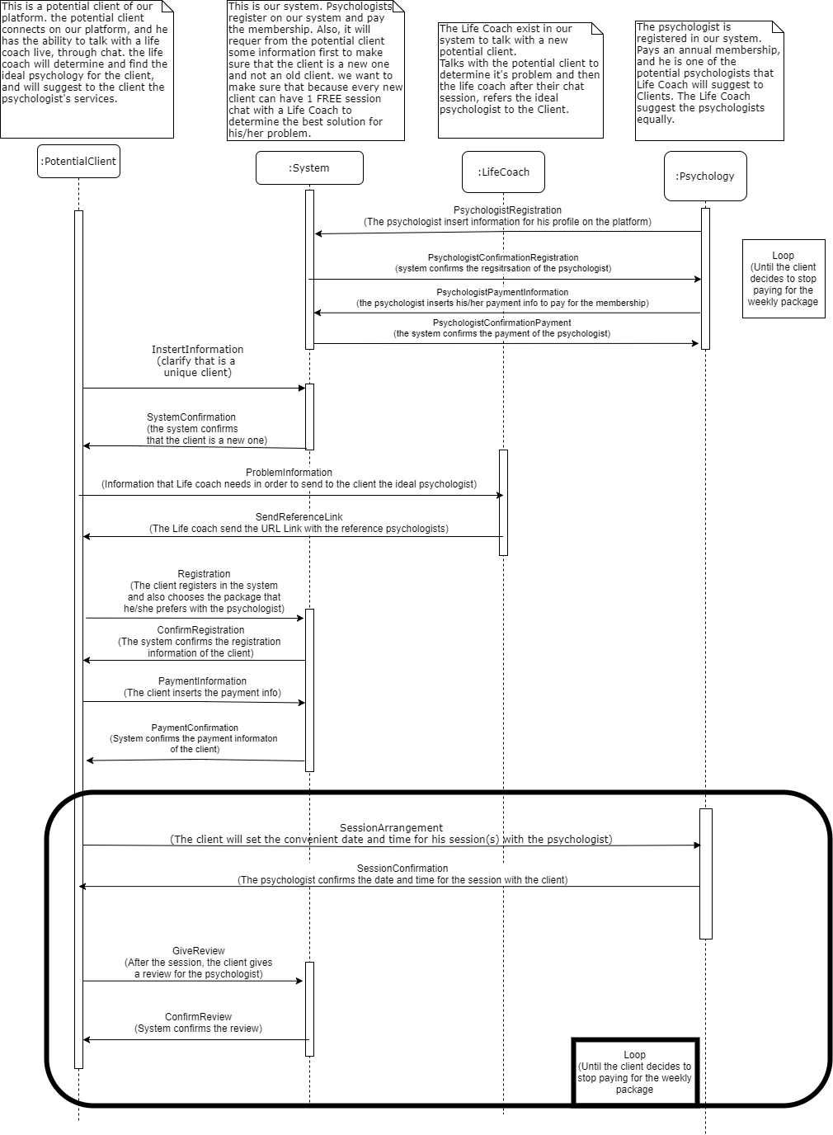3.2 Data Flow of the Basic Functionalities
Above you can see the Data Flow of the main functionalities of our platform. We have 4 entities in our platform, the Client, the System, the Life Coach and the Psychologist.
The first functionality is the Registration of a Psychologist in our Platform’s Dictionary. The psychologist fills a form with all the important information in order to create his account. Then the system will reply back to him with a Confirmation of the Registration. After the psychologist fills his payment information so he can pay for his membership in the platform. Eventually the System sends the confirmation of his payment for his membership, and also the information so he can log in the platform.
The second functionality is between the client and the system, when the client wants to do the 1st evaluation. In this functionality we want to verify that the client is a real person, and that is the first time that he takes the 1st evaluation. The client inserts his information to clarify that it’s the first time taking the evaluation. After the system confirms that is a real person, and it’s the first time that he is using the 1sst evaluation chat conversation.
The 3rd functionality is between the client and the life coach. It’s the 1st evaluation between them so the Life Coach eventually advice the most Ideal Psychologist to the client. Between their conversations the client gives all the necessary information to the Life Coach, and the Life Coach replies back to the client with the Referral Link, to the Profile of the Ideal Psychologist.
The 4th functionality is between the client and the system again. The client chooses the package with the psychologist. He fills a form with his information so he can create his account on the platform, and register. Then the system confirms the information of the client. Then the client inputs his payment information. Eventually, the system confirms the payment information of the client.
The 5th functionality is a loop, and is repeated as long as the client pays the weekly fee. The 5th functionality is between the Client and the Psychologist and the System. The client sends the data to arrange the 1st session with the psychologist. The psychologist confirms the session date and time. After the weekends, the client leaves a feedback to the System for the psychologist and the system confirms the feedback.

3.3 Description of possible Technologies that we can use
In this sub-chapter we are going to describe all the available technologies that are available for us. We will describe their advantages, and disadvantages for each technology. After in the next sub-chapter, 3.4, we are going to discuss the technologies that we choose because we believe are the ideal for our platform.

In every system when you want to program it there are several layers, from the Highest which is the one that the user sees until the lowest. In every layer there are hundreds of options. There are Programming Languages, and each programming language has it’s own versions and frameworks. We are going to discuss only few of the possible options that we can choose from and after we will choose between them the ideal that we want. So the highest level is the Front-End Programming Languages. Here is most for the design, and how the system will look like! After that we go lower, and are the Back-end programming languages. Here are the services and functionalities that our system will do. After the back-end programming languages we have the Database-Programming Languages which are separated into SQL programming languages, and Non-SQL programming Languages.

So to sum it up we have 3 Categories of Technologies that we are going to choose from:
1) Front-End Programming Languages.
2) Back-End Programming Languages.
3) Database Programming Languages.

3.3.1 Front-End Programming Languages
So as we’ve said above there are hundreds of options out there, and every single month, new options appear. A front-end programming Language is the language where is browser-based, or in other words client-based. Some of the most known languages are: 1) HTML, 2) Javascript, 3) CSS, 4) CoffeeScript (it is based on Javascript), 5) XML-based languages (there are various options here too), 6) TypeScript, and so many other languages. Below we are going to discuss a bit of each one of the 6 languages that we’ve mentioned above.

- HTML^{9,10}:
HTML stands for Hypertext Markup Language. With HTML you can achieve font, color, graphics, and hyperlink effects on Web-based pages. HTML is composed by tags. Tags in simple words are short codes and we code them in a text-file. HTML is one of the oldest programming languages for front-end and own of the most well known.
Advantages: Very simple programming language to learn and very easy. HTML is the forefather for web page creation. Easy to combine with other languages (and it’s like mandatory, it’s like a “disadvantage”).
Disadvantages: Well it’s not so much a disadvantage, but with HTML alone you can create a beautiful website. You need to combine HTML with other programming languages as CSS, Javascript, etc.
Versions: HTML versions are from 2.0 – 5.1. Of course here we are interested between the last versions HTML 4, and HTML 5, as are the newest versions. So comparing HTML 4 VS 5 we see that HTML 5 has some advantages, as it is better web application features, it has also some improved element semantics, and consistency in handling malformed documents.

- Javascript (JS)¹¹:
Javascript is an Object-Oriented programming language as it is Java, C#, etc. The difference with Javascript is that, it is commonly used to create interactive effects within Web-based pages. JS is a multi-paradigm language, which means that it support event-driven and functional programming styles.
Advantages: JS is executed on the browser side, so the code is executed on user’s processor. This means that we can save bandwidth in the web server. Another advantage is that JS is a very easy to learn language. A third advantage is that JS is very fast language to use in the end-user side. With JS you can also extend the code with 3rd parties’ add-ons.
Disadvantages: It has security issues. Though with it’s latest versions some issues were solved, it still has security problems. JS rendering varies. What means is that some layout engines may render JS different so we have inconsistency in our webpage.
Versions: Javascript is a well known language so many other languages also are compiled to javascript, and people use them as alternatives for javascript (JSON, coffeScript, Node.js, TypeScript, etc.). JS’s newest version is version 1.8.5.

- CSS¹⁰:
CSS stands for Cascading Style Sheets. CSS is used to create and design the style of a document. With CSS you can design aspects as it is layout, colors, fonts, etc.
Advantages: You can do changes in layout and design of the website very easy. Also because CSS file sizes are very small, the website loads really fast.
Disadvantages: CSS works differently on different browsers. E.g Between Internet explorer and Opera, CSS has a different logic.
Versions: CSS has versions 1.0 - 4.0. Each version is adding new features to the previous, the newer the version the better.

- CoffeeScript¹²:
CoffeeScript is a programming language front-end based on the logic of Javascript. CoffeeScript has a compiler written in Ruby, and programming in CoffeeScript reminds a lot more like programming in Ruby.
Advantages: It has really cleaner syntax than Javascript. CoffeesScript is also clearer and safer than JavaScirpt and it still holds the flexibility and power of Javascript.
Disadvantages: It has a really difficult and “painful” compilation. When you have a compile error the throws are really vague, so you can’t easily debug. So compilation is a pain, secondly debugging can be a huge pain too. In addition when you code in one version of CoffeScript, it’s possible your code to not run in a newer version of CoffeScript.
Versions: The newest version of CoffeScript is 2.0 and is still in beta. Also we need to mention that the newer the version the better.

- XML-based languages^{13,14}:
XML stands for Extensible Markup Language. XML is a markup language and you can create documents that are both human and machine readable.
Advantages: XML supports Unicode (so almost any information in any written human language can be communicated). With XML we can represent computer science data structures (trees, lists, etc.). It has simple, efficient, and consistent, parsing algorithms. XML is used as a format for document storage and processing.
Disadvantages: The syntax of XML is large, if we relative to binary representations. XML may affect application efficiency because of the higher storage, transmission, and processing costs.
Versions: Currently there are 2 versions. XML 1.0 and XML 1.1. The advantage of XML 1.1 is that XML 1.1 allows the use of more control characters than XML 1.0.
In XML there are many options that we can choose (HML, ODD, OML, OPML, etc.)

- TypeScript¹⁵:
TypeScript is another alternative compare to JS. TypeScript adds optional static typing and object-oriented programming based on classes, increasing its power.
Advantages: Similar Syntax with Javascript. Code from JS is also valid code in TypeScript and Integrates much better than CofeeScript. It also has a rich IDE and automatic refactorings.
Disadvantages: It’s not as flexible as it is Javascript. Also if we want to compile and run typescript we need to first compile it into JS and then run the JS to the browser.
Versions: TypeScript versions are from 0.8 – 2.6 and the newer the version the better.

3.3.2 Back-End Programming Languages
Now moving forward to Back-End programming languages and here is where we are going to program the services and functionalities of our program. Here we are going to study the languages: 1) PHP, 2) .NET, 3) Python, 4) Ruby, 5) Java.
Of course again there are so many languages for Back-end development but we will discuss the most famous and common use.

- PHP^{16,17,18}:
PHP is a recursive acronym of Hypertext Preprocessor. PHP is a general purpose scripting language and it’s really common used for web development. In addition is an open source language.
Advantages: PHP has both procedure programming language and also an OOP language. Also PHP is open source. It is a relative fast since it uses much system resources. It’s easy to use (uses the C syntax). It has really easy debugging and built-in database connection modules.
Disadvantages: Because it’s open source, there are some issues with security. Also it has weak type. Some conversions may lead to unexpected bugs.
Using plain PHP the coding becomes really poor and difficult. So there are many frameworks available:
- Laravel¹⁹: A very new framework but also very popular. It has many features and it is also a light-weight templating engine. Also, laravel is an elegant syntax and you can do common tasks very easily (authentication, sessions, queuing, caching).
- Symfony²⁰: Symfony is older as a framework and has a wide developer community. Symfony provide you with a huge variety of components, libraries, that you can use, and can complete different tasks with. So symfony can does tasks for you, so you don’t need to do them on your own.
- CodeIgniter²¹: It’s a very lightweight PHP framework. Its 10 years old, and it’s easy to program on. There are not so many features on but you can easily download 3rd-party plugins.
There are more frameworks for php but those are the 3 more famous and compare to all of them those 3 are the most Ideal frameworks that are possible to use in the project.

- .NET²²
.Net is a software framework that was created from Microsoft. It is used mainly in Microsoft Windows. You can use it for specific business functions such as finance, CRM, etc.
Advantages: It’s also an object oriented language. It’s easy to maintenance powerful and flexible. It’s time saving because it has large parts of code ready, it has so many features. It is also very simple.
Disadvantages: Apps on .Net are really expensive. It’s a very slow framework, and it has Vendor lock-in. Because is developed from Microsoft future development will be only dependent on Microsoft.

- Python²³
Python is a general purpose programming language. You can also implement it for back-end programming but it has so many uses.
Advantages: Very easy to learn programming language. It is object-oriented programming language; it’s simpler and clearer code. It has extensive support from libraries and integration features. With so many languages it improves programmer’s productivity.
Disadvantages: It’s difficult to use other languages, it’s a very slow language (in runtime), and it it has a lot of run-time errors (requires more testing time).
Versions: Python has versions from 1.4 – 3.6.3 and the newer the version the better.

- Ruby²⁴
Ruby is a very dynamic and simple programming language to use. It is object oriented and it is an open source programming language too. It is a general purpose programming language as Python and Java.
Advantages: Ruby provides you a lot of tools in order to do more features in less time. Also in ruby you have a lot of libraries that you can do anything you want. The quality of code is really good. Ruby has a very easy and good way to test your code.
Disadvantages: Ruby as a programming language is slow. Also the boot in order to load the framework is significantly slow.
Versions: Ruby has versions from 1.0 – 2.4 until today, and of course the newer the version, the better.

- Java²⁵
Java is a general purpose programming language and it is also an object oriented language. Is one of the most famous programming languages. Java apps can run on any system that has java without recompilation.
Advantages: Is a very common language, and people that know java they can understand each other (compare to other languages that 2 people may know the same programming language, and don’t understand a lot each other). Also it has a lot of libraries and tools that are free, and the JVM provides a lot of standard off-the-shelf functionality.
Disadvantages: Java is not a good language for latency. If you need to spare every ms, then is not the best option. There is not so much good development for GUI.
Versions: Java SE (standard edition) has versions from 1.0, 1.1, 1.2, 1.3, 1.4, 5, 6, 7, 8, 9. The best version for Java is SE 9 and it has all the latest features.

3.3.3 Database programming Language
Finally we have the Database programming languages. Here the DB languages are separated into 2 categories: a) SQL, b) non-SQL programming languages. In this sub-chapter we will discuss the languages: 1) Oracle, 2) MySQL, 3) MS SQL Server, 4) MongoDB. Based on research those are the 4 most popular Database programming languages at the moment. There at tens of different programming languages for DB but we are going to describe only those 4.

All of the DB programming languages are used to save, delete, edit, and get data. We use queries for the databases and we do all these.

- Oracle²⁶
Oracle belongs to the non-SQL category of programming languages for DBs.
Advantages: Oracle supports the creation of large databases. It also supports object-oriented database storage. Oracle has the ability to manage multiple databases and it also provides a lot of security. Also Oracle supports online back up and recovery and has a lot of different development tools.
Disadvantages: Oracle isn’t an easy programming language to learn. It Isn’t ideal for users that don’t know how to program it. Also oracle isn’t a good choice for small or mid-size databases. It is used for big size databases.

- MySQL²⁷
MySQL is in the category of SQL programming languages for Databases.
Advantages: MySQL is a very easy to learn and install programming language. It has a lot of third-party tools. MySQL it’s open source and you can find almost anywhere on the internet support as it is one of the most famous programming languages for DB. Also MySQL is a very inexpensive language compare to other languages.
Disadvantages: It has few stability problems (not so many). It has relatively poor performance scaling and if you need advance functionality you may need to download a lot of addons.

- MS SQL Server²⁸
MS SQL Server is a database programming language developed from Microsoft. As it appears MS SQL Server is in the SQL category for programming languages of DB.
Advantages: MS SQL is an easy to use programming language for DB. It has a professional enterprise level DB management software. It has an excellent data recovery support (if power loss or shutdowns occurred and you lost some of your data). MS SQL has self-contained units that are ready to be executed as they are already compiled. MS SQL is also really efficient.
Disadvantages: First disadvantage is that the licensing for buying MS SQL is pretty expensive. Also S SQL doesn’t have so much compatibility and this is because is designed to run mainly on Windows-based servers. Also when you design a program, the code needs to be specific for each hardware. So if you plan to program MS SQL code you will need multiple versions of the source code in order to be available in multiple hardware.

- MongoDB²⁹
MongoDB belongs to the non-SQL category.
Advantages: Main advantage is that MongoDB is a free software. With MongoDB you can choose what level your consistency will be (if you want fast performance then you will not have so consistent inserts. But if you want to wait until it has been replicated the data in the whole database you before returning, then you will have less fast performance). MongoDB also is an ease of scale-out programming language.
Disadvantages: MongoDB has higher data sizes. MongoDB doesn’t have so much flexibility with querying. MongoDB doesn’t have support for transactions (only few atomic operations are supported).

3.4 Ideal technologies that we decided to use
Now that we’ve described and discuss few possible technologies that we can use, we are ready to make a decision about what Programming Languages and technologies we can use for our project. We need to choose the ideal Front-End programming languages, the ideal Back-End programming language, and finally the ideal Database Programming Language.

Front-End Programming Language:
First of all we will choose for sure HTML as one of our options. The reason is because HTML is the forefather of web development, and it exists for many years now. HTML gives us the opportunity to have a huge community for questions and help, and also give us the chance to combine it with other front-end programming languages so we can have a more professional result. HTML doesn’t have any significant disadvantages, is easy and simple to use, and is also a fast programming language. For HTML we are going to use specifically HTML 5 as it is the latest version of it.

In addition to HTML we will use also CSS for sure. CSS can do many jobs as XML, but CSS is a faster language. The CSS file size is so small so it doesn’t need so much time to load. For CSS, we will specifically use CSS 4.0 so we can have all the features and tools that are available.

Combining HTML and CSS, I believe we can also choose JavaScript (JS). We don’t want to use CoffeeScript because it has a very difficult and painful debugging and compilation. Also we don’t prefer TypeScript because is not as flexible as it is JavaScript, and in the end of the day when we will compile the TypeScript source code; it will be compiled first into JavaScript. So, for JS we will use, JavaScript 1.8.5 so we can have a lot of features and we will be able to add a lot of 3rd-party add-ons.

Back-End Programming Language:
Now that we’ve found out what we will choose for Front-End we have to decide what we prefer for Back-End. For Back-End programming languages the competition and the choices are more, and are more difficult to decide.
We don’t want choose .Net because is a very slow and very expensive language and those are 2 disadvantages that assure us not to choose it as our back-end programming language. Also for Ruby, it is a very slow programming language and on runtime and on loading, which is something that we definitely don’t want in our platform. Moving to Python it’s also very slow on run-time, and it also has a lot of possible run-time errors which is very difficult to test and debug them. So eventually we have Java and PHP for our project. Between them we choose PHP. The reason is because Java is not an ideal language if you care about latency. Also PHP by using one of the available frameworks it can make our life easier. By using PHP frameworks we can have tasks done for us and may features that are going to help us for a more productive work. Now we must choose which framework we prefer for PHP. Above we describe Laravel, Symfony, and CodeIgniter. CodeIgniter is a very lightweight framework. The negative about CodeIgniter is that it may be lightweight but if we want to have a great functionality and features with it we need to download a lot of 3rd-party add-ons and plugins. And we want to make our life easier, not more difficult. So, now between Lavarel and Symfony, we choose symfony as it is older framework so it give us more trust. Also symfony has a huge variety of libraries, tools, and features. Also because it is older it give us the advantage that we have a lot of references if we need any help or guidance. In addition by choosing PHP Symfony 7.0 we have the framework Doctrine for databases, which give us more security and more simple and easy way to execute queries.

Database Programming Language:
Now for database we need something that will be compatible with our choices from above, it can be fast, easy and simple to use, and it can provide us a lot of features. Oracle is for sure out of our options as it is a very expensive and difficult programming language to use. Now MongoDB is also out of our options because the MongoDB files have huge sizes (so low performance) and also there is no flexibility on Queries at all. So we are between MySQL and MS SQL Server. We choose MySQL as it is expensive software, and is compatible only with windows-based servers. Also, using PHP Symfony with MySQL is a great combination, because Doctrine fits perfect with MySQL. So, for our Database Programming Language we prefer to use MySQL 5.7.
Chapter 4
Requirements Analysis and Specifications
4.1 Wire Frames of the System & Prototyping
4.2 The Use Case we will present in the Final Presentation of Thesis

4.1 Wire Frames of The System
In this chapter we are going to start talking about the system we want to design. Below there are the Wire frames of the main pages in our Application. You can see how each page is connected with the other, and information about each Page.

1. Homepage
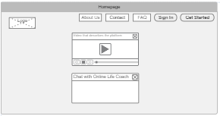

On Figure 1, is the first page the user will be able to see once he visit our WebPage. There is going to be a video that will start play when the user pass from it, and to the up and right corner will be 5 tabs: “About us”, “Contact”, FAQ”, “Sign in”, “Get Started”. Each tab will lead to another page. Below the video will be a chatbox, where the user will be able to chat with our Live Online Life Coach.

2. About Us
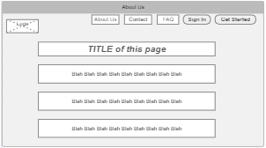
On Figure 2 it’s the “About Us” page. Once the user clicks the tab “About Us” on the up and right corner, it will lead the user to this page. In this page we will have different information about our Organization.

3. Contact
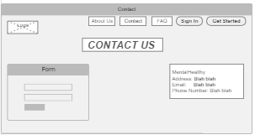
On Figure 3, is the contact page. This page is when the user will click the “Contact” tab on the up and right corner. Here is a form, where user can fill and type a question, feedback, advice for our services or for the website.

4. FAQ
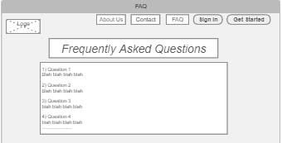
In Figure 4, it’s the FAQ page. User will be able to check this page when he clicks the “FAQ” tab o the up and right corner of the website. In FAQ page the user will be able to see frequently asked questions about our services, and the answers to those questions.

5. Get Started – Screen 1
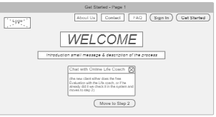
In Figure 5 it’s the 1st page of the Get Started procedure. This page will appear when the user click the tab on the Up and right corner that says “Get Started” or when the user clicks the chatbox in the homepage of our website. This is the first page that a user will be lead in order to register as a client in our Mental Health services.

6. Get Started – Screen 2
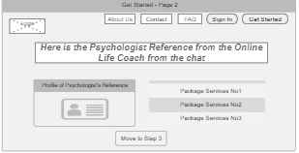
In figure 6, is the second page of the get started process. The user will be lead here after he presses the button “Move to Step 2” in the Figure 5. Here is the reference of a psychologist from the Life Coach when the user chatted with the life coach. The user will be able to see the profile of the psychologist and on the right the 3 different available packages to choose.

7. Get Started – Screen 3
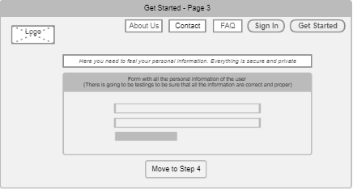
In figure 7, is the 3rd page of the get started process. Here is where the user will fill his personal information in order to create an account to our platform. There will be a lot of information in order to make sure the user is a real person, and to verify that he is the person he claims that he is.

8. Get Started – Screen 4
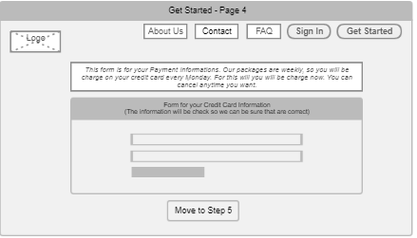
Figure 8, is step 4 of the get started process. Here the user will be redirected to his bank’s payment page in order to pay for the weekly membership through his bank’s online payment system.

9. Get Started – Screen 5
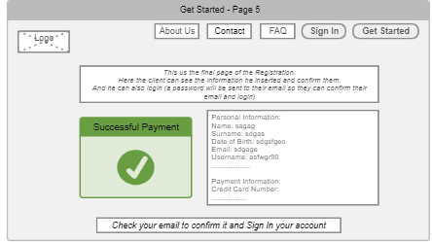
In figure 9, is the final step of the get started process. Here the user will be redirected once he pays in his bank’s page and his payment is confirmed. At this page a confirmation page will appear to him with the information he inputted, and a confirmation email will be sent to his email address too.

10. Sign In
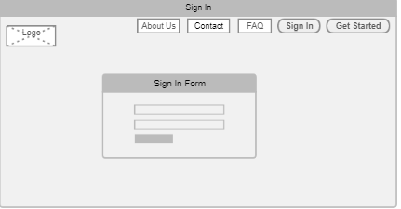
Figure 10, is the “Sign In” page. The user will be lead to this page as long as he press the “Sign In” button to the up and right corner of the website. Here he will need to insert his username and password and we will check if his account exist in the system. Here the user will be able to choose if he is a client or a Psychologist, and then he will insert his username or password.
11. Dashboard Page – After Sign In

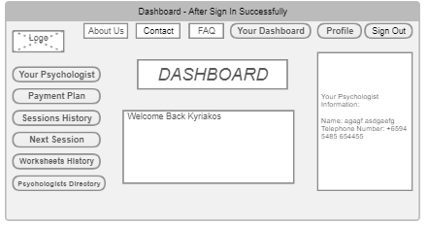
Figure 11 is the Dashboard page after the Client sign in the system. There are a lot of tabs that the user can press and be directed to different pages. There are the tabs of “About Us”, “Contact”, “FAQ”, “Your Dashboard”, “Profile”, and “Sign Out”. On the left side there are the tabs “Your Psychologist”, “Payment Plan”, “Sessions History”, “Next Session”, “Worksheets History”, and “Psychologists Directory”.

12. Profile Button – While you are Signed In
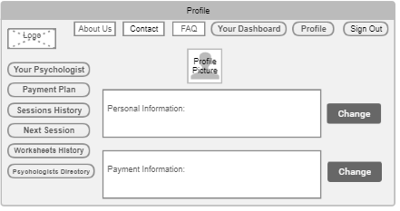
Figure 12, is the page when the user clicks the button “Profile” to the up and right corner of the page. Here the user can see all the information he inserted. There is going to be a button “Change” where the user can click it to change his information.

13. About Us – While you are Signed In
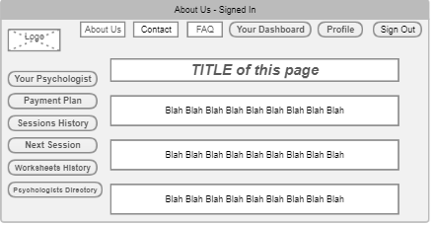
Figure 13, is the page “About Us” when the user will click the “About us” button while he is signed in. The page will have all the available tabs when the user is signed in and the text of the “About us” page.

14. Contact – While you are Signed In
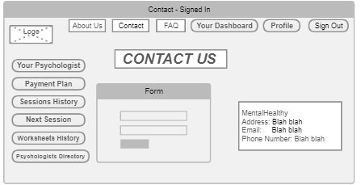
Figure 14, is the contact page when the user click the “Contact” tab and he is signed in. The page will have the same tabs as the dashboard page, and the form of the contact page.

15. FAQ – While you are Signed In
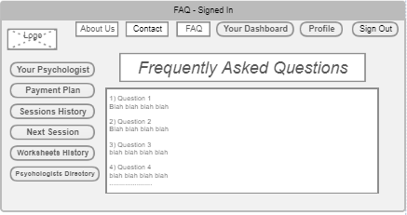
Figure 15, is the FAQ page when the user is Signed In. Is the same as the “FAQ” page with the Dashboard tabs on top and right side of the page and in the Left side.

16. Your Psychologist – While you are signed in
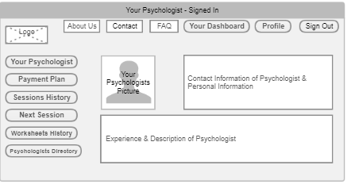
Figure 16, is the page of your psychologist when the client clicks the tab “Your Psychologist”. Here the user can see all the information for his psychologist, the contact information, and a picture of his psychologist.

17. Payment Plan - While you are signed in
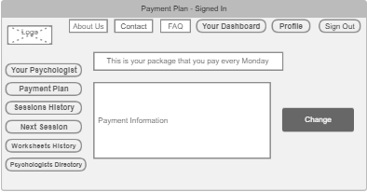
Figure 17, is the Payment plan of the user. The user here can see the package that he is currently have activated. With the “Change” button the user can cancel his subscription, can change his payment plan. User is directed here when he clicks the tab “Payment Plan”.

18. Session History - While you are signed in
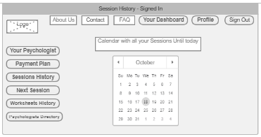
Figure 18, is the session history page. The user here will be able to see a calendar with all the sessions that he already did with his psychologist. The user will be directed here by clicking the tab “Session History”.

19. Next Session - While you are signed in
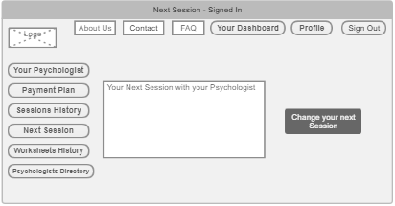
Figure 19, is the Next Session page. The user here will be able to see the information about his next session with his psychologist. There is also a “Change your next session” button where the user can click it and will be able to change his next session. The user can come to this page by clicking the tab “Next Session” on the left.

20. Worksheets History - While you are signed in
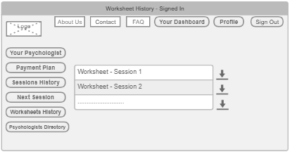
In figure 20, is the worksheets history page. In this page the user will be able to find and download all the available worksheets his psychologist gave him until today. He can find this page by clicking the tab “Worksheets History” on the left.

21. Psychologists Directory - While you are signed in
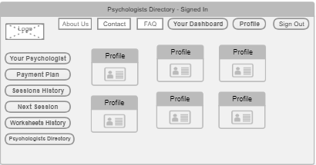
Figure 21, is the Psychologists directory. The user can see all the available psychologists in the website. He can click in each profile and see more details about the specific psychologist. This page can be found by clicking the tab “Psychologists Directory”.

22. a) Personal Information - Change
b) Payment Information - Change
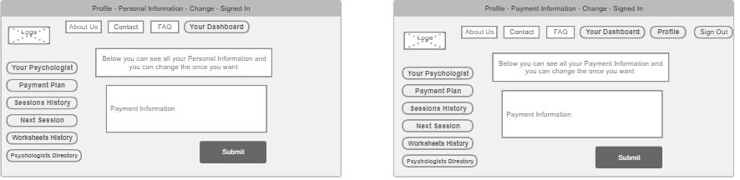
(While you are Signed in)
In Figures 22.a), is the page of Personal Information when the user clicks the “Change” button. Here the user can change any information he prefers, and by clicking the “Submit” button his data will change. In figure 22.b) you can find the pages when the user clicks the “Change” button in Payment Information. Here the user can change his current payment information.

23. Payment Plan – Change – While you are Signed In
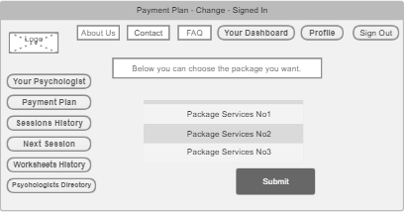
Figure 23, is the Payment Plan, change page, when the user clicks the tab “Change” in the payment plan page. Here the user can cancel his subscription, or change the package he pays weekly. With the “Submit” button he submits the changes in the system.

24. Next Session – Change – While you are Signed In
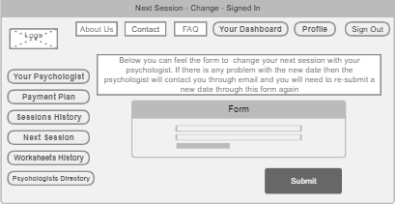
Figure 24, is the page where user can change the next session with his psychologist. The user can be directed in this page by clicking “Change” button in the “Next Session” page. The user choose the new date for his next session, and by clicking the “Submit” button the change will be directed to his psychologist to review the change.

25. Psychologist selected Profile – While you are signed in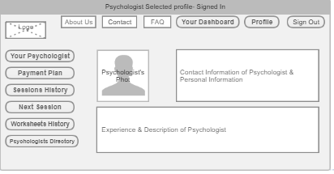
Figure 25, is the page of a Profile for a selected Psychologist. When the user is in the page of “Psychologists Directory” and clicks one of the profile, this page comes out with the information for the specific Psychologist. If the user wants, he can change his psychologist from visiting another psychologist’s profile, and change his current Professional.

4.2 The Use Case we will present in the Final Presentation of Thesis

This Project has a potential in the future to expand and become a usable product. For the purpose of Thesis though we will develop fully and present the next Use Case Scenario:
The User visits the homepage of our Platform. He clicks the “Get Started” button in order to register as a new Client. He fills the Registration Form with his personal information and then he proceeds in the Matching process with the ideal Psychologist. The process match the client with a psychologist in our platform and then his account is created. After he will sign in his account where he will be able to see all the personal information he registered in our platform and also he will be able to find all the information of the psychologist that he has been matched. After that step he will be able to start conversation through email with the psychologist so they can arrange their first Session online.

Chapter 5
System Design and Implementation
5.1 System Implementaton v1.0

5.1 System Implementaton v1.0
In the First version of the platform we found many difficulties. Because we needed to do both Back-End Development and Front-End Development we needed to research and learn specific technologies and how to develop them.
First we developed our Controllers, DTOs, and our Services. We developed those components in order to create a proper back end development. After we developed our Database with MySQL in order to be able to save, and retrieve our data.
In our Database we have the tables:
Table for the Package Bookings, Table for the Services Packages, Table for Sessions Histories, Table for the Users in our Database, Table for the Logins of the User and a Table for the Worksheets.
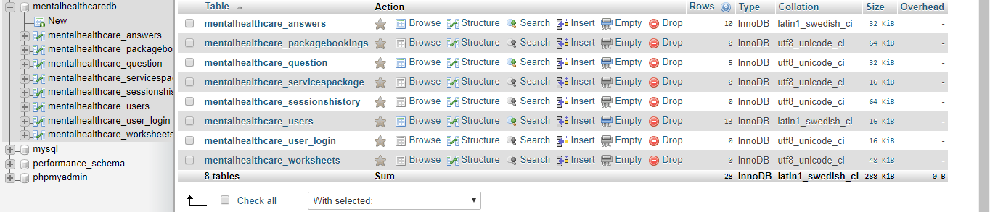
Below is also a screenshot of our Database with all the Tables that we created:

After we developed our Back End Components and we Developed our Database we Used Doctrine in order to developed the connection between the Back End and the Database. After we finished the whole Back End Development we proceed to the Front End Development.
In the front end development, for the V1.0 we created 5 Pages:
- Homepage
- About Us
- Contact
- FAQ
- Get Started
- Login (was not developed)

For the Front End Development we needed to learn new technologies in order to develop it. The technologies are HTML, CSS, and JavaScript. The 5 Pages that we developed for the V1.0 Front End Development are below.

First is the Screenshot for the Homepage:
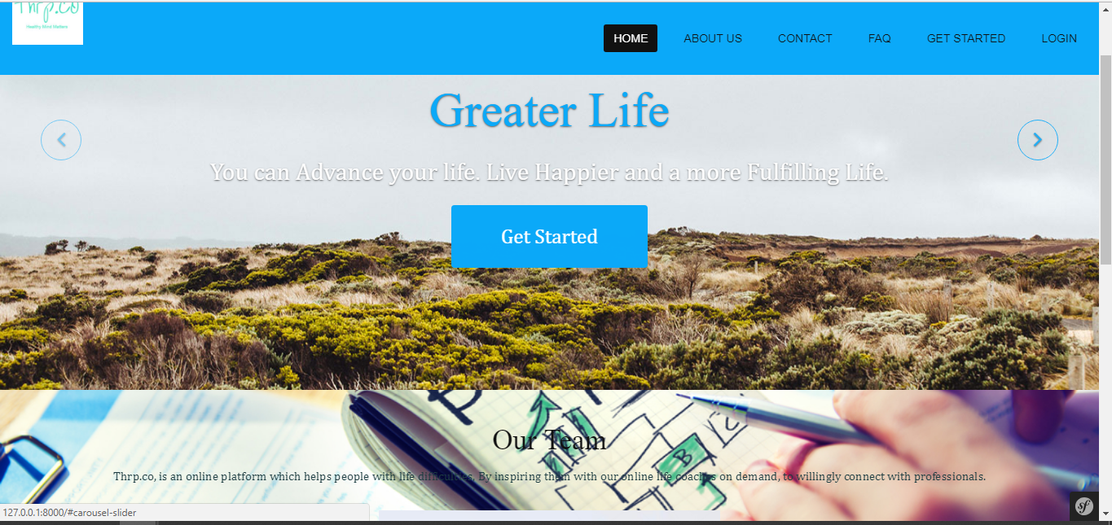

Next is the “About Us” Page:
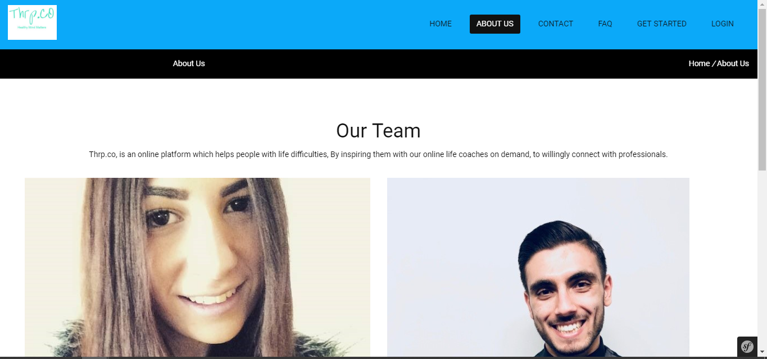

After is the “Contact Us” Page:
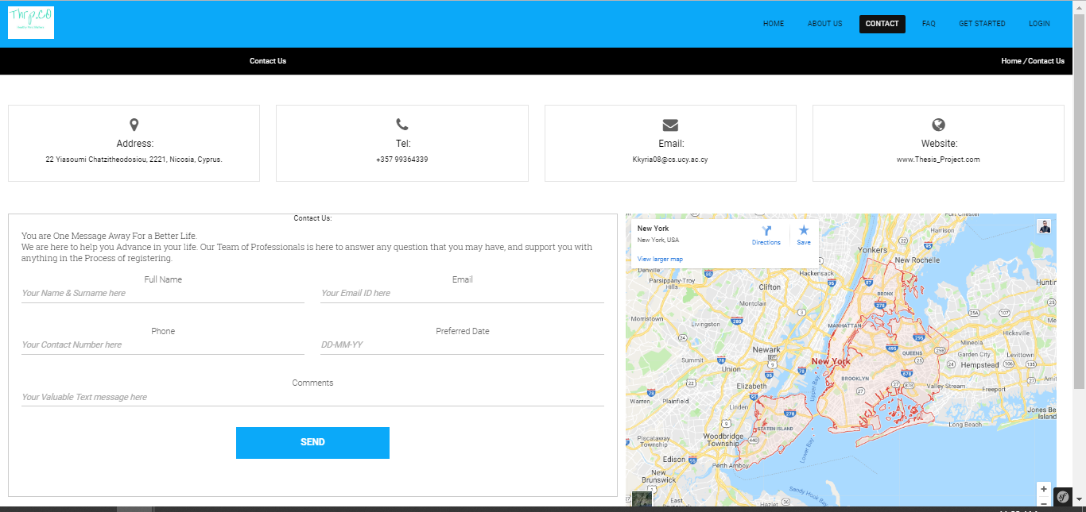

Next is the “FAQ” Page where the user can find questions that usually are asked for our Platform:
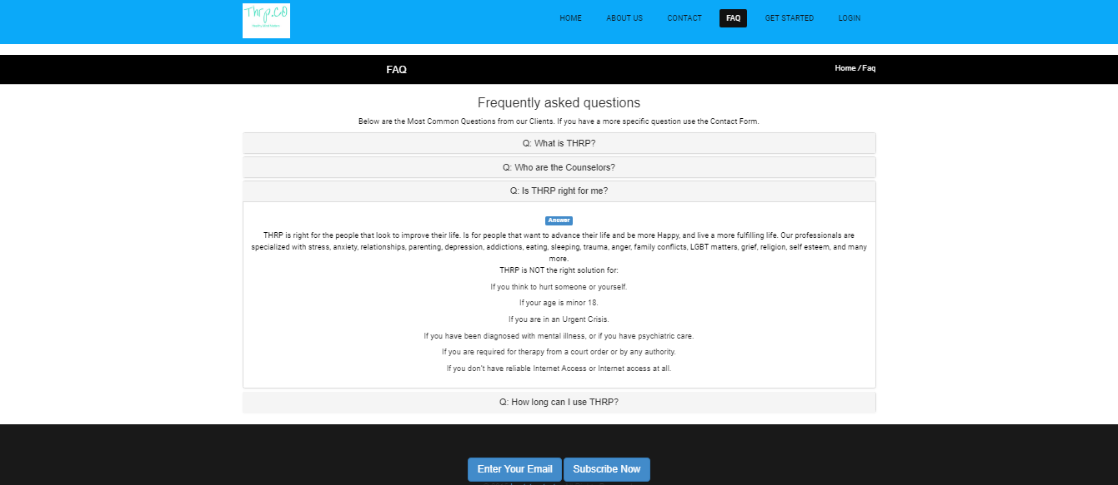

The Last page that we developed for the V1.0 of our Platfrom is The “Get Started” Page:
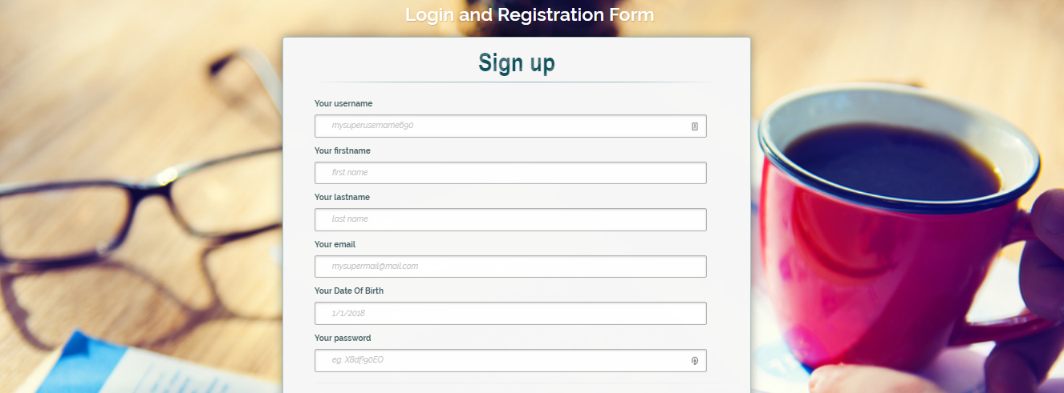
After we finished the first version of our platform we asked professional Psychologists and potential users for our platform so they can give us Feedback of what we need to change, what to add, and what we can develop more in order to create an even better platform. In the next part of our Report we discuss the Feedback the professionals gave us and also we provide more screenshots with the changes, and the further development that we did after their feedback.

Chapter 6
Evaluation of the Project
6.1 Evaluation of the Project
6.2 System Implementation v2.0

6.1 Evaluation of the Project

Evaluation from a Psychologist:
When we showed our platform to a Psychologist he asked us that we needed to do it more specific for the client. We needed to get psychological Information from the client so we can develop a Psychological Profile for Him and to know what services and treatment he will probably need. We discussed with the Psychologist ideal questions that we can ask the new client in the Sign Up process.

The Ideal Questions that we can ask our Clients are:
- Activities that you enjoyed in the past, do you enjoy them now (Yes/No)?
- How would you Rate your current Sleeping Habits (Poor/Fair/Good)?
- How would you Rate your current Eating Habits (Poor/Fair/Good)?
- Do you feel that you have someone in your environment that you can talk to (Yes/No)?
- Have you ever thought about hurting Yourself (Yes/No)?

After we wrote down the questions we needed to create 2 new Tables in our Database: A table for the Answers of the User, and a table for the Questions we ask the User in the Sign Up.

Evaluation from a Potential Client:
When we asked the client we got a really powerful feedback. He suggested us to develop from now the Dashboard for the user when he signs in. In order to do that we had to develop: A new page which would be called “Sign In” and a whole new Front End development for the Dashboard. For our Dashboard development we need to created several different tabs:
- Dashboard: Will redirect the user to the dashboard again.
- Your Psychologist: Will display the contact information of the Psychologist that the user were matched.
- Payment Plan: Will display the payment plan that the user chose on his registration.
- Next Session: Will display the next session the user scheduled with his psychologist.
- Profile: Will display all the information that the user insert on his Sign Up process and his answers on the Questions that the user was asked on the Sign Up.
- Psychologist Directory: Will Display all the psychologist in our database.
- Sign Out: This signs out the user and redirects him to the homepage.

6.2 System Implementation v2.0
After the evaluation from the Psychologist and the User we created a v2.0 of our Platform with their Feedback and the additions for our platform. Below are screenshots and explanation with all the changes that we did after their evaluation:

Below is the New Sign Up page with the Questions added in:
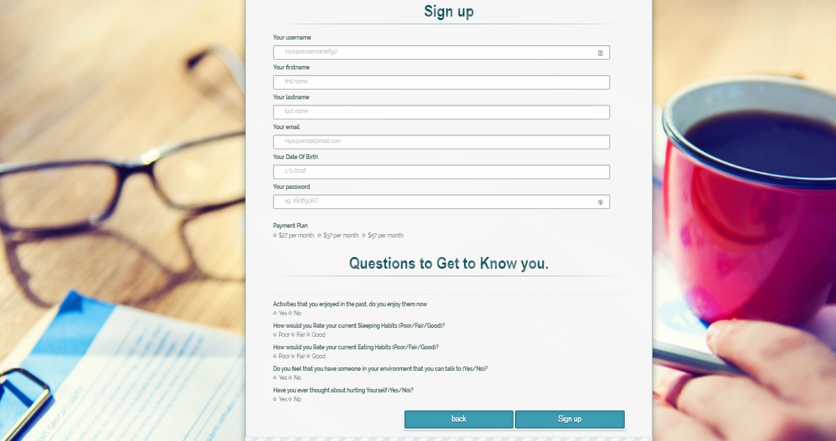

We added 5 questions in the sign up process with the goal to build a Psychological Profile for our Client. The answers and the questions are added in our Database for further use from us in order to provide the best service and value to our clients.

Below is the Main Page of our Dashboard:
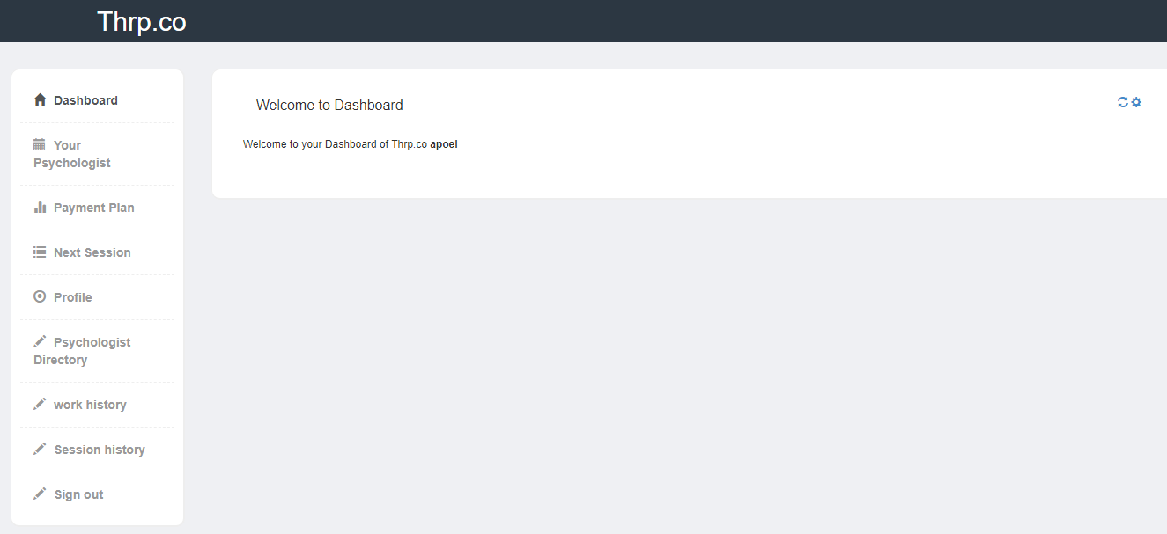

Below is the “Your Psychologist” Page:
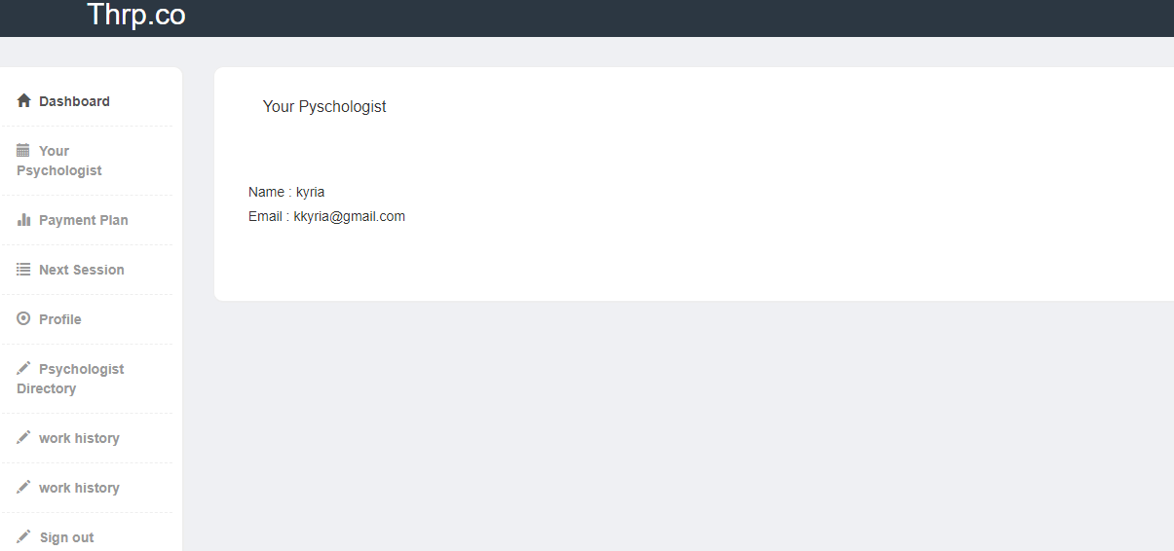

Below is the “Payment Plan” Page:
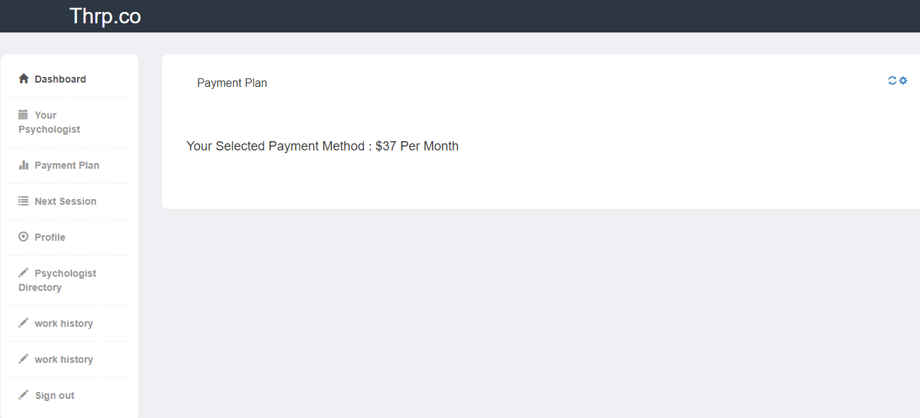

Below is the “Next Session” Page:
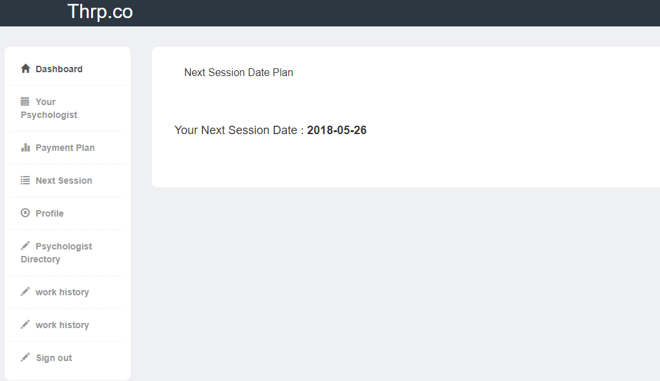

Below is the page “Profile”:
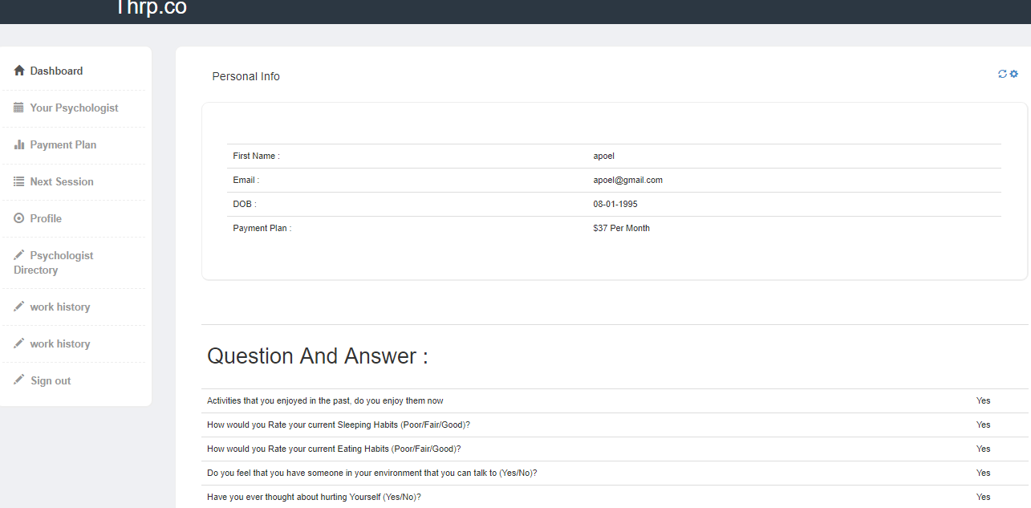

Eventually we created a responsive platform where a user can find information about us, can see our homepage, and can also create and register as a new user. Once the user create an account he can also log In in his Dashboard in order to see a lot of information and interact with our Platform and Information. In the Dashboard he can interact also with the tabs that we explained and we also posted the screenshots above.

Chapter 7
Results and Future Work
7.1 Results
7.2 Future Work

7.1 Results
After hard work, Commitment, and dedication we’ve built a great platform that we can work further more with and build something great! We build a database that can be extended really easy, and can add new features on. We’ve build a back end that support more expansion and is connected really well with our Front-End Development. Our Front End is built this way that allows us to develop it more. We’ve built a responsive front end with a nice homepage, about us page, contact us page, FAQ page, and of course our Get Started page and a sign in page. In addition the Dashboard that we’ve built for our Users has the ability to be extended even further more because of the way that is developed.

7.2 Future Work
In the future we plan to bring this project as a product. We have vision to build it even further more, extend it’s functionalities and it’s abilities and bring it to the market. Our platform in the future will have even more pages, even more functionalities, and an even more beautiful design. In addition we will build further more our Dashboard in order to have more functionalities, also the sessions will be able to happen from our platform and the booking of a session will be able to happen through our platform.

BIBLIOGRAPHY/REFERENCES
- http://www.who.int/whr/2001/media_centre/press_release/en/
- http://www.who.int
- The Structure of the Thesis Project is based on the Template that my Supervisors gave me.
- www.betterhelp.com
- www.yourdost.com
- www.talkspace.com
- www.online-therapy.com
- www.7cups.com
- https://en.wikipedia.org/wiki/HTML
- https://www.w3.org/standards/webdesign/htmlcss
- https://en.wikipedia.org/wiki/JavaScript
- https://whatis.techtarget.com/definition/CoffeeScript
- https://www.w3.org/standards/xml/
- https://en.wikipedia.org/wiki/XML
- https://en.wikipedia.org/wiki/TypeScript
- https://en.wikipedia.org/wiki/PHP
- http://php.net/manual/en/intro-whatis.php
- http://php.net/manual/en/intro-whatcando.php
- https://en.wikipedia.org/wiki/Laravel
- https://symfony.com/what-is-symfony
- https://codeigniter.com/
- https://www.quora.com/What-is-net-technology
- https://en.wikipedia.org/wiki/Python_(programming_language)
- https://en.wikipedia.org/wiki/Ruby_(programming_language)
- https://en.wikipedia.org/wiki/Java_(programming_language)
- https://www.oracle.com/solutions/technology.html
- https://en.wikipedia.org/wiki/MySQL
- https://en.wikipedia.org/wiki/Microsoft_SQL_Server
- https://en.wikipedia.org/wiki/MongoDB

