Ατομική Διπλωματική Εργασία

EFFICIENT LIVE FILESYSTEM MIGRATION

MICHAIL CHRISTOU

ΠΑΝΕΠΙΣΤΗΜΙΟ ΚΥΠΡΟΥ



ΤΜΗΜΑ ΠΛΗΡΟΦΟΡΙΚΗΣ

Μάιος 2018

ΠΑΝΕΠΙΣΤΗΜΙΟ ΚΥΠΡΟΥ
ΤΜΗΜΑ ΠΛΗΡΟΦΟΡΙΚΗΣ

Efficient Live File-system Migration

Michail Christou

1`

Research Consultant: Prof. George Samaras
Committee Member: Dr Andreas Pamporis

Η Ατομική Διπλωματική Εργασία υποβλήθηκε προς μερική εκπλήρωση των απαιτήσεων απόκτησης του πτυχίου Πληροφορικής του Τμήματος Πληροφορικής του Πανεπιστημίου Κύπρου

Μάιος 2018

ABSTRACT

This thesis is going to study 3 series of implementations of Migration mechanisms in a Hyper-Active environment. Our implemented system is called Efficient Live File-system Migration hereafter known as ELFM. EFLM is a decentralized migration system.

As hyper-active data driven applications become more and more demanding, server migrations should become more efficient at handling this change. Our system aims to lower the time it takes to migrate the file-system of a user from one server node to another by sending just the changes of the system as well as taking advantage of concurrent processing todays system allow. Additionally we have introduced the backtracking logic to keep all the server nodes updated to the most recent migration. More specifically we are going to evaluate the following 3 different versions of ELFM.

- Base-case hereafter known as Simple
- Diff and Patch hereafter known as DaP [12]
- Backtracking

Simple is the baseline of ELFM, the system copies the original file-system compresses it and sends it to the new server node where it’s uncompressed and replaces that server’s file-system. In this scenario there is no logic and we use it to compare our results for the other 2 implementations.

DaP introduced OverlayFS [2] to the system. With the help of OverlayFS we are able to identify the changes that happened to the file-system before the migration. Which we compressed, send to the new server node and are adapted.

Backtracking introduces concurrent processing as well as “backtracking” migrations, were the servers send versions backwards to keep all the servers updated. In order to reduce data that would be send between the servers.

Our tests were run on the Common Open Research Emulator hereafter known as CORE.
Our tests include migrations for file-system sizes of 500MB, 1000MB and 2500MB with 10%, 20%, 30% and 40% random changes generated before each migration.

TABLE OF CONTENTS
Chapter 1 Introduction…………………………………………………………… 1
1.1 Motivation 1
1.2 What is ELFM 1
1.3 Synopsis of ELFM 2
1.4 Thesis Structure 2

Chapter 2 Related Work…………………………………………………………. 3 2.1 Linux File-system 3
2.2 Overlay File-system 4
2.3 Tape Archiving (tar) 5
2.4 Sockets 6
2.5 Ubuntu Operating System 6
2.6 Python 2.7 7
2.7 Bash Scripts and Terminal 7
2.8 Common Open Research Emulator (CORE) 7

Chapter 3 Related Work…………………………………………………………. 8 3.1 Live Wide-Area Migration of Virtual Machines
Including Local Persistent State 8
3.2 The Design and Evolution of Live Storage
Migration in VMware ESX 9

Chapter 4 Design and Development………………………………………….. 10
4.1 System Implementation Information 11
4.1.1 Client 11
4.1.2 Simple 11
4.2 Base-case implementation (Simple) 11
4.3 Diff and patch (DaP) 12
4.3.1 Client 12
4.3.2 Server 12
4.3.3 Example 13
4.3.4 Versioning 13
4.3.5 Adaptation 14
4.4 Threaded (Version 1 of improvements) 14
4.4.1 Client 14
4.4.2 Server 15
4.4.3 Example 16
4.4.4 Versioning 17
4.4.5 Compression and Adaptation 17
4.5 Backtracking (Version 2 of improvements) 17 4.5.1 Client 18
4.5.2 Server 19
4.5.3 Example 19

Chapter 5 Evaluation……………………...…………………………….……………. 22
5.1 Scenario 23
5.1.1 Simple 24
5.1.2 DaP 24
5.1.3 Backtracking 25
5.2 Results 26
5.2.1 500MB 27
5.2.1.1 10% changes 27
5.2.1.2 20% changes 30
5.2.1.3 30% changes 33
5.2.1.4 40% changes 36
5.2.2 1000MB 39
5.2.2.1 10% changes 39
5.2.2.2 20% changes 42
5.2.2.3 30% changes 45
5.2.2.4 40% changes 48
5.2.3 2500MB 51
5.2.3.1 10% changes 51
5.2.3.2 20% changes 54
5.2.3.3 30% changes 57
5.2.3.4 40% changes 60
Chapter 6 Conclusion and Discussion…..…………………………………………… 63
6.1 Conclusion 63
6.2 Future Work 65

R e f e r e n c e s …………………………………………………………………………. 66

Chapter 1

Introduction

1.1 Motivation 1
1.2 What is ELFM 1
1.3 Synopsis of ELFM 2
1.4 Thesis Structure 2

1.1 Motivation

With the progression of online gaming augmented reality and generally of hyper-active data driven applications came the need of low-latency access to real-time servers. This had as a result the distribution of the applications data to multiple servers. This way a user connecting to the application would retrieve data from its closest or most efficient for him server hence reducing the latency and response time for the application. However in order for the user to connect to the server, the servers must be able to migrate the user’s data between themselves in an efficient manner. Hence the purpose of this thesis is to reduce the time it takes to migrate the data of a user from server to another, while the user “moves” within our network connecting to different servers.

1.2 What is ELFM

Efficient Live File-system Migration (ELFM) is an implementation of a distributed file-system. A distributed file-system utilizes a Client - Server connection, where the server allows the client to store data just like they are storing information locally. However, the servers have full control over the data and give access control to the client.
In ELFM we have two main Class service processes, Client and Server. The Client service emulates the user as well as the server node it is currently connected to while the Server service emulates the systems servers. Each server in the emulation runs a Server service. When a user migrates from one server node to another, the server nodes connect over a TCP socket [13] and migrate the file-system for data reliability.

1.3 Synopsis of ELFM

The implementation of ELFM runs on a linux operating system and is implemented mainly in Python 2.7 ([1]) and uses some bash scripts to automate some of its operations. More over the detection of changed, new and deleted files of any file-system is done using the file-system service of Linux called OverlayFS. [2]
OverlayFS creates 4 different directories called lower, upper, over and work. The Work directory is needed by OverlayFs in order for it to function. The lower directory contains the contents of the file-system in a read-only format. The over directory at the the time of initialization is a duplicate of the lower directory. This directory is the directory where the user has access, read and write operations are available here. Finally the upper directory includes the changed content that is the result of comparing the lower directory with the over directory.
Furthermore all the simulations were run on CORE, CORE [3] is a real-time network emulator that allows instantiation of hybrid topologies composed of both real hardware and virtual network nodes. For the ELFM simulations virtual network nodes were used on 100MB network lines.

1.4 Thesis Structure

The Structure of this thesis is as follows:

Chapter 2 Tools

Chapter 2 Related Work

Chapter 3: Design and Development.

Chapter 4: Evaluation.

Chapter 5: Conclusion and Discussion.
Chapter 2

Tools

2.1 Linux File-system 3
2.2 Overlay File-system 4
2.3 Tape Archiving (tar) 5
2.4 Sockets 6
2.5 Ubuntu Operating System 6
2.6 Python 2.7 7
2.7 Bash Scripts and Terminal 7
2.8 Common Open Research Emulator (CORE) 7

2.1 Linux File-system

File-system in general controls how data is stored and retrieved within an operating system. If it wasn’t for file-systems our information would just be big chunks of data. We wouldn’t be able to differentiate different files. The purpose of a file-system is to break the information we store into smaller pieces and knowingly place them into storage memory, so it can be retrieved later by name/address.

In ELFM we use a Linux file-system because “On a UNIX system, everything is a file; if something is not a file, it is a process.” [14]. Unix differentiates the type of file by assigning it a special symbol. There are 7 type of files in a unix file-system and they are as follows.

Symbol | Meaning
- | Regular file
d | Directory
l | Link
c | Special file
s | Socket
p | Named pipe
b | Block device
Figure 2.1 types of file in a unix file-system

2.2 Overlay File-system

OverlayFS is a file-system service for Linux, it was merged into the Linux kernel mainline in kernel version 3.18.

When the overlay file-system is mounted by using the command mount on a specific storage location it creates four directories. Lower directory, upper directory, work directory and overlay directory.

The lower directory is a read-only directory and it contains the contents of the storage location at the point of mounting.

The work directory is a directory that overlayFS uses to function.

The Overlay directory is writable directory and is also the user’s workspace. It also contains the contents of the storage location at the point of mounting. But here the user can do whatever changes to the file-system he wants. These include adding, deleting and modifying any of its files.

The upper directory is also a writeable directory that the OverlayFS stores changes that happen in overlay directory.

For example if the initial storage location contained 4 regular files and 1 directory
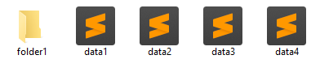
And the user modified the data2 and also created the file “data5” then the upper directory would look like this.
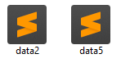
It’s important to note that the data2 file in the upper directory it has the same content as the data2 file in the overlay directory. It does not contain only the changes.

2.3 Tape Archiving (tar)

Tar or tarball reference the tape archiving computer software utility program, which is used for compression of multiple files and/or file-systems into a single file. Tar files are widely used to move files from one disk to another and/or from machine to machine.

Tar archiving is often used together with a compression method, such as gzip, to create a compressed archive.

For example to create a tar archive you would use the command

$ tar cvf archive.tar inputFolder/
Which would create a .tar file with the contents of inputFolder.
2.4 Sockets

A network socket is an endpoint for sending or receiving data within a computer network. In programming a socket behaves much like an input/output stream of data, were the programmer can read (receive) data and/or write (send) data.

In a Linux file-system a socket can be characterized by a file with the special symbol s.

There are two noteworthy types of sockets which are TCP short for Transmission Control Protocol and UDP which is short for User Datagram Protocol. These types extend for Internet sockets to SCTP and DCCP respectively.

SCTP is short for Stream Control Transmission Protocol and uses TCP. It provides a sequenced of unique flow of data and transmits it reliably and in order.

DCCP on the other hand is short for Datagram Congestion Control Protocol and uses UDP. It is unreliable by which we mean it doesn’t guarantee data delivery, as well as the order of the packets send might not be received in order, unsequenced.

2.5 Ubuntu Operating System

Ubuntu is a Debian-based Linux distribution of operating system. Ubuntu has three official releases, Ubuntu Desktop for personal computers, Ubuntu server for servers and generally the cloud and finally the Ubuntu Core which is used for Internet of things devices and large container deployments.

Ubuntu has access to free software from the package management tool like APT and Ubuntu Software but can also load from external repositories software not listed in the above packages. Furthermore Ubuntu protects the file-system by requiring administrative permissions to alter core files. Additionally the build in firewall by default closes most external network ports for additional security.

The ELFM system runs on Ubuntu 16.04 LTS Xenial Xerus as it was the latest stable release when the system was implemented.
2.6 Python 2.7

Python is a high-level programming language used for general - purpose programming and it was first release in 1991. It emphasizes on code readability by abandoning the use of curly brackets and adapting the use of whitespace to determine code blocks. Furthermore it supports multiple programming paradigms suck as object-oriented programming, imperative programming as well as functional and procedural programming.

A key feature for python is its large and comprehensive standard library. Many of the packages support only the 2.x branch which is why Python 2.7 is the common go to for programmers rather than its 3.x counterpart.

2.7 Bash Scripts and terminal

Bash is command language and a UNIX shell released in 1989 and is the replacement of the Bourne shell. Bash is typically run from a text window where the user inputs commands for the bash to execute. Additionally bash can execute commands written in files. A series of commands written in a file are executed linearly similar to most programming languages and are these files are called bash scripts.

A terminal is a command-line interpreter for bash shell. A terminal is an interactive text window where the user can execute any bash commands.

2.8 Common Open Research Emulator (CORE)

The Common Open Research Emulator (CORE) is a tool for emulating networks on one or more machines. That is to say that it can emulate a structured network by using one or more machines. In Linux CORE uses Linux containers for each machine it emulates to isolate it from the rest of the system. Additionally as an emulator a COREs live-running emulation can be connected to physical networks and routers.
Chapter 3

Related Work

3.1 Live Wide-Area Migration of Virtual Machines Including Local Persistent State 8
3.2 The Design and Evolution of Live Storage Migration in VMware ESX 9

3.1 Live Wide-Area Migration of Virtual Machines Including Local Persistent State

The team in “Live Wide-Area Migration of Virtual Machines Including Local Persistent State” have a similar setup of ELFM system as to the server communication. They have server daemons running on all server nodes and when a client service wants to migrate its server communicates at with the destination server to initiate a migration.

Their design follows was produced with the following for requirements

- “Live migration. The VM continues to run while transferring its memory and local persistent state.”

- “Consistency. When the VM is started on the destination after migration, its file system is consistent and identical to the one the VM was using on the source.“

- “Minimal service disruption. Migration does not significantly degrade the performance of services running in the VM, as perceived by their users — three seconds for a running web server providing dynamic content to 250 simultaneous clients in the local area, and several orders of magnitude lower than using freeze-and-copy approaches in the wide area.”

- “Transparency. Services running in the migrated VM do not need to be migration-aware in any way, and can be out-of-thebox. The VM’s open network connections remain alive, even after an IP address change, and new connections are seamlessly redirected to the new IP address at the destination.”

Their idea was for the user to migrate to the destination server whilst still working on the source server until the migration was completed. The system would bulk transfers the file-system from the source server to the destination server and any writes to the file-system that were made whilst the migration is in progress are intercepted and also sent to the destination so they can be applied there as well. If however the user was making changes at a higher rate than the migration was happening, they would throttle the write speed enough so that the migration would in time finish. [4]

In their attempt to decrease user – application response time they allow the user to keep making changes which could result in a far slower migration and/or poor user experience. We however halt the user until the migration is complete this way the user will wait a specific time.

3.2 The Design and Evolution of Live Storage Migration in VMware ESX

In this paper the team compared three different approaches to live storage migration.
Snapshotting, Dirty Block Tracking and finally IO Mirroring.

Snapshotting begins by taking a snapshot of the base disk, all new writes are sent to this snapshot. This snapshot may reside on the destination node. Concurrently, they copy the base disk to the destination. For this reason snapshotting is not atomic, as a network outage will render the system useless.

Dirty Block Tracking sought to overcome the limitations of Snapshotting. Bulk copying at the block level had an increase of roughly 50% from snapshotting. Moreover it was atomic.

IO Mirroring works by mirroring all new writes to the destination concurrently with a bulk copy of the file-system. IO Mirroring guarantees an atomic switchover between the source and the destination. [5]

Our versioning system works similarly to snapshotting, but instead of taking a snapshot of the entire file-system we take a snapshot of current changes and save it as a version. Since this does not affect the active file-system we do not have the problems snapshotting has.
Chapter 4

Design and Development

4.1 System Implementation Information 11
4.1.1 Client 11
4.1.2 Simple 11

4.2 Base-case implementation (Simple) 11

4.3 Diff and patch (DaP) 12
4.3.1 Client 12
4.3.2 Server 12
4.3.3 Example 13
4.3.4 Versioning 13
4.3.5 Adaptation 14

4.4 Threaded (Version 1 of improvements) 14
4.4.1 Client 14
4.4.2 Server 15
4.4.3 Example 16
4.4.4 Versioning 17
4.4.5 Compression and Adaptation 17

4.5 Backtracking (Version 2 of improvements) 17
4.5.1 Client 18
4.5.2 Server 19
4.5.3 Example 19

4.1 System Implementation Information

Here we are going to discuss how the system in a whole works. How it’s structured and how its different parts are connected. The system implements two services Client and Server. Apart from the Simple implementation of the migration, the system also implements a kind of versioning.

4.1.1 Client

The Client service simulates a user (hereafter known as the user) as well as his connection to the active server node. It establishes a connection to the server via a socket and port from which the two services will communicate. This service is also responsible to setup the overlayFS to track the user’s changes. Additionally this service, the part where it emulates the active server, it’s responsible for compressing the file-system into a Tar file based on the algorithm used and sending it to the new active server.

4.1.2 Server

The Server service emulates the server nodes and for this reason it is always running in the background on all nodes in the network. The service is listening on a predefined port for a new user to connect. Once a new user has connected to the service they will exchange a series of messages, depending on the algorithm that is being used for the migration these messages vary. Once this service sends the “ready” message it means it’s in a position to receive the new state of the file-system. Once the Tar File is received, it is adapted to the current system and the user can now begin using his data.

4.2 Base-case implementation (Simple)

The Simple (algorithm) method as its name implies is the simplest solution to the migration solution. When the user moves from one server to the next, the Client service will compress all of his data into a Tar file and wait for the ready signal from the server. Once the “ready” message is received the service sends the file to the new server.
The Server service will in turn take the Tar file decompress it and replace all contents from the file with current file-system.

4.3 Diff and patch (DaP)

Diff and patch introduced versioning to the system and instead of migrating the whole file-system from one server to another it migrates only the new changes that have happened to the file-system. Because a migration now consists of only the changes to the file-system we name these versions. This implementation aims to improve the base-case by sending less data which in turn will decrease the overall time that system needs to complete the migration.

4.3.1 Client

For this algorithm the Client service implements a new way of compressing the current file-system when migrating the user to a new active server node. By using the overlayFS when the user wants to migrate we know in O (1) complexity which files are new, which files are modified and which files were deleted. From there on for each modified file the bash command “diff” [6] is run to generate the changes that have happened to that specific file and are then written in a .patch file. We create another file called “modmanager” which emulates in a 2line format an associative array between .patch file and which file to patch to. For the deleted files we create a single file that indicates which files have been deleted. Once the deleted and modified files have been processed the creation of a new version is issued with the processed files as well as the new files that the user created on this node. The Client service then proceeds to compress this version into a Tar File and sends it to the server. Once this is done the Client service makes this version permanent on the current service as well, as up until now these changes resided only in the upp directory of the overlayFS.

4.3.2 Server

When a user is migrating to the Server for this algorithm it sends a series of messages before the process of migration begins. The first message that it sends is the version of the current file-system and then waits to receive a message indicating how many version behind it is from the active file-system. Once these messages have been exchanged and the server knows how many versions it is to receive it sends a “ready” message indicating that it’s now ready to receive said versions. The Client service here sends one by one the versions needed to adapt the file-system to its updated state, once all versions have been received the Server service begins to apply each Tar file to the current file-system. As soon as all the versions have been adapted the file-system is ready to be used by the user.
4.3.3 Example

In figure 3.1 we see the user migrating from Server A to server B and below are the messages they exchange until the file-system is fully migrated to Server B. Also Server B has version 0 this means that the user has never migrated to this machine before.

User connects to server B
Server B sends current version to server A
Server A compresses the users latest changes to a new version
Server A sends version difference to server B
Server B emits “ready” message
Server A begins migrating data
Server B receives all versions that was missing
Server B decompresses each version and applies it to the system
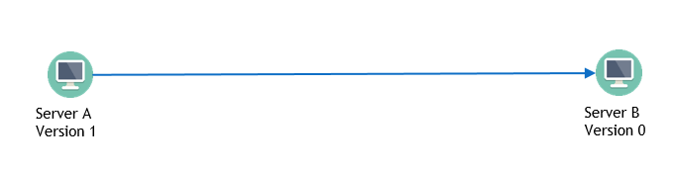
Server B is ready to be used by the user.
Figure 3.1

4.3.4 Versioning

The structure of a version Tar file is as follows:

A single version file has 3 folders are its immediate children.
- Added
- Deleted
- Modified

In the “Added” folder exists all new files that were create in this version for the file-system. For example if the user created a new file “folder1/folder2/folder3/file.extension” then this file will reside here “Added/folder1/folder2/folder3/file.extension”

In the Deleted folder exist a single file called deleted.txt. In this file in a 1line format reside each file that has been deleted for this version.
For example if the user deleted the file “folder1/folder2/folder3/file.extension” then there will be a line in the file that reads “folder1/folder2/folder3/file.extension”

In the Modified folder exists a number of .patch files equal to the number of the files that have been modified, plus the modmanager file. For this version of the algorithm the name of each patch file is a generated uuid. In the modmanager file there is an association between patch and file in a 2line format.
For example if the user modified the file “folder1/folder2/folder3/file.extension” then there will be 2 continuous lines in the file that read
“xxxxxxxx-xxxx-Mxxx-Nxxx-xxxxxxxxxxxx
folder1/folder2/folder3/file.extension”
this means that the uuid patch file is to be patched to that specific file.

4.3.5 Adaption

When the Server service adapts a version file it does the following things. First it decompresses the file. It first reads which files need to be deleted from the deleted.txt file and deletes them on the current version. After this has been completed the service adds all new files to the current file-system that were in the Added folder. Once this process has finished it starts applying each patch file from the modified folder by reading the lines from the modmanager file.

4.4 Threaded (Version 1 of improvements)

After examining the DaP version of ELFM we concluded that most of the processing intensive tasks that both services use, could benefit from being executed concurrenly. This also means that by executing processes in parallelism ( threads [7] ) we could cut down on network idle time, a thing that occurred when the server was compressing the current version before it could send it to the new active server. This implementation introduces Pipelining to the system where server A can be compressing a version whilst sending another and server B can be receiving a version and adapting another. This is a pipeline effect because versions must be send/applied in a specific order.

4.4.1 Client

One of the key issues for the Client service of the DaP version was that when it would migrate to the new active server, the active server had to wait for the service to finish compressing the current version before sending it. Here the threaded version of ELFM created a huge boost in performance when the connected active server node had a version difference that was greater than one. This meant that the Client service had to send to the active server node one or more versions that was stored in its system. The threaded version takes advantage of the extra version that it has to send and starts sending the version while also compressing the current version. But that is not all. Looking at how the DaP version compressed its versions we can derive that the added, deleted and modified files have no actual connection between them. This means that processing of Added, deleted and modified files can also be implemented in parallelism. In conclusion the compressing of current version process now runs at the same time while sending previous versions (if there no previous versions to send or the service has send all previous versions it will wait for current compression to finish before continuing ) In the compressing thread we have a new thread for each and every file that was touched by the user in some way, this includes new, modified and or deleted files. This way the expensive command “diff” for modified files will each live in its own thread taking advantage of multiple CPU cores.

4.4.2 Server

For the version 1 of the improvements the number of messages between the client and the server has remained unchanged. However the way it works has been refactored to also profit from concurrent processing. The Server service no longer waits for all the versions to be received before it starts adapting them. As soon as one version has been received the service will create a new thread where it will start adapting it to the file-system. This is the second big improvement from the DaP version of the ELFM system where it really shines when the servers are exchanging more than one version of data changes. As with the Client service, the Server service has applied nested threads. Each adaptation will start 3 new threads, one for deleted files, one for new files and one for the modified files. It is important to note that any subsequent versions that come are put into a queue that wait for all previous versions to be adapted before they themselves are adapted. Without this queue the version system would crash because of the chance of the system adapting version 5 prior to version 4 for example.
Since the deletion and the addition of files is done with a one line bash command concludes that from the 3 new threads that are created in the adaptation process the most costly one is the one that processes modified files. Since the size of the changes may vary from file to file, we create a new thread for each file in the modified folder. Now that bash patch command lives in its own thread and can take as much time as needed without much impact on its parent thread. As soon as all the versions have been received and adapted the file-system is ready to be used by the user.

4.4.3 Example

In figure 3.2 we see a user migrating from Server A to server B. Server A had received the first two versions and the users current changes will created the third version.
Below we can see the series of messages the servers exchange until server B is ready for the user. Note that in the below example we highlight all possible messages that could happen from the migration, where in a normal migration not all messages may appear. Also Server B has version 0 this means that the user has never migrated to this machine before.

User was on server A did some changes and now wants to migrate to server B.

User connects to server B

Server A | Server B
 | Sends current version number [0]
Starts compressing the new version
Send version difference [3]
 | Prepares to receive 3 versions
 | Sends ready message
Starts sending previous version 1
 | Receives Version 1
Starts sending previous version 2 | Starts Adapting Version 1
 | Receives Version 2
Sending is on hold until compression finishes | Starts Adapting Version 2
 | Adaptation of Version 2 is on hold until adaptation of version 1 finishes
Compression finishes | Adaptation of Version 1 finishes
Starts sending previous version 3 | Starts Adapting Version 2
 | Adaptation of Version 2 finishes
 | Receives Version 3
 | Starts Adapting Version 3
 | Adaptation of Version 3 finishes
 | File-system is ready
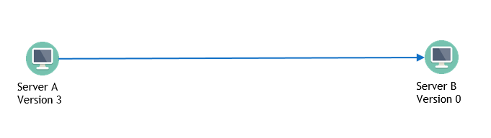
Figure 3.2
4.4.4 Versioning

The threaded structure of versions is about the same structure that was used for the DaP version of the ELFM. With one difference that can potentially save processing power. The patch files that are created for the modified files are no longer named with a generated uuid number, instead each versions patch files are named with an incrementing integer zero based for each version. Since the association between patch files and files to patch is done in the modmanger file the generation of uuid was something that could only slow the system down.

4.4.5 Compression and Adaptation

As descripted above both compression and adaptation make heavy use of threads. It is important to note that no matter how many cores our server has the hard cap of both compression and adaptation is from I/O (Input/Output) from deleted.txt, modmanager file to the .patch files that are being generated. Each of these generate I/O on the hard drive and are therefore hard capped by the hard drive capabilities.

4.5 Backtracking (Version 2 of improvements)

Having implemented Version 1 of improvements we have theoretically improved the DaP version as much as it could improve, but even with this improvements the logic behind the system was quite basic. This version of improvement is the final improvement done to the system and is also the improvement we are going to evaluate later on in this thesis. It introduces a new complexity to the system that aims to reduce the number of versions that the servers need to exchange without it affecting the decentralised part of the system and also without creating a topology map of the network. The main idea behind this version of improvement is to keep all connected server nodes up to the latest version, so when the user wants to migrate to a server it will only have to send one version. The way this is done is each server keeps track which server previously connected to it. For example if server A migrates to server B, server B will save server A as its previous connection. Now when server B migrates to server C once the migration has completed server B will also migrate to server A, hence the name of this improvement “Backtracking”. For the implementation of this improvement we refactored the code into Object Oriented Programming [8] this way the code became more versatile to improvements compared to its previous state.

4.5.1 Client

The implementation of the new improvement introduced an additional exchange of messages between the two server nodes. These messages indicate the reason for of the migration, if it’s backtracking or if it is a normal connection. Each server node knows if it is the active server and or if it is currently in the process of backtracking. Now when the user tries to migrate the old server node becomes inactive and the new server node becomes active. If the new server node was in the process of backtracking it stops and it reverts back to the last received file. For example if the new server node was in the process of receiving version 4 via backtracking and it became the active node. It will break the backtracking connection and remove the half received version 4 from its system. This way the background process of backtracking does not get in the way of main process. It’s important to note that the main process will wait until the backtracking process is killed.
The backtracking process works almost identically to the normal migration process the difference is the reason message the server nodes will exchange will be marked as backtracking and that this process can be terminated at any moment. Another key feature to mention is after each backtracking process is completed that server node also initiates a backtracking process and so on and so forth until each previous server node is up to date or the connection gets refused.

4.5.2 Server

As I’ve mentioned above the number of messages exchanged between the two server nodes has changed for this version of improvement. The first thing that happens when the users tries to migrate is to set the new server node to active following that the server checks if it is currently backtracking, if it is it sends a kill signal and waits for that process to die afterwards it sends its current version to the other server and from then on it works almost identically to the first version of improvement. With the difference that when the migration process finishes it will store the server that the user migrated from as the current servers previous server. When another server connects to a server for backtracking the server checks if it’s currently active and if it is, it refuses the connection. If however it is not currently active, it marks itself as backtracking sends the server the ready message. After the backtracking has been completed the service initiates backtracking to its own previous server, if it doesn’t have a previous server it stops the backtracking process.

4.5.3 Example

In figure 3.3 we see a user migrating from Server B to server C. Note that this example assumes the user was at server A and has migrated at version B already. The state of the three servers at the point of initialisation are:
Server A: version 1
Server B: version 1
Server C: version 0
Server B will start compressing its own changes which will make version 2. Once the migration completes between server B and C the state is as follows
Server A: version 1
Server B: version 2
Server C: version 2
Here the backtracking algorithm will kick in from server B and will try to also migrate the file-system to Server A. After that migration the state of all three servers will be version 2.

Below we can see the series of messages the servers exchange until backtracking has finished from server A. Note that in the below example we highlight all possible messages that could happen from the migration, where in a normal migration not all messages may appear. Also Server C has version 0 this means that the user has never migrated to this machine before.

User was on server A did some changes migrated to server B then did some more changes and wants to migrate to server C. Server C will receive 2 versions (changes from A and changes from B)

User connects to server C

Server A | Server B | Server C
 | Send reason of connection [normal migration]
 | Starts compressing the new version | Sends current version number [0]
 | Sends version difference [2]
 |  | Prepares to receive 2 versions
 |  | Sends ready message
 | Starts sending version 1
 |  | Receives Version 1
 | Starts sending previous version 2 | Starts Adapting Version 1
 | Sending is on hold until compression finishes | Adaptation of Version 1 finishes
 | Compression finishes
 | Starts sending version 2
 | Initiates Backtracking | Receives Version 2
 | Sends reason of connection | Starts Adapting Version 2
Sends current version number [1] |  | Adaptation of Version 2 finishes
 | Sends version difference [2] | File-system is ready
Prepares to receive 1 version
Sends ready message
 | Starts sending version 1
Receives Version 2 | Terminates
Starts Adapting Version 2
Adaptation of Version 2 finishes
Initiates Backtracking
Terminates – no previous server

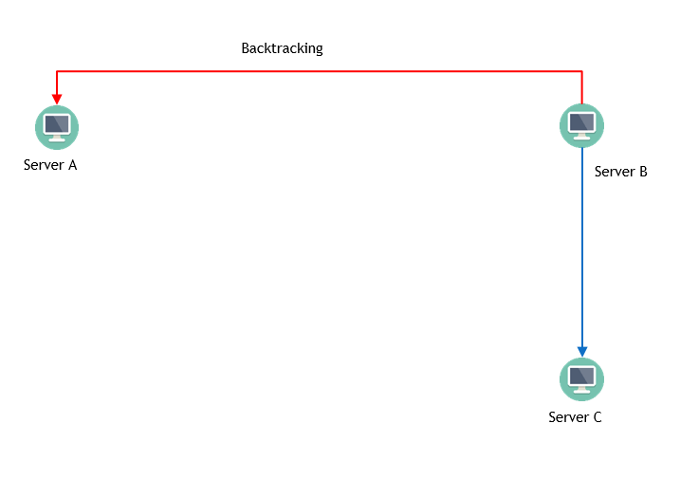
Figure 3.3
Chapter 5

Evaluation

5.1 Scenario 23
5.1.1 Simple 24
5.1.2 DaP 24
5.1.3 Backtracking 25

5.2 Results 26
5.2.1 500MB 27
5.2.1.1 10% changes 27
5.2.1.2 20% changes 30
5.2.1.3 30% changes 33
5.2.1.4 40% changes 36
5.2.2 1000MB 39
5.2.2.1 10% changes 39
5.2.2.2 20% changes 42
5.2.2.3 30% changes 45
5.2.2.4 40% changes 48
5.2.3 2500MB 51
5.2.3.1 10% changes 51
5.2.3.2 20% changes 54
5.2.3.3 30% changes 57
5.2.3.4 40% changes 60

5.1 Scenario

The scenario of which we are going evaluate the implementations has been simulated by CORE. This scenario includes 5 server nodes connected via an Ethernet switch. All server nodes are connected to the Ethernet switch with 100Mbps bandwidth links (see Figure 4.1). It is important to note that these simulations were run on a single machine on an Ubuntu distribution [9] run on Oracle Virtual Machine [10].
The virtual machine (VM) had access to 8192MB of RAM and access to 4 cores with an execution cap at 100% of Intel’s CPU i7-6700K @ 4.00GHz. Also the storage device of which the VM was run was an SSD [11].
Because of the simulation being run on one machine the multithreaded algorithm has most likely worse results than it would have in an actual environment due to two servers wouldn’t share a CPU.
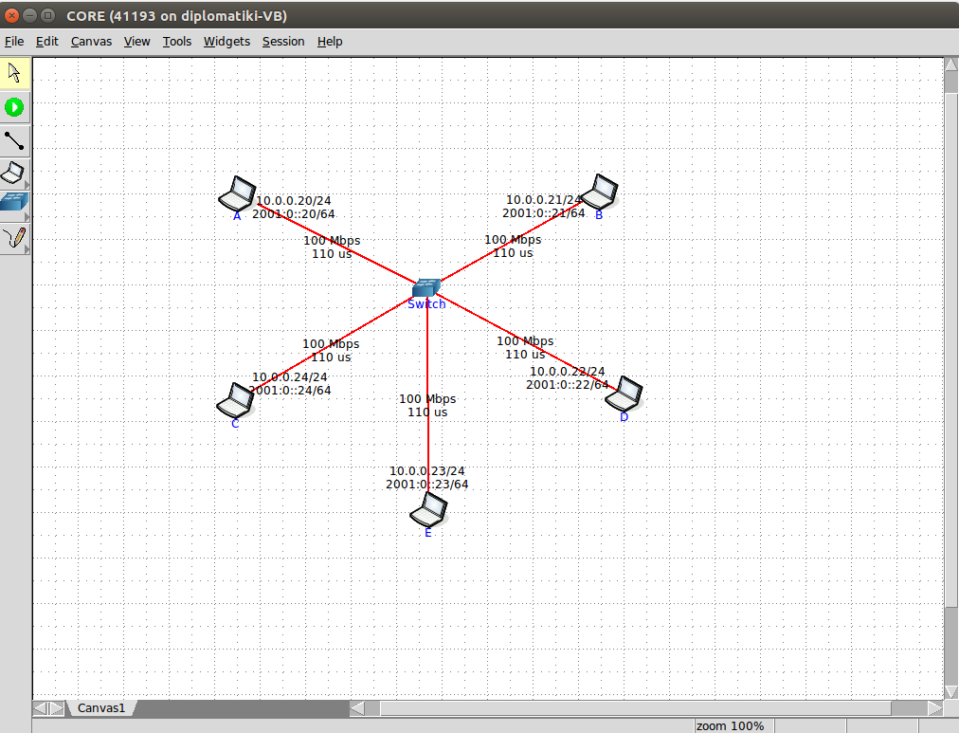
Figure 4.1 Network Topology

The above scenario has been simulated for 3 different size of file-system 500MB 1000MB and 2500MB and for each file-system size with 10%, 20%, 30% and 40% of changes on each migration.
The user follows a predefined route so we can better compare the results, this route is
A -> B -> D -> E -> C -> E -> B -> D -> A. This route include a total of 8 migrations, which also means a total of 8 version files will be created in the case of DaP and Backtracking algorithm. Before each migration occurs we simulate the changes by deleting, adding files randomly as well as modifying the remainder of the files by adding, deleted and modifying their lines.

5.1.1 Simple

The Simple algorithm, on each of the migrations simply packages the whole file-system and relays it to the next server node.

5.1.2 Diff and Patch (DaP)

On figure 4.2 we can see the changes that happen to each server node when we use the DaP method. A, B, C, D, E depict a server, for a total of five servers. While the number in each box depicts the version that each server nodes has any given time.
 |  | Idle | Not in Network | Active
The number in each box indicates the version the current server node has
A | B | C | D | E
0 | 0 | 0 | 0 | 0
1 | 0 | 0 | 0 | 0
1 | 1 | 0 | 0 | 0
1 | 2 | 0 | 0 | 0
1 | 2 | 0 | 2 | 0
1 | 2 | 0 | 3 | 0
1 | 2 | 0 | 3 | 3
1 | 2 | 0 | 3 | 4
1 | 2 | 4 | 3 | 4
1 | 2 | 5 | 3 | 4
1 | 2 | 5 | 3 | 5
1 | 2 | 5 | 3 | 6
1 | 6 | 5 | 3 | 6
1 | 7 | 5 | 3 | 6
1 | 7 | 5 | 7 | 6
1 | 7 | 5 | 8 | 6
8 | 7 | 5 | 8 | 6
8 | 7 | 5 | 8 | 6
Figure 4.2
5.1.3 Backtracking

On figure 4.3 we can see the changes that happen to each server node when we use the backtracking method. Note that when server C connects to server E due to the circular connection the server E overwrites its stored previous server node to C and because E connected C, Cs previous server node is set to E this is the reason backtracking stops reaching the servers A, B and D.

 | Idle | Not in Network | Active | Backtracking
The number in each box indicates the version the current server node has
A | B | C | D | E
0 | 0 | 0 | 0 | 0
1 | 0 | 0 | 0 | 0
1 | 1 | 0 | 0 | 0
2 | 2 | 0 | 0 | 0
2 | 2 | 0 | 2 | 0
3 | 3 | 0 | 3 | 0
3 | 3 | 0 | 3 | 3
4 | 4 | 0 | 4 | 4
4 | 4 | 4 | 4 | 4
4 | 4 | 5 | 4 | 4
4 | 4 | 5 | 4 | 5
4 | 4 | 6 | 4 | 6
4 | 6 | 6 | 4 | 6
4 | 7 | 7 | 4 | 7
4 | 7 | 7 | 7 | 7
4 | 8 | 8 | 8 | 8
8 | 8 | 8 | 8 | 8
8 | 8 | 8 | 8 | 8
Figure 4.3

5.2 Results

For each scenario we run the two final implementations DaP and Backtracking as well as the base case for comparison.
We have three types of graphs in our evaluation.

The first type of graph can be seen in figure 4.4.

Figure 4.4 shows the overall time the migration took on each migration process. It’s vertical axis shows time in seconds while its horizontal axis shows the number of versions the ELFM system had to send to the new server node in order to complete the file-system migration and the new server node to become active.
Due to our route A -> B -> D -> E -> C -> E -> B -> D -> A. the horizontal axis will always hold the same values as we know how many versions each migration will send.

Figure 4.5, 4.6 and 4.7 make up for the second type of graph in our evaluation. These graphs show were each implementation spends its time in order to complete the migration. The vertical axis in these graphs show from the 100% of its overall time the allocation of time in each task compressing, sending/receiving and adapting. The horizontal axis show the number of versions it had to send for the migration to be completed, with the exception of Simple in which the horizontal axis does not depict anything other than the hop count.

Figures 4.8 and 4.9 is the final type of graph in our evaluation and they show the performance increase backtracking had compared to Simple and DaP algorithms respectively. Its vertical axis depicts the number of versions the algorithm had to send in order for the migration to be completed, whilst the horizontal axis shows the performance increase or decrease in percentage in relation.

5.2.1 500MB

When the file-system size is small as well as the percentage of changes the migration time of our implementation is far lower than that of the baselines. However cumulative migrations result in multiple versions that need to be send for the system to be up to date. As we can see in 4.22 in 40 percentage of changes the DaP implementation when it has to transfer 7 versions (7 * 40% 500MB ~= 1400MB) it has to transfer almost thrice the size of the file-system and as a consequence is almost thrice times as slow.

5.2.1.1 10% Changes

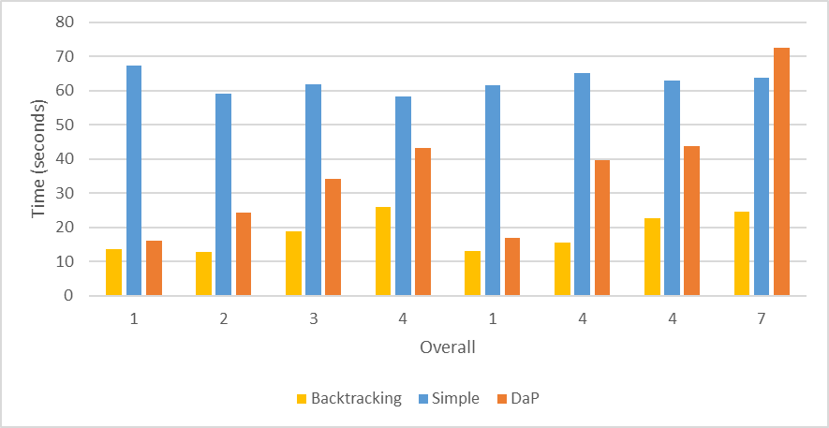
Figure 4.4

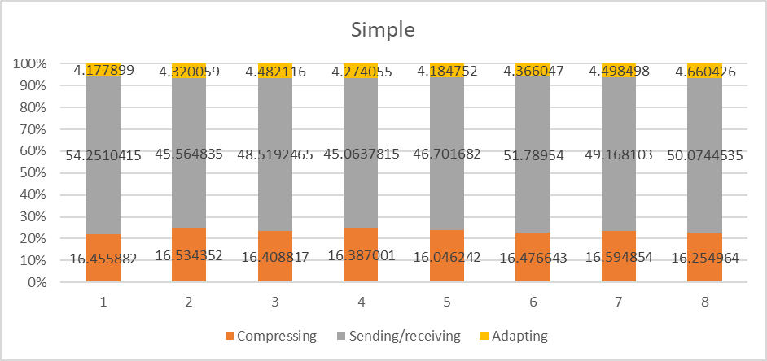
Figure 4.5

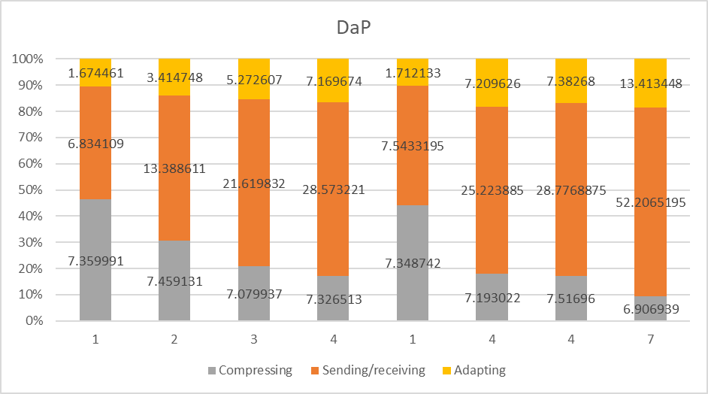
Figure 4.6

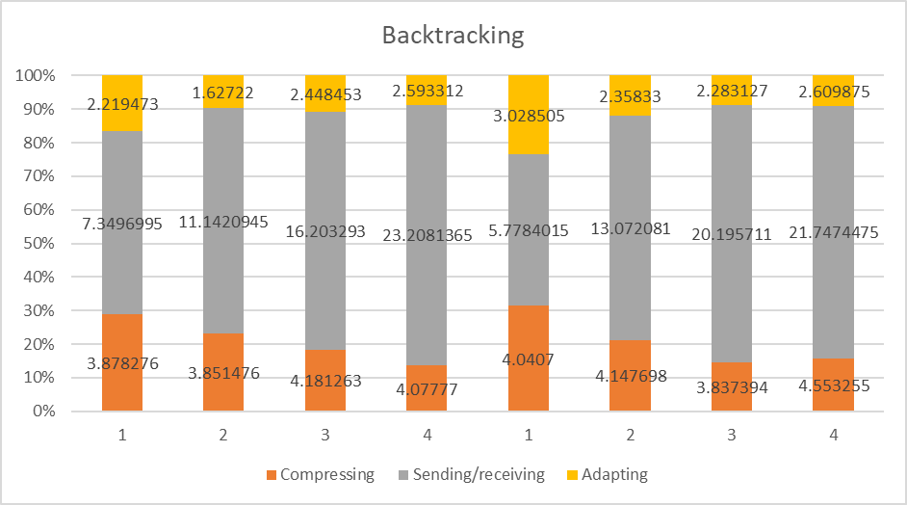
Figure 4.7

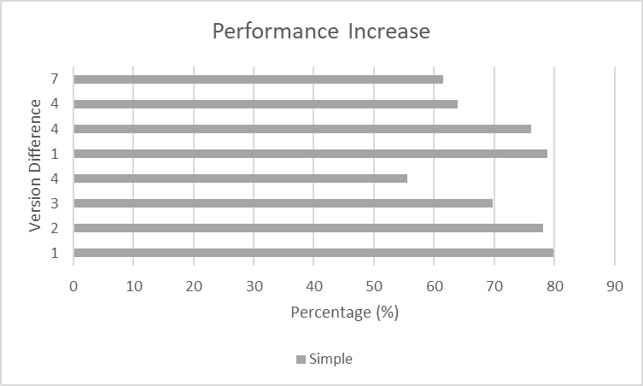
Figure 4.8

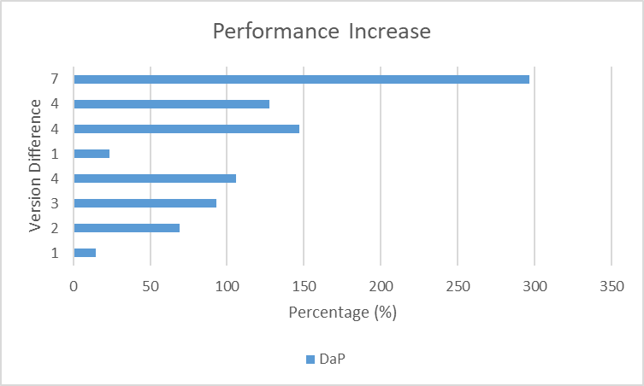
Figure 4.9

5.2.1.2 20% Changes

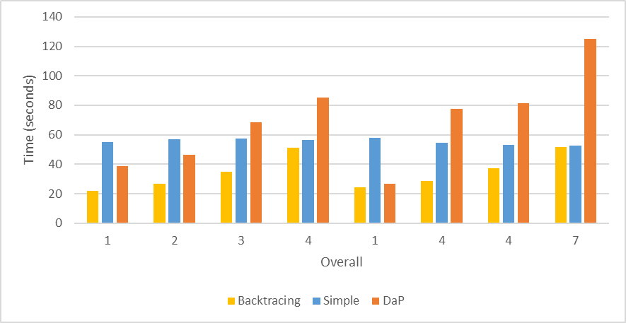
Figure 4.10

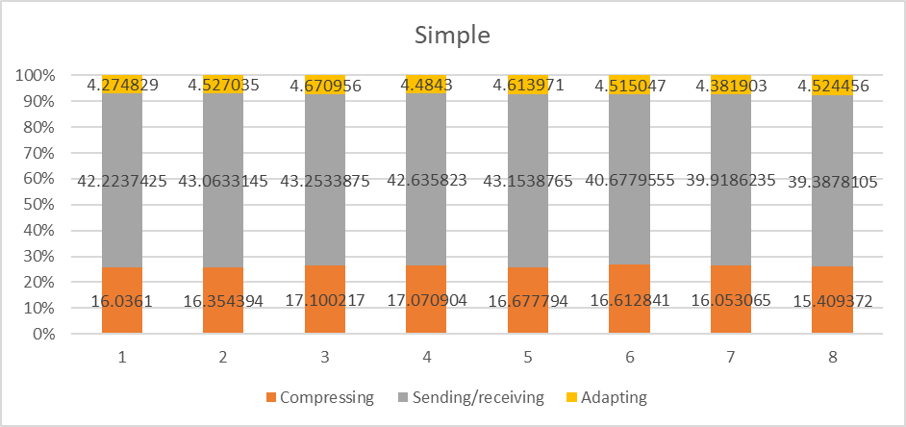
Figure 4.11

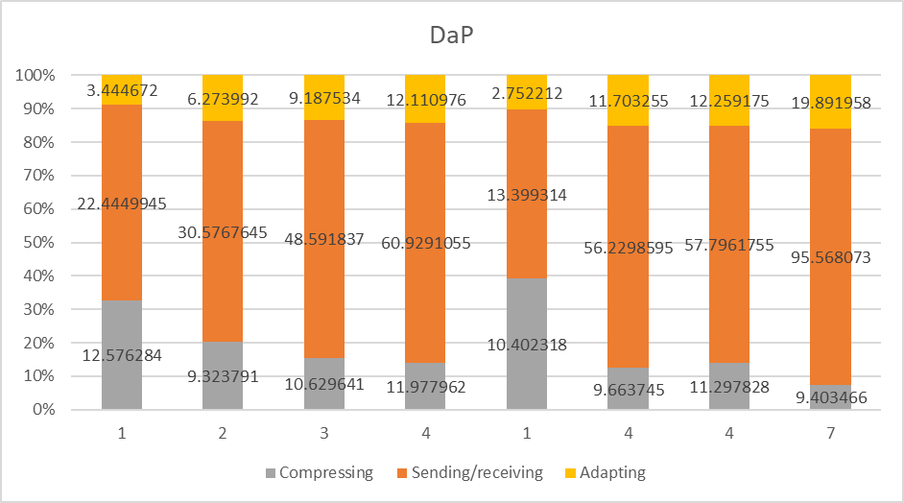
Figure 4.12

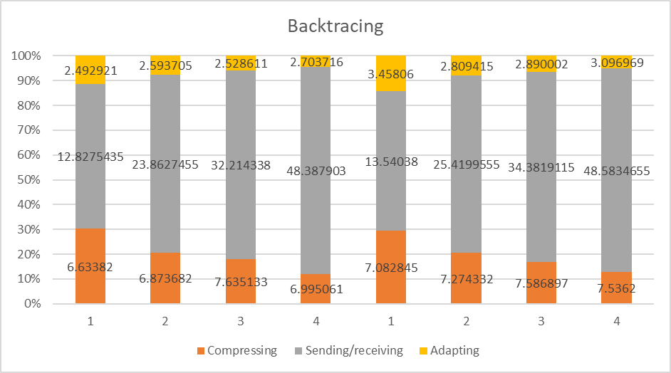
Figure 4.13

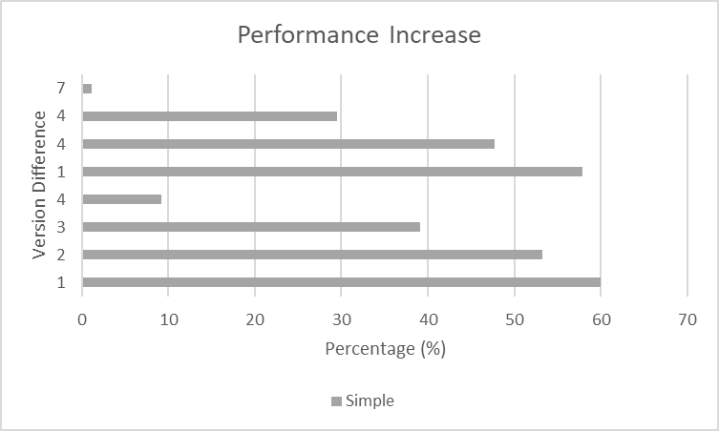
Figure 4.14

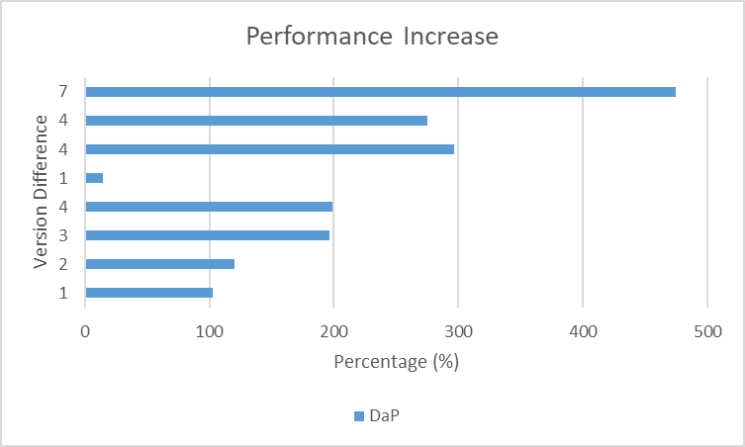
Figure 4.15

5.2.1.3 30% Changes

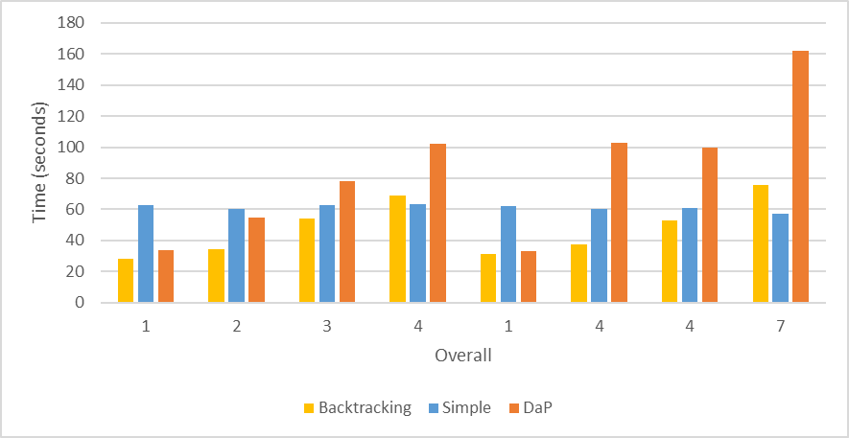
Figure 4.16

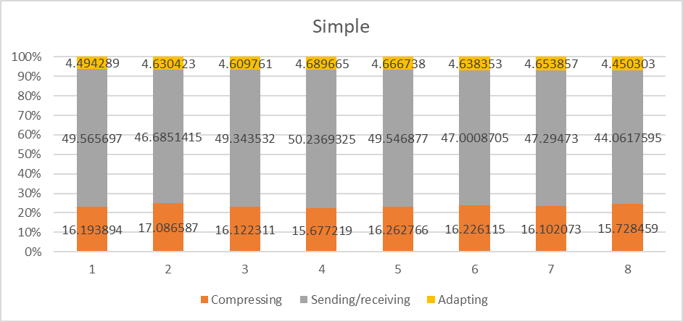
Figure 4.17

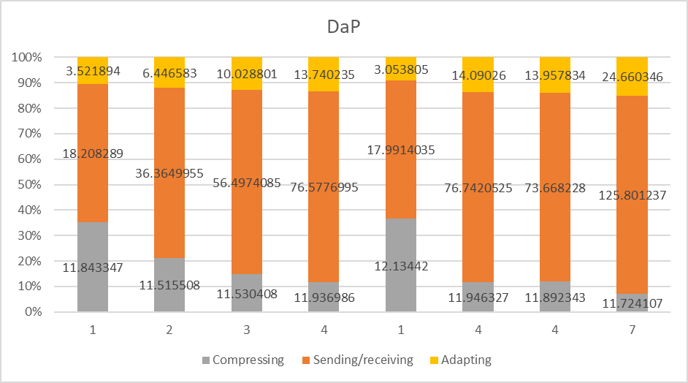
Figure 4.18

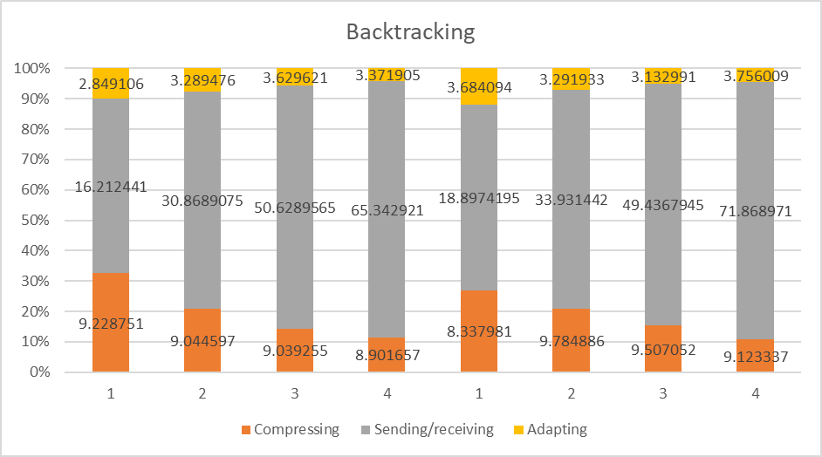
Figure 4.19

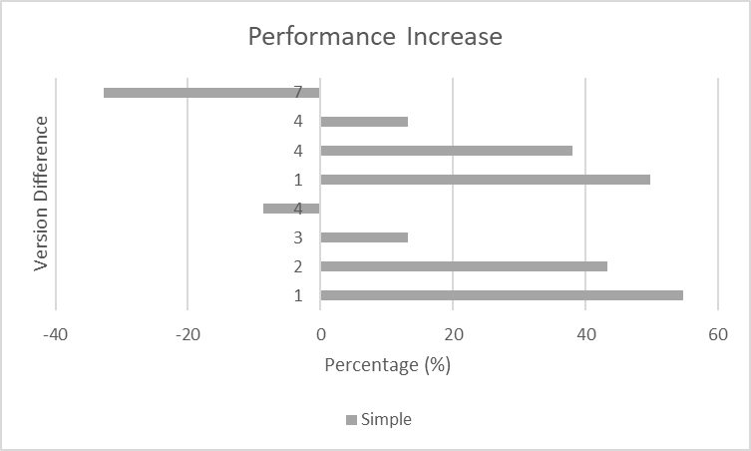
Figure 4.20

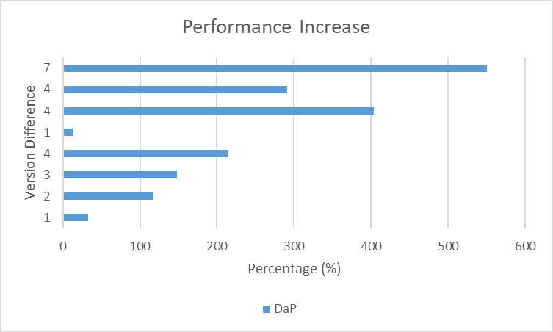
Figure 4.21

5.2.1.4 40% Changes

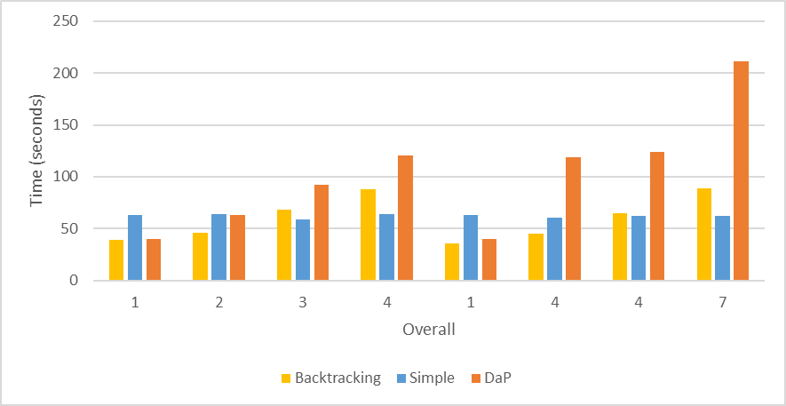
Figure 4.22

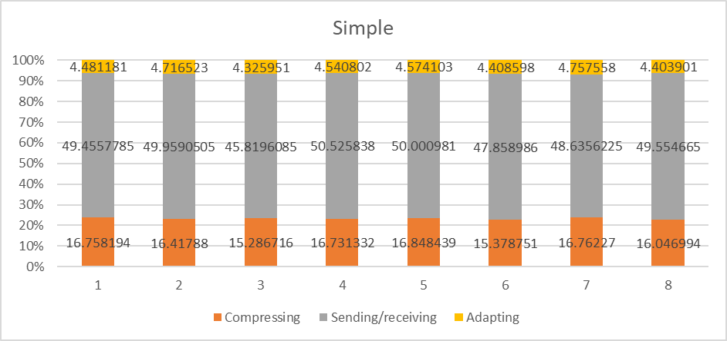
Figure 4.23
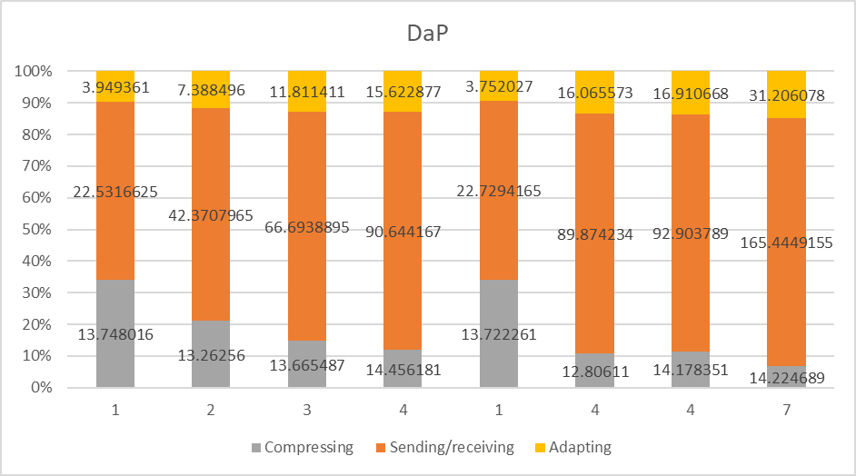
Figure 4.24

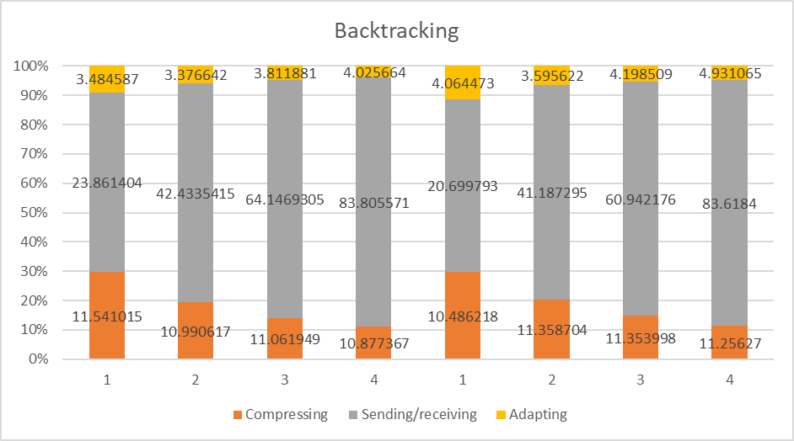
Figure 4.25

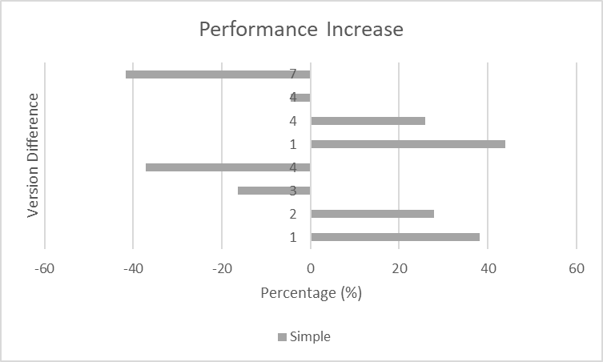
Figure 4.26

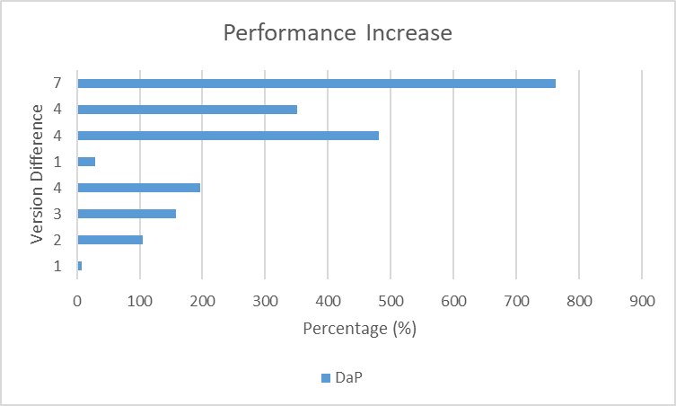
Figure 4.27
5.2.2 1000MB

Increasing the file-system size we can see that the overall time is in relation relatively the same. However concurrent processing of data becomes more apparent as we can see from 4.29 and 4.31.

5.2.2.1 10% Changes

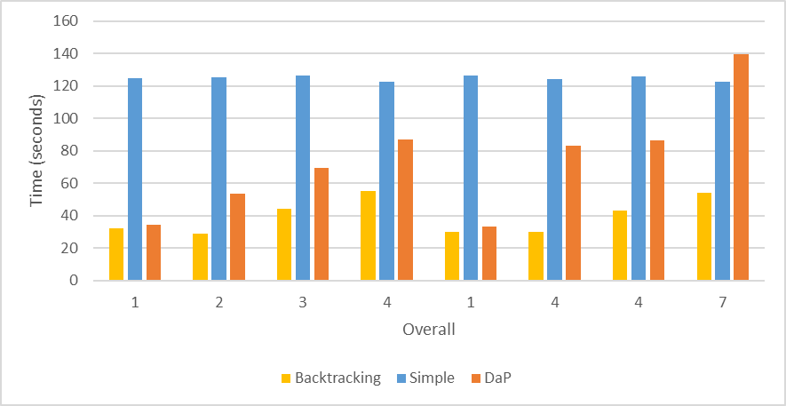
Figure 4.28

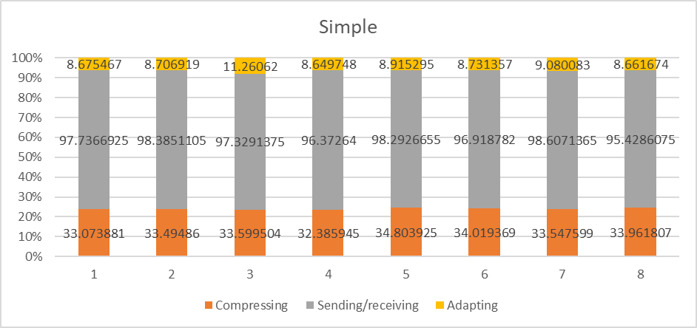
Figure 4.29

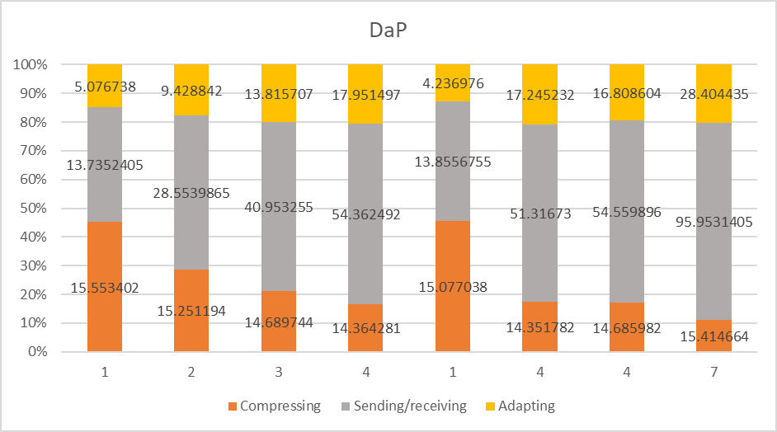
Figure 4.30

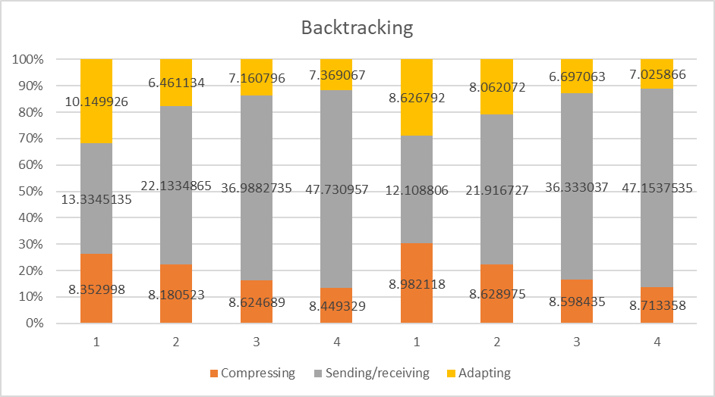
Figure 4.31

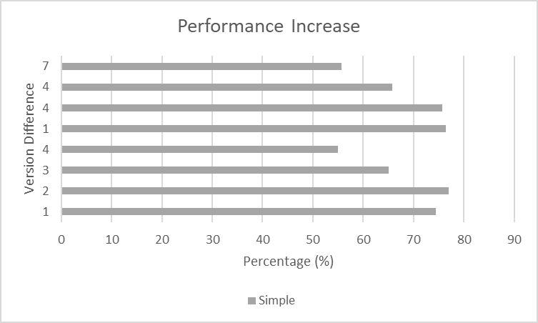
Figure 4.32

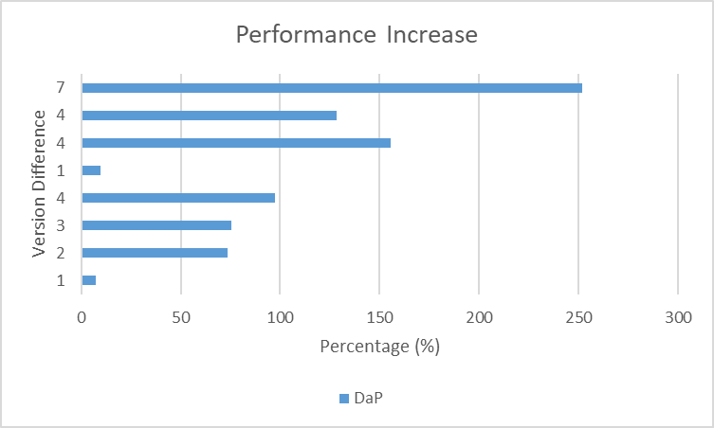
Figure 4.33
5.2.2.2 20% Changes

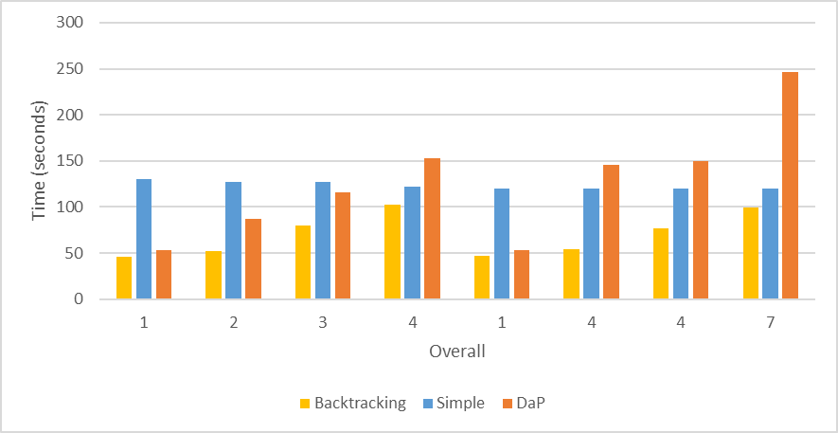
Figure 4.34

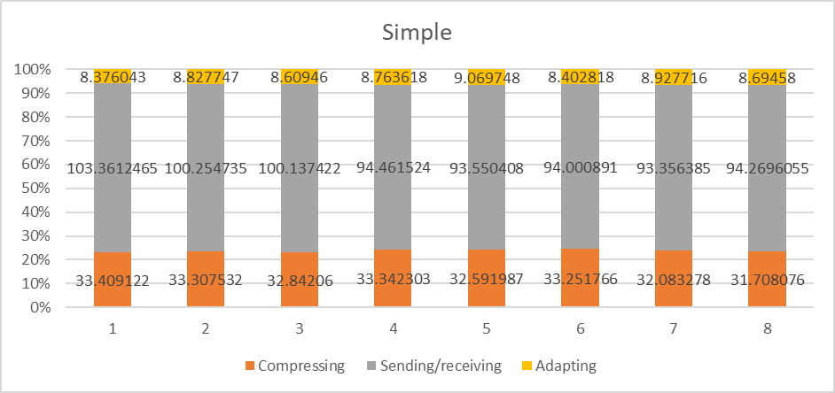
Figure 4.35
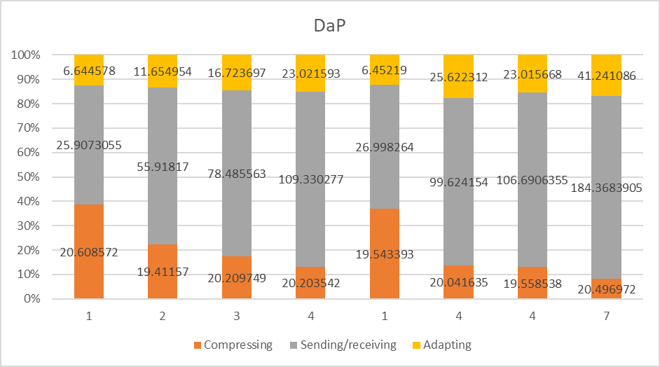
Figure 4.36

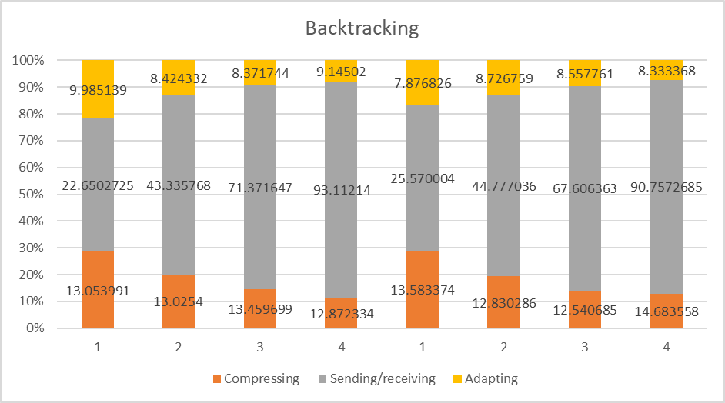
Figure 4.37
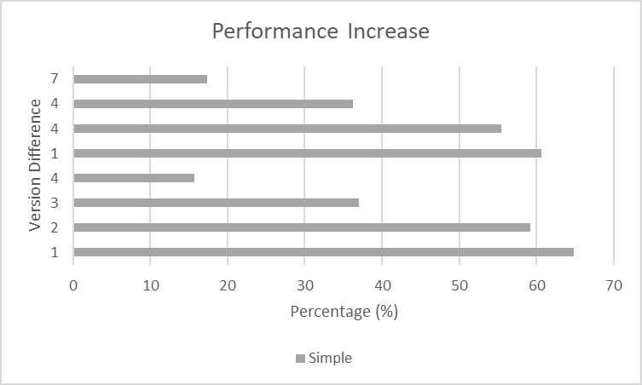
Figure 4.38

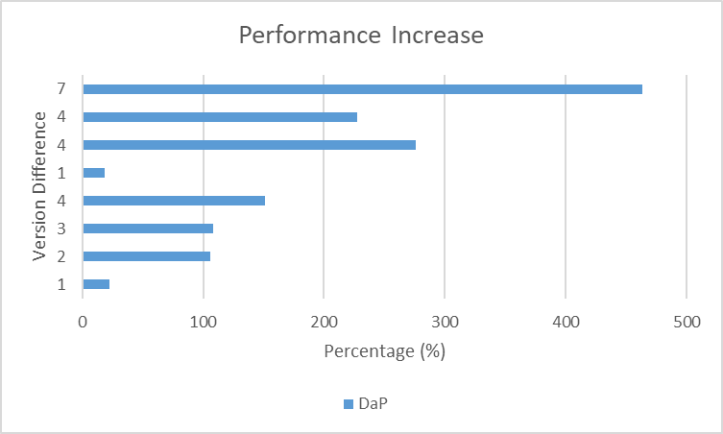
Figure 4.39
5.2.2.3 30% Changes

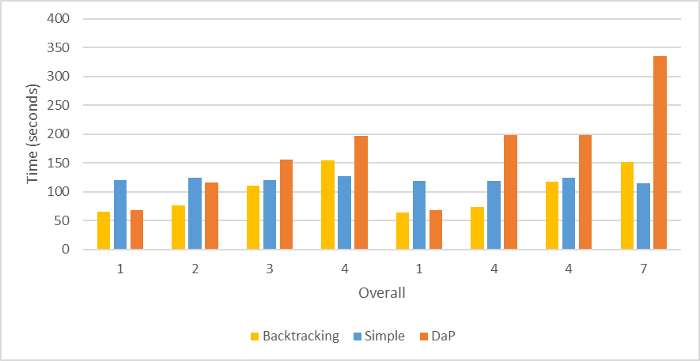
Figure 4.40

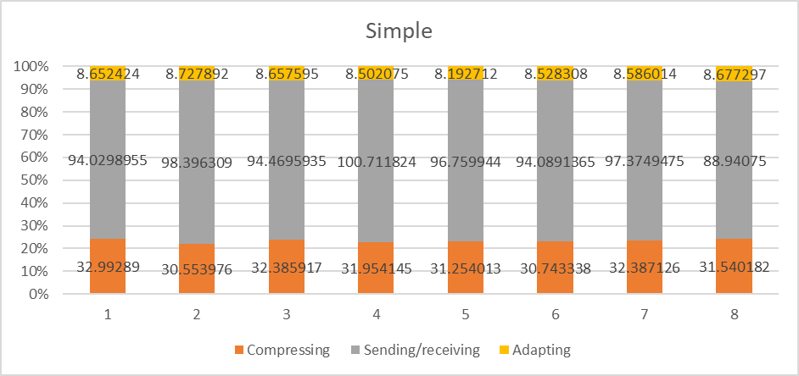
Figure 4.41
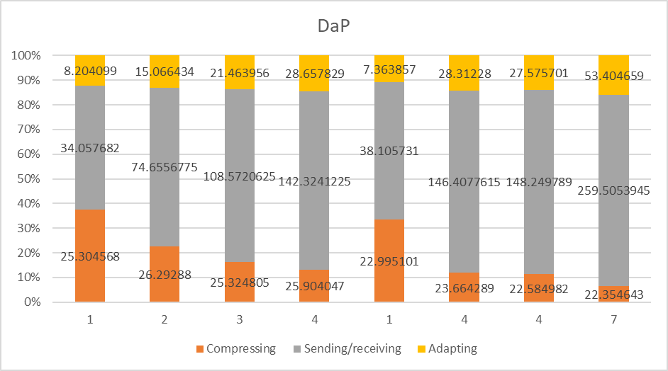
Figure 4.42

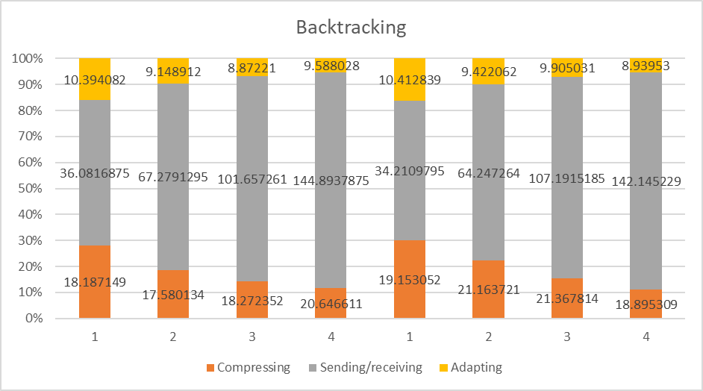
Figure 4.43
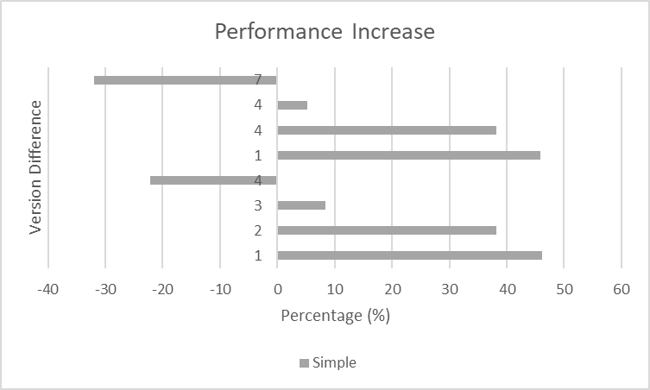
Figure 4.44

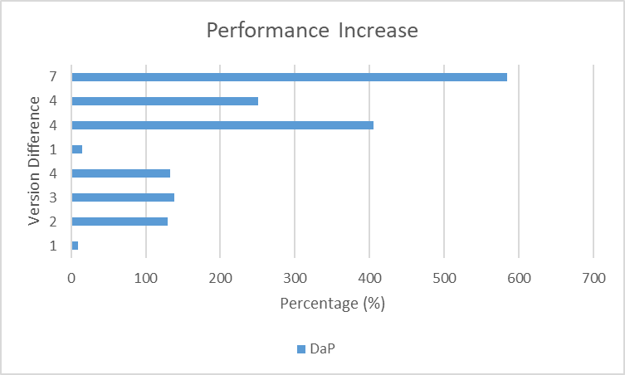
Figure 4.45
5.2.2.4 40% Changes

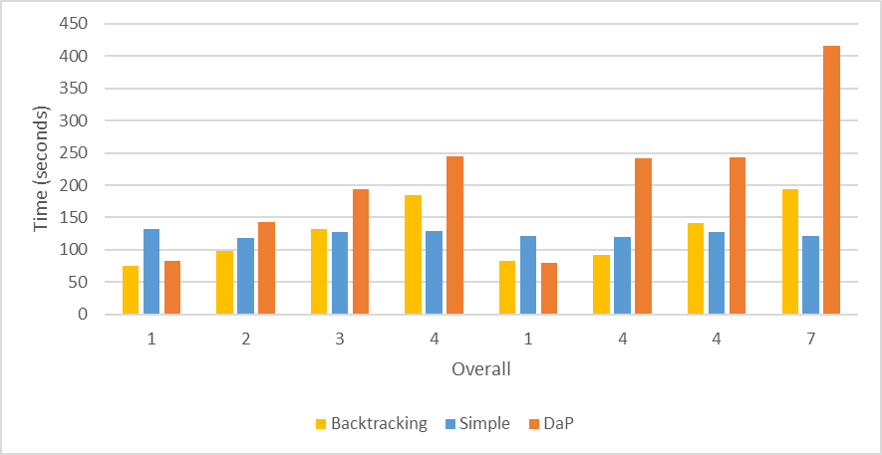
Figure 4.46

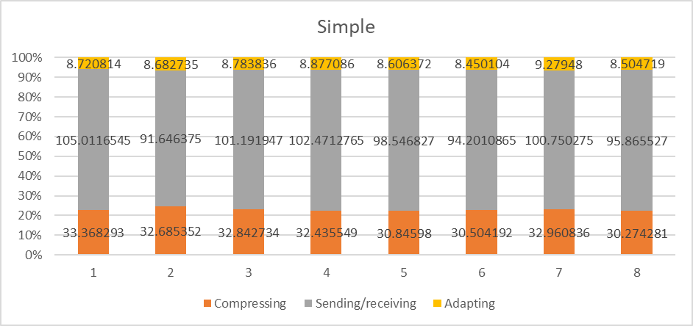
Figure 4.47
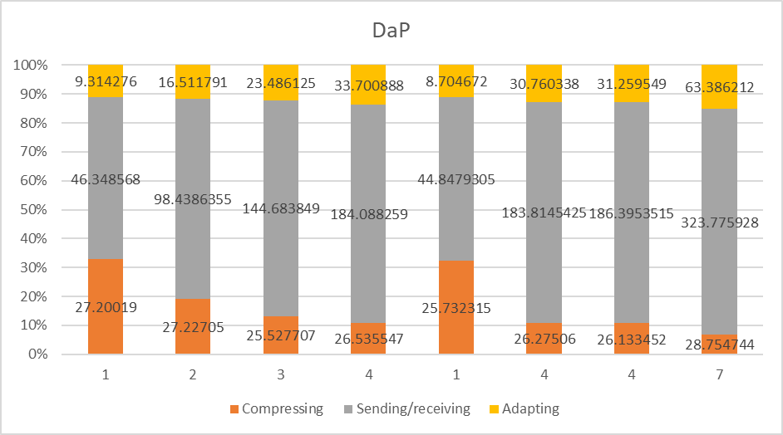
Figure 4.48

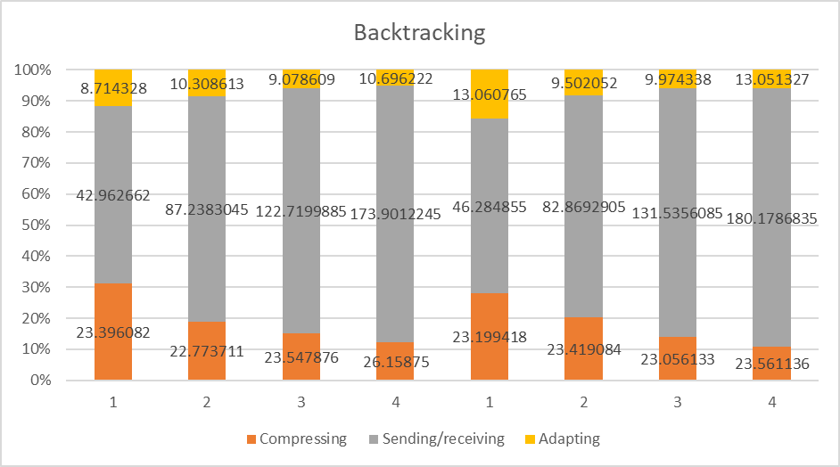
Figure 4.49
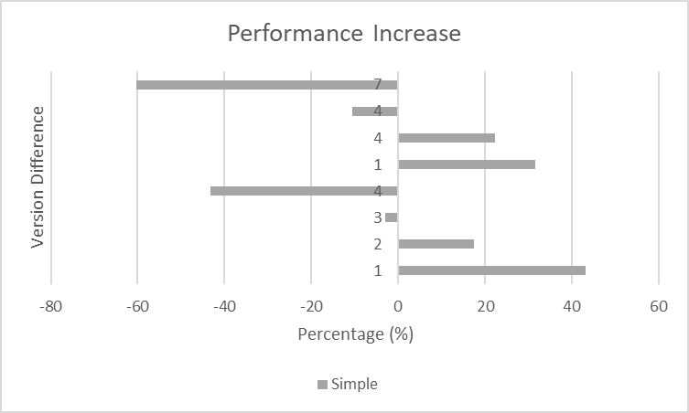
Figure 4.50

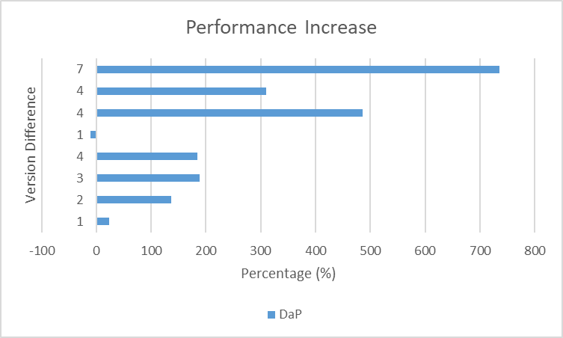
Figure 4.51
5.2.3 2500MB

Finally from the biggest file-system size results we can see that the DaP implementation after a number of migrations it always start to decrease in performance and increase in data ( 7 * 40% 2500MB ~ = 7GB ) The same is true for the backtracking implementation but backtracking is subject to the route of connection.

5.2.3.1 10% Changes

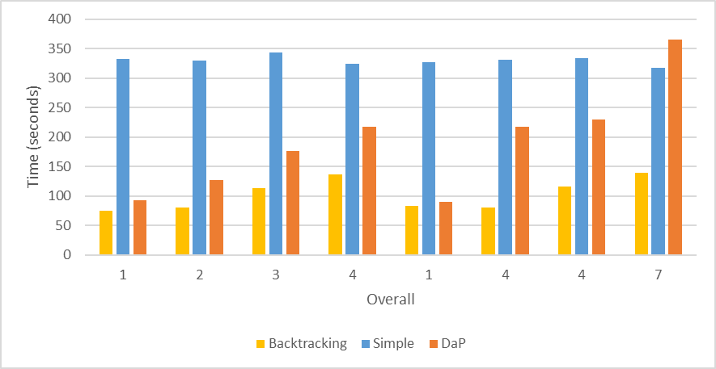
Figure 4.52

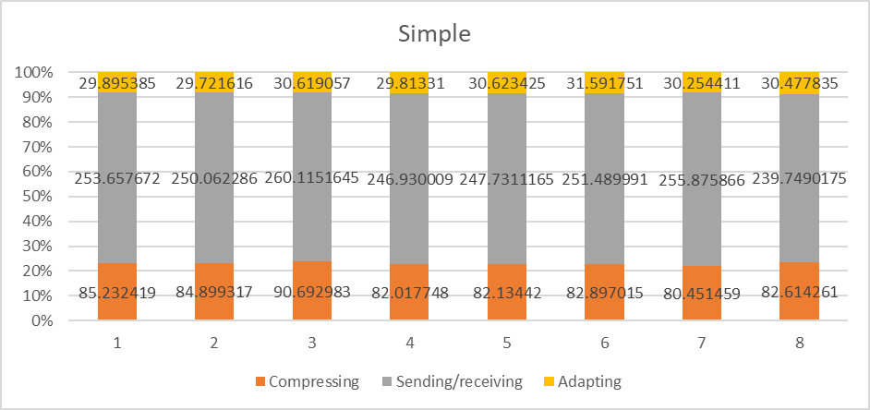
Figure 4.53
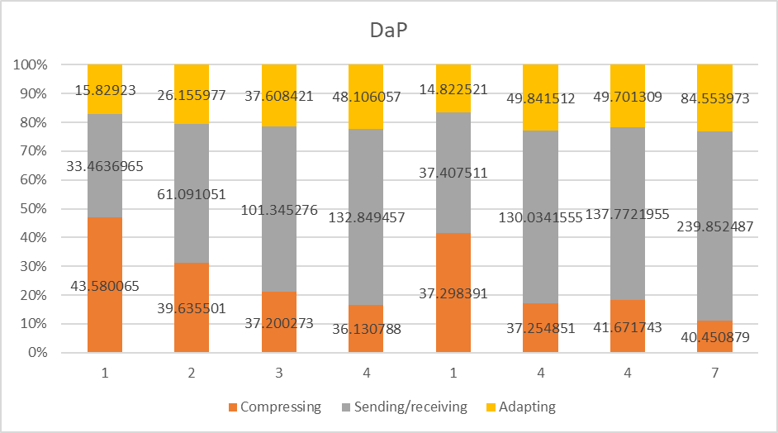
Figure 4.54

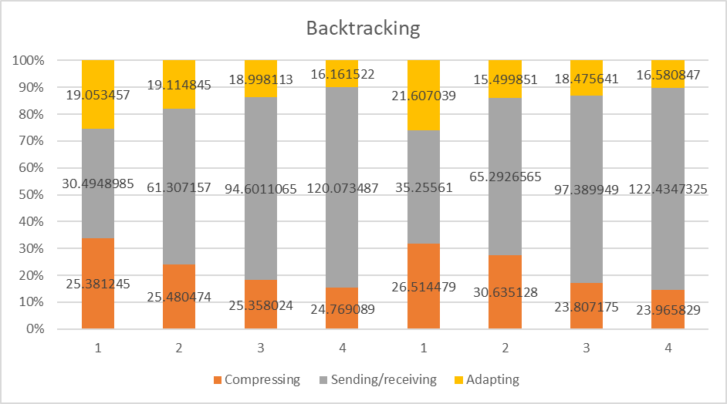
Figure 4.55
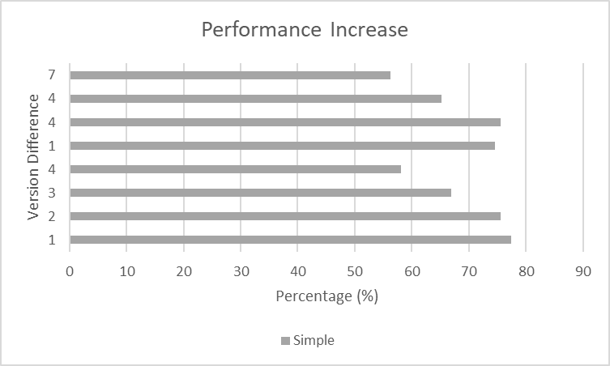
Figure 4.56

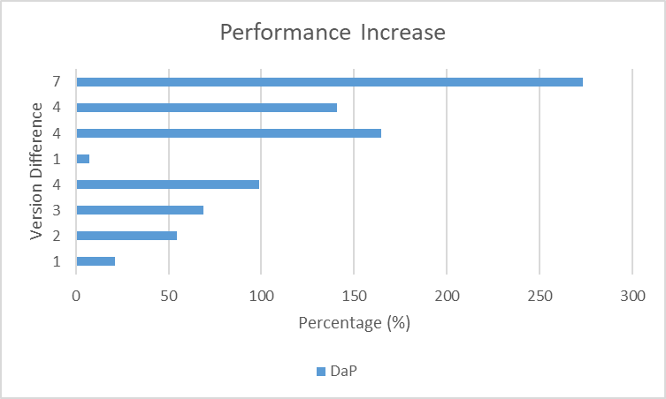
Figure 4.57
5.2.3.2 20% Changes

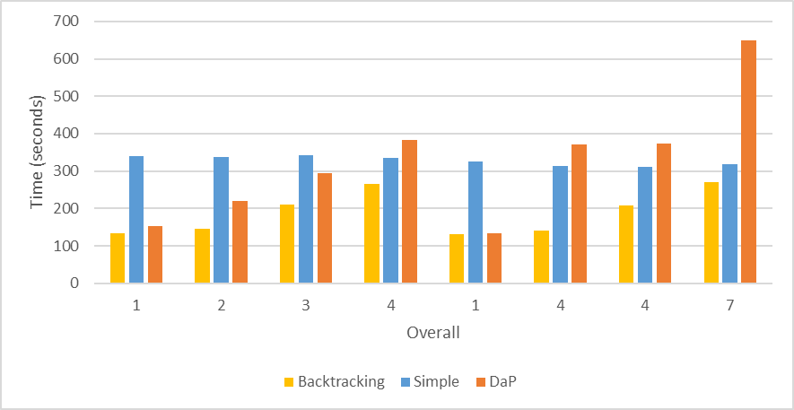
Figure 4.58

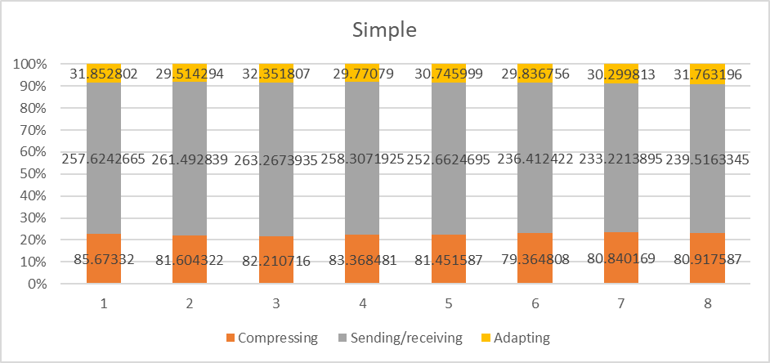
Figure 4.59
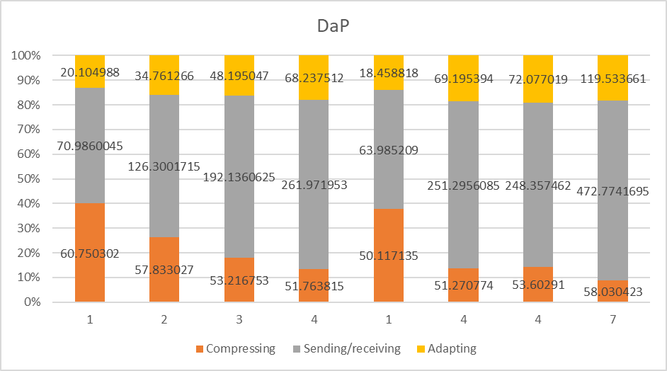
Figure 4.60

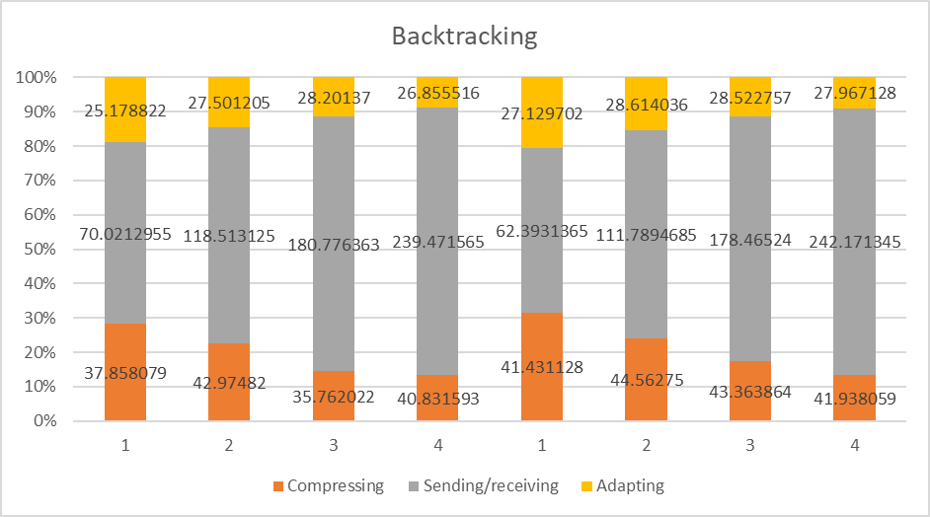
Figure 4.61
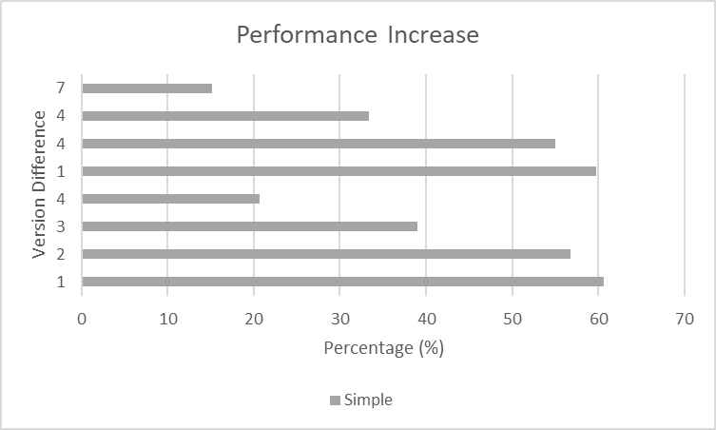
Figure 4.62

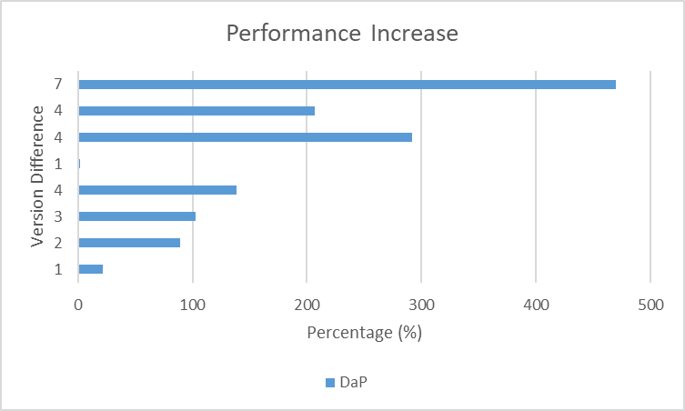
Figure 4.63
5.2.3.3 30% Changes

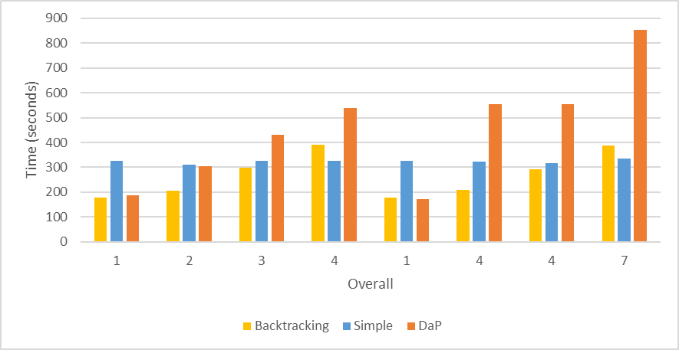
Figure 4.64

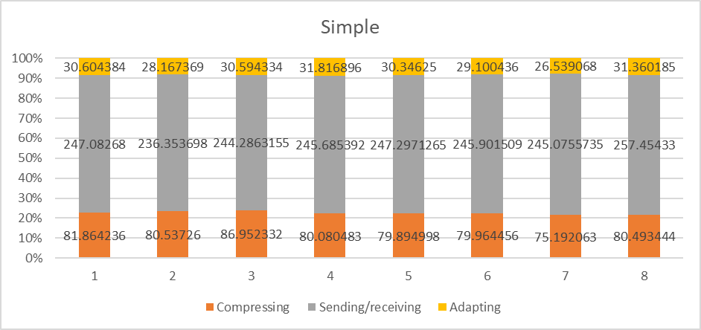
Figure 4.65
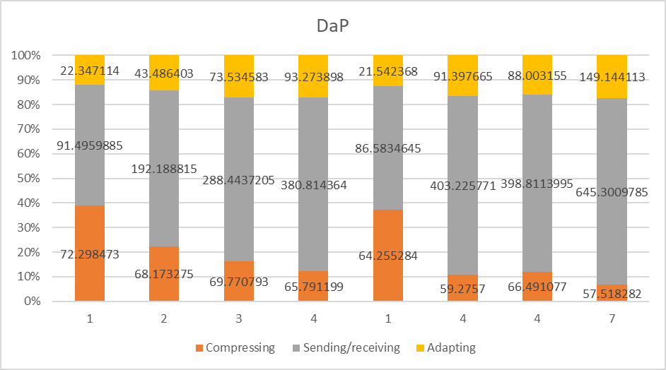
Figure 4.66

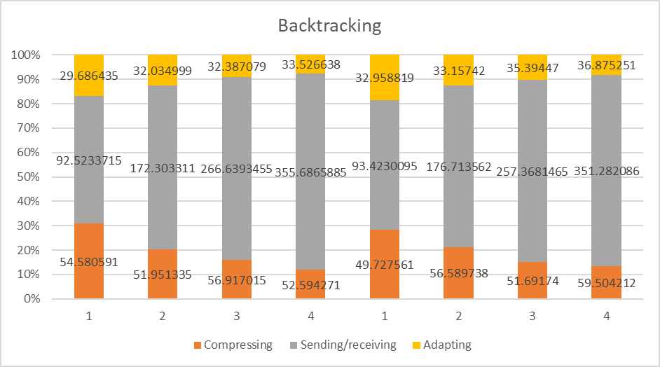
Figure 4.67
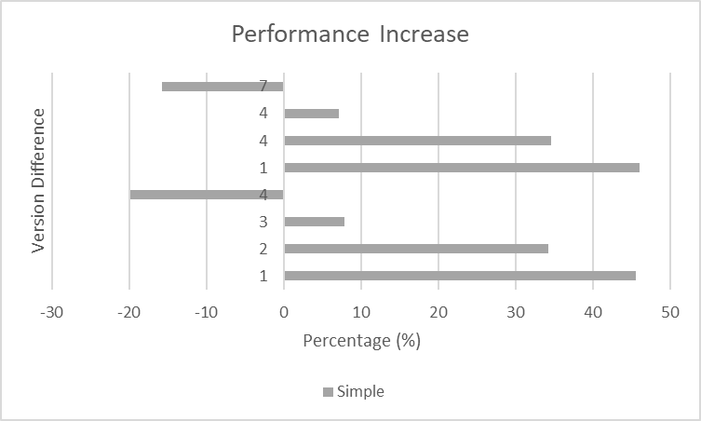
Figure 4.68

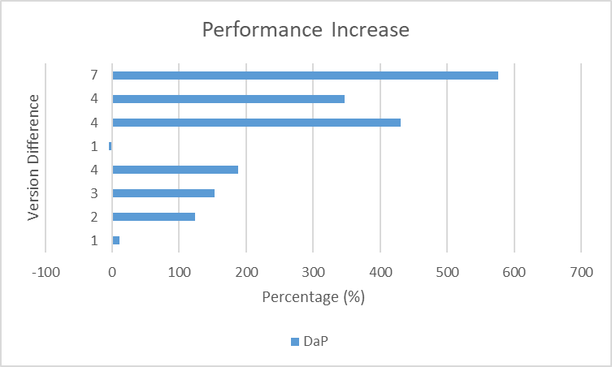
Figure 4.69
5.2.3.4 40% Changes

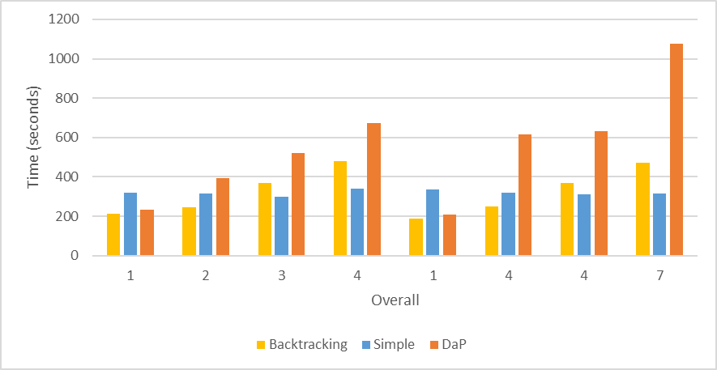
Figure 4.70

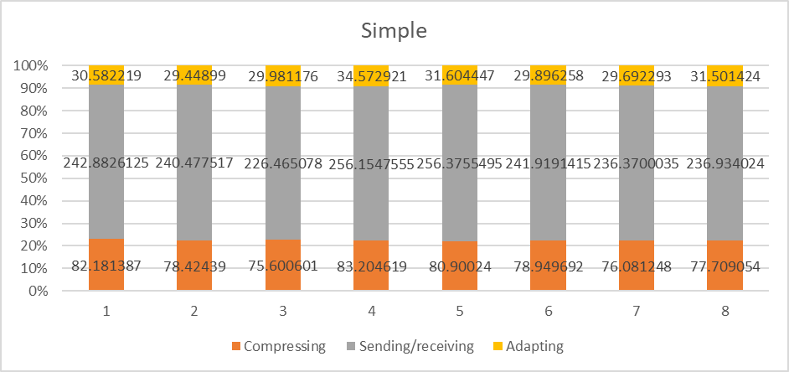
Figure 4.71
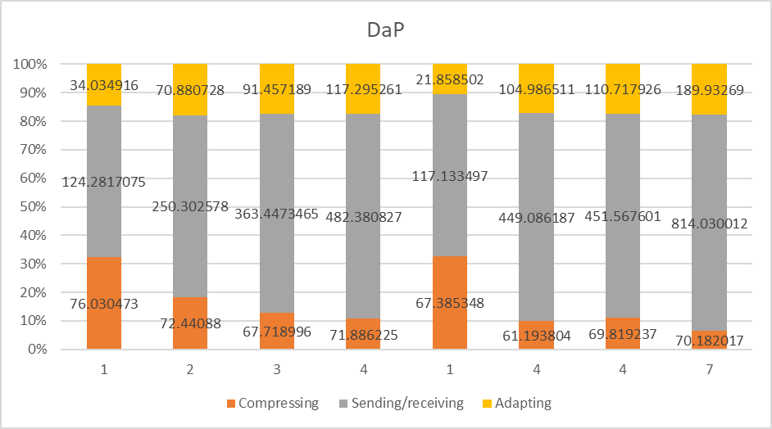
Figure 4.72

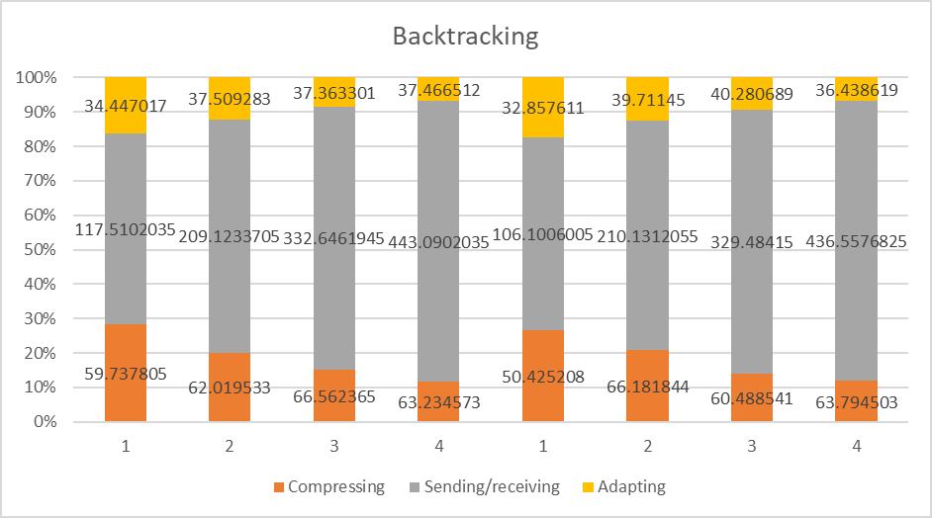
Figure 4.73
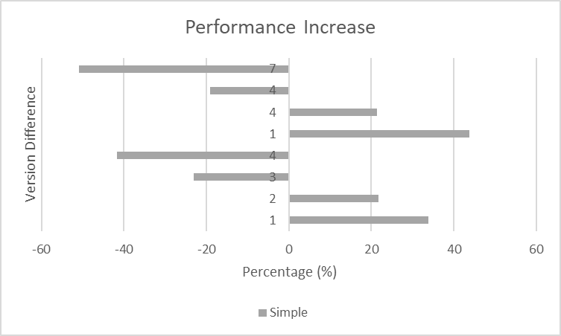
Figure 4.74

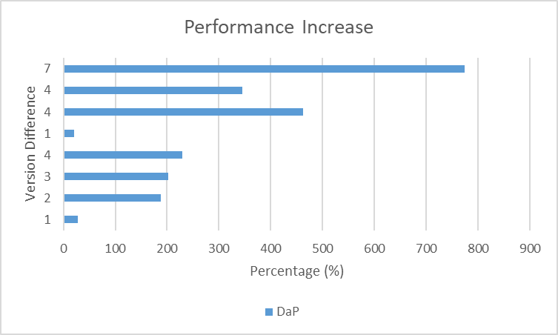
Figure 4.75

Chapter 6

Conclusion and Discussion

6.1 Conclusion 63
6.2 Future Work 65

6.1 Conclusion

Analysing the overall graphs (first type of graphs ex figure 4.70) we can see the results of the threaded implementation in the first four columns. The first four migrations happen on new machines, machine were the user has not migrate before. The performance increase we have here is due to concurrent processing and pipelining of migrating versions. Notably in the second column it can be seen that the increase in time for DaP is far greater than the increase in time for Backtracking. The reason of the small increase in backtracking is specifically due to pipelining.

Furthermore for the results with 40% changes on the third and fourth columns our implementation is slower than the baseline. This is because the system has to send more data due to cumulative versions. Even at four versions, 4 * 0.4 * 2500 = 4GB which is 1.5GB greater than the total size of the file-system.

Following the final three columns in the overall graphs we can see the performance increase backtracking brings to the table. In this three columns we can see that the overall time for DaP has skyrocketed compared to our backtracking implementation. This is because DaP still sends cumulative versions whereas the backtracking implementation has already send them when the user wasn’t active on the other server nodes.

However still for the results with 40% changes on the last two columns our implementation is slower than the baseline. This is because of the same reason as above, the system needs to three and four versions for the migration to be completed which means we send more data than the whole file-system.

From this we can conclude that the backtracking implementation favours one to two version difference for migrations. In such cases the backtracking algorithm can show up to 60% performance increase (figure 4.56) from the base-line depending on how much the file-system has changed.

It is important to note that the higher percentage of difference we have the less performance increase we will have because the size of the changed data are closing on the file-system size.

Finally the backtracking algorithm effectively increases performance between the “most” active servers. This is true because backtracking always sees the previous server node of each server. If the circle of connection from server to server is big then all server nodes will be up to date. But if it small then only the servers within the circle will be up to date. (See Figure 4.3 how the backtracking stops when a circle occurs).

Additionally it is noteworthy that due to the nature of the system it could potentially be built and launched on a block chain network.

In conclusion we have shown great performance increase from the DaP version, in some cases we have up to 600% performance increase (figure 4.75) and the new backtracking implementation shows great promise we still need to reduce the overhead that occurs from cumulative versions. We’ll cover these in the future work section.

6.2 Future Work

In order to make the ELFM system more efficient the overhead of sending multiple versions should be reduced.

One way to achieve this could be that each server node will save all of its previous server nodes and it will backtrack to all of them. This way all migrations and new versions that happen in any circular connections will always propagate to the very first server.

Another way to achieve this would be to merge old sequential versions into one single version file. This way the versions would “reset” and stop creating over increasing overhead of the migrations.

A third way to achieve this could be when the user tries to migrate depending on the version difference the system would choose to migrate via Simple (send all the current files) or create a version file and send it. In case the size of the versions to be send exceeded the current file-system we would use Simple so the user could get a working file-system sooner and afterwards in the background we also send the versions.

References
[1] What is Python?
https://www.python.org/doc/essays/blurb/

[2] Neil Brown “Overlay File-system” https://www.kernel.org/doc/Documentation/filesystems/overlayfs.txt

[3] “Common Open Research Emulator (CORE)” https://www.nrl.navy.mil/itd/ncs/products/core

[4] Robert Bradford, Evangelos Kotsovinos, Anja Feldmann, Harald Schi¨oberg, “Live Wide-Area Migration of Virtual Machines Including Local Persistent State”
https://www.net.t-labs.tu-berlin.de/papers/BKFS-LWMVMILPS-07.pdf

[5] Ali Mashtizadeh, Emre Celebi, Tal Garfinkel, Min Cai “The Design and Evolution of Live Storage Migration in VMware ESX”
http://static.usenix.org/legacy/events/atc11/tech/final_files/Mashtizadeh.pdf

[6] What is the command Diff
https://ss64.com/bash/diff.html

[7] Multithreading
https://en.wikipedia.org/wiki/Multithreading_(computer_architecture)

[8] Object Oriented Programming
https://en.wikipedia.org/wiki/Object-oriented_programming

[9] What is Ubuntu?
https://help.ubuntu.com/lts/installation-guide/s390x/ch01s01.html

[10] Oracle VM Virtualbox
https://www.virtualbox.org/wiki/VirtualBox

[11] What is SSD (Solid-State-Drive)
https://en.wikipedia.org/wiki/Solid-state_drive
[12] Efficient Live File-system Migration – Jiayi Fu

[13] “What is a Socket?”
https://www.tutorialspoint.com/unix_sockets/what_is_socket.htm

[14] Machtelt Garrels “Introduction to Linux”
http://www.tldp.org/LDP/intro-linux/html/sect_03_01.html

